
Minimise theft
D2.TGA.CL6.05
Trainer Guide

Minimise theft
D2.TGA.CL6.05
Trainer Guide



Project Base
William Angliss Institute of TAFE
555 La Trobe Street
Melbourne 3000 Victoria
Telephone: | (03) 9606 2111
Facsimile: | (03) 9670 1330
Acknowledgements
Project Director: | Wayne Crosbie
Project Manager | Jim Irwin
Chief Writer: | Alan Hickman
Subject Writer: | Alan Hickman
Editor: | Jim Irwin
DTP/Production: | Daniel Chee, Mai Vu, Cindy Curran

The Association of Southeast Asian Nations (ASEAN) was established on 8 August 1967. The Member States of the Association are Brunei Darussalam, Cambodia, Indonesia, Lao PDR, Malaysia, Myanmar, Philippines, Singapore, Thailand and Viet Nam.
The ASEAN Secretariat is based in Jakarta, Indonesia.
General Information on ASEAN appears online at the ASEAN Website: www.asean.org.
All text is produced by William Angliss Institute of TAFE for the ASEAN Project on “Toolbox Development for Front Office, Food and Beverage Services and Food Production Divisions”.
This publication is supported by the Australian Government’s aid program through the ASEAN-Australia Development Cooperation Program Phase II (AADCP II).
Copyright: Association of Southeast Asian Nations (ASEAN) 2015.
All rights reserved.
Disclaimer
Every effort has been made to ensure that this publication is free from errors or omissions. However, you should conduct your own enquiries and seek professional advice before relying on any fact, statement or matter contained in this book. The ASEAN Secretariat and William Angliss Institute of TAFE are not responsible for any injury, loss or damage as a result of material included or omitted from this course. Information in this module is current at the time of publication. Time of publication is indicated in the date stamp at the bottom of each page.
Some images appearing in this resource have been purchased from stock photography suppliers Shutterstock and iStockphoto and other third party copyright owners and as such are non-transferable and non-exclusive. Clip arts, font images and illustrations used are from the Microsoft Office Clip Art and Media Library. Some images have been provided by and are the property of William Angliss Institute.
Additional images have been sourced from Flickr and SXC and are used under Creative Commons licence: http://creativecommons.org/licenses/by/2.0/deed.en
File name: TG_Minimise_theft_280115



Table of contents
Competency Based Training (CBT) and assessment – An introduction for trainers 1
Competency standard 11
Notes and PowerPoint slides 23
Recommended training equipment 227
Instructions for Trainers for using PowerPoint – Presenter View 229
Appendix – ASEAN acronyms 231

Competency Based Training (CBT) and assessment – An introduction for trainers

Competency
Competency refers to the ability to perform particular tasks and duties to the standard of performance expected in the workplace.
Competency requires the application of specified knowledge, skills and attitudes relevant to effective participation, consistently over time and in the workplace environment.
The essential skills and knowledge are either identified separately or combined.
Knowledge identifies what a person needs to know to perform the work in an informed and effective manner.
Skills describe the application of knowledge to situations where understanding is converted into a workplace outcome.
Attitude describes the founding reasons behind the need for certain knowledge or why skills are performed in a specified manner.
Competency covers all aspects of workplace performance and involves:
- Performing individual tasks
- Managing a range of different tasks
- Responding to contingencies or breakdowns
- Dealing with the responsibilities of the workplace
- Working with others.

Unit of competency
Like with any training qualification or program, a range of subject topics are identified that focus on the ability in a certain work area, responsibility or function.
Each manual focuses on a specific unit of competency that applies in the hospitality workplace.
In this manual a unit of competency is identified as a ‘unit’.
Each unit of competency identifies a discrete workplace requirement and includes:
- Knowledge and skills that underpin competency
- Language, literacy and numeracy
- Occupational safety and health requirements.
Each unit of competency must be adhered to in training and assessment to ensure consistency of outcomes.

Element of competency
An element of competency describes the essential outcomes within a unit of competency.
The elements of competency are the basic building blocks of the unit of competency. They describe in terms of outcomes the significant functions and tasks that make up the competency.
In this manual elements of competency are identified as an ‘element’.

Performance criteria
Performance criteria indicate the standard of performance that is required to demonstrate achievement within an element of competency. The standards reflect identified industry skill needs.
Performance criteria will be made up of certain specified skills, knowledge and attitudes.

Learning
For the purpose of this manual learning incorporates two key activities:
- Training
- Assessment.
Both of these activities will be discussed in detail in this introduction.
Today training and assessment can be delivered in a variety of ways. It may be provided to participants:
- On-the-job – in the workplace
- Off-the-job – at an educational institution or dedicated training environment
- As a combination of these two options.
No longer is it necessary for learners to be absent from the workplace for long periods of time in order to obtain recognised and accredited qualifications.

Learning approaches
This manual will identify two avenues to facilitate learning:
Competency Based Training (CBT)
This is the strategy of developing a participant’s competency.
Educational institutions utilise a range of training strategies to ensure that participants are able to gain the knowledge and skills required for successful:
- Completion of the training program or qualification
- Implementation in the workplace.
The strategies selected should be chosen based on suitability and the learning styles of participants.

Competency Based Assessment (CBA)
This is the strategy of assessing competency of a participant.
Educational institutions utilise a range of assessment strategies to ensure that participants are assessed in a manner that demonstrates validity, fairness, reliability, flexibility and fairness of assessment processes.

Flexibility in learning
It is important to note that flexibility in training and assessment strategies is required to meet the needs of participants who may have learning difficulties. The strategies used will vary, taking into account the needs of individual participants with learning difficulties. However they will be applied in a manner which does not discriminate against the participant or the participant body as a whole.
Catering for participant diversity
Participants have diverse backgrounds, needs and interests. When planning training and assessment activities to cater for individual differences, trainers and assessors should:
- Consider individuals’ experiences, learning styles and interests
- Develop questions and activities that are aimed at different levels of ability
- Modify the expectations for some participants
- Provide opportunities for a variety of forms of participation, such as individual, pair and small group activities
- Assess participants based on individual progress and outcomes.
The diversity among participants also provides a good reason for building up a learning community in which participants support each other’s learning.
Participant centred learning
This involves taking into account structuring training and assessment that:
- Builds on strengths – Training environments need to demonstrate the many positive features of local participants (such as the attribution of academic success to effort, and the social nature of achievement motivation) and of their trainers (such as a strong emphasis on subject disciplines and moral responsibility). These strengths and uniqueness of local participants and trainers should be acknowledged and treasured
- Acknowledges prior knowledge and experience – The learning activities should be planned with participants’ prior knowledge and experience in mind
- Understands learning objectives – Each learning activity should have clear learning objectives and participants should be informed of them at the outset. Trainers should also be clear about the purpose of assignments and explain their significance to participants
- Teaches for understanding – The pedagogies chosen should aim at enabling participants to act and think flexibly with what they know
- Teaches for independent learning – Generic skills and reflection should be nurtured through learning activities in appropriate contexts of the curriculum. Participants should be encouraged to take responsibility for their own learning
- Enhances motivation – Learning is most effective when participants are motivated. Various strategies should be used to arouse the interest of participants
- Makes effective use of resources – A variety of teaching resources can be employed as tools for learning
- Maximises engagement – In conducting learning activities, it is important for the minds of participants to be actively engaged
- Aligns assessment with learning and teaching – Feedback and assessment should be an integral part of learning and teaching
- Caters for learner diversity – Trainers should be aware that participants have different characteristics and strengths and try to nurture these rather than impose a standard set of expectations.
Active learning
The goal of nurturing independent learning in participants does not imply that they always have to work in isolation or solely in a classroom. On the contrary, the construction of knowledge in tourism and hospitality studies can often best be carried out in collaboration with others in the field. Sharing experiences, insights and views on issues of common concern, and working together to collect information through conducting investigative studies in the field (active learning) can contribute a lot to their eventual success.
Active learning has an important part to play in fostering a sense of community in the class. First, to operate successfully, a learning community requires an ethos of acceptance and a sense of trust among participants, and between them and their trainers. Trainers can help to foster acceptance and trust through encouragement and personal example, and by allowing participants to take risks as they explore and articulate their views, however immature these may appear to be. Participants also come to realise that their classmates (and their trainers) are partners in learning and solving.
Trainers can also encourage cooperative learning by designing appropriate group learning tasks, which include, for example, collecting background information, conducting small-scale surveys, or producing media presentations on certain issues and themes. Participants need to be reminded that, while they should work towards successful completion of the field tasks, developing positive peer relationships in the process is an important objective of all group work.

Competency Based Training (CBT)
Principle of Competency Based Training
Competency based training is aimed at developing the knowledge, skills and attitudes of participants, through a variety of training tools.
Training strategies
The aims of this curriculum are to enable participants to:
- Undertake a variety of subject courses that are relevant to industry in the current environment
- Learn current industry skills, information and trends relevant to industry
- Learn through a range of practical and theoretical approaches
- Be able to identify, explore and solve issues in a productive manner
- Be able to become confident, equipped and flexible managers of the future
- Be ‘job ready’ and a valuable employee in the industry upon graduation of any qualification level.
To ensure participants are able to gain the knowledge and skills required to meet competency in each unit of competency in the qualification, a range of training delivery modes are used.
Types of training
In choosing learning and teaching strategies, trainers should take into account the practical, complex and multi-disciplinary nature of the subject area, as well as their participant’s prior knowledge, learning styles and abilities.
Training outcomes can be attained by utilising one or more delivery methods:
Lecture/tutorial
This is a common method of training involving transfer of information from the trainer to the participants. It is an effective approach to introduce new concepts or information to the learners and also to build upon the existing knowledge. The listener is expected to reflect on the subject and seek clarifications on the doubts.
Demonstration
Demonstration is a very effective training method that involves a trainer showing a participant how to perform a task or activity. Through a visual demonstration, trainers may also explain reasoning behind certain actions or provide supplementary information to help facilitate understanding.
Group discussions
Brainstorming in which all the members in a group express their ideas, views and opinions on a given topic. It is a free flow and exchange of knowledge among the participants and the trainer. The discussion is carried out by the group on the basis of their own experience, perceptions and values. This will facilitate acquiring new knowledge. When everybody is expected to participate in the group discussion, even the introverted persons will also get stimulated and try to articulate their feelings.
The ideas that emerge in the discussions should be noted down and presentations are to be made by the groups. Sometimes consensus needs to be arrived at on a given topic. Group discussions are to be held under the moderation of a leader guided by the trainer. Group discussion technique triggers thinking process, encourages interactions and enhances communication skills.
Role play
This is a common and very effective method of bringing into the classroom real life situations, which may not otherwise be possible. Participants are made to enact a particular role so as to give a real feel of the roles they may be called upon to play. This enables participants to understand the behaviour of others as well as their own emotions and feelings. The instructor must brief the role players on what is expected of them. The role player may either be given a ready-made script, which they can memorise and enact, or they may be required to develop their own scripts around a given situation. This technique is extremely useful in understanding creative selling techniques and human relations. It can be entertaining and energising and it helps the reserved and less literate to express their feelings.

Simulation games
When trainees need to become aware of something that they have not been conscious of, simulations can be a useful mechanism. Simulation games are a method based on "here and now" experience shared by all the participants. The games focus on the participation of the trainees and their willingness to share their ideas with others. A "near real life" situation is created providing an opportunity to which they apply themselves by adopting certain behaviour. They then experience the impact of their behaviour on the situation. It is carried out to generate responses and reactions based on the real feelings of the participants, which are subsequently analysed by the trainer.
While use of simulation games can result in very effective learning, it needs considerable trainer competence to analyse the situations.
Individual /group exercises
Exercises are often introduced to find out how much the participant has assimilated. This method involves imparting instructions to participants on a particular subject through use of written exercises. In the group exercises, the entire class is divided into small groups, and members are asked to collaborate to arrive at a consensus or solution to a problem.
Case study
This is a training method that enables the trainer and the participant to experience a real life situation. It may be on account of events in the past or situations in the present, in which there may be one or more problems to be solved and decisions to be taken. The basic objective of a case study is to help participants diagnose, analyse and/or solve a particular problem and to make them internalise the critical inputs delivered in the training. Questions are generally given at the end of the case study to direct the participants and to stimulate their thinking towards possible solutions. Studies may be presented in written or verbal form.
Field visit
This involves a carefully planned visit or tour to a place of learning or interest. The idea is to give first-hand knowledge by personal observation of field situations, and to relate theory with practice. The emphasis is on observing, exploring, asking questions and understanding. The trainer should remember to brief the participants about what they should observe and about the customs and norms that need to be respected.
Group presentation
The participants are asked to work in groups and produce the results and findings of their group work to the members of another sub-group. By this method participants get a good picture of each other's views and perceptions on the topic and they are able to compare them with their own point of view. The pooling and sharing of findings enriches the discussion and learning process.
Practice sessions
This method is of paramount importance for skills training. Participants are provided with an opportunity to practice in a controlled situation what they have learnt. It could be real life or through a make-believe situation.

Games
This is a group process and includes those methods that involve usually fun-based activity, aimed at conveying feelings and experiences, which are everyday in nature, and applying them within the game being played. A game has set rules and regulations, and may or may not include a competitive element. After the game is played, it is essential that the participants be debriefed and their lessons and experiences consolidated by the trainer.
Research
Trainers may require learners to undertake research activities, including online research, to gather information or further understanding about a specific subject area.

Competency Based Assessment (CBA)
Principle of Competency Based Assessment
Competency based assessment is aimed at compiling a list of evidence that shows that a person is competent in a particular unit of competency.
Competencies are gained through a multitude of ways including:
- Training and development programs
- Formal education
- Life experience
- Apprenticeships
- On-the-job experience
- Self-help programs.
All of these together contribute to job competence in a person. Ultimately, assessors and participants work together, through the ‘collection of evidence’ in determining overall competence.
This evidence can be collected:
- Using different formats
- Using different people
- Collected over a period of time.
The assessor, who is ideally someone with considerable experience in the area being assessed, reviews the evidence and verifies the person as being competent or not.
Flexibility in assessment
Whilst allocated assessment tools have been identified for this subject, all attempts are made to determine competency and suitable alternate assessment tools may be used, according to the requirements of the participant.
The assessment needs to be equitable for all participants, taking into account their cultural and linguistic needs.
Competency must be proven regardless of:
- Language
- Delivery Method
- Assessment Method.
Assessment objectives
The assessment tools used for subjects are designed to determine competency against the ‘elements of competency’ and their associated ‘performance criteria’.
The assessment tools are used to identify sufficient:
- Knowledge, including underpinning knowledge
- Skills
- Attitudes
Assessment tools are activities that trainees are required to undertake to prove participant competency in this subject.
All assessments must be completed satisfactorily for participants to obtain competence in this subject. There are no exceptions to this requirement, however, it is possible that in some cases several assessment items may be combined and assessed together.
Types of assessment
Allocated Assessment Tools
There are a number of assessment tools that are used to determine competency in this subject:
- Work projects
- Written questions
- Oral questions
- Third Party Report
- Observation Checklist.
Instructions on how assessors should conduct these assessment methods are explained in the Assessment Manuals.
Alternative assessment tools
Whilst this subject has identified assessment tools, as indicated above, this does not restrict the assessor from using different assessment methods to measure the competency of a participant.
Evidence is simply proof that the assessor gathers to show participants can actually do what they are required to do.
Whilst there is a distinct requirement for participants to demonstrate competency, there are many and diverse sources of evidence available to the assessor.
Ongoing performance at work, as verified by a supervisor or physical evidence, can count towards assessment. Additionally, the assessor can talk to customers or work colleagues to gather evidence about performance.
A range of assessment methods to assess competency include:
- Practical demonstrations
- Practical demonstrations in simulated work conditions
- Problem solving
- Portfolios of evidence
- Critical incident reports
- Journals
- Oral presentations
- Interviews
- Videos
- Visuals: slides, audio tapes
- Case studies
- Log books
- Projects
- Role plays
- Group projects
- Group discussions
- Examinations.
Recognition of Prior Learning
Recognition of Prior Learning is the process that gives current industry professionals who do not have a formal qualification, the opportunity to benchmark their extensive skills and experience against the standards set out in each unit of competency/subject.
Also known as a Skills Recognition Audit (SRA), this process is a learning and assessment pathway which encompasses:
- Recognition of Current Competencies (RCC)
- Skills auditing
- Gap analysis and training
- Credit transfer.
Assessing competency
As mentioned, assessment is the process of identifying a participant’s current knowledge, skills and attitudes sets against all elements of competency within a unit of competency. Traditionally in education, grades or marks were given to participants, dependent on how many questions the participant successfully answered in an assessment tool.
Competency based assessment does not award grades, but simply identifies if the participant has the knowledge, skills and attitudes to undertake the required task to the specified standard.
Therefore, when assessing competency, an assessor has two possible results that can be awarded:
- Pass Competent (PC)
- Not Yet Competent (NYC).
Pass Competent (PC)
If the participant is able to successfully answer or demonstrate what is required, to the expected standards of the performance criteria, they will be deemed as ‘Pass Competent’ (PC).
The assessor will award a ‘Pass Competent’ (PC) if they feel the participant has the necessary knowledge, skills and attitudes in all assessment tasks for a unit.
Not Yet Competent’ (NYC)
If the participant is unable to answer or demonstrate competency to the desired standard, they will be deemed to be ‘Not Yet Competent’ (NYC).
This does not mean the participant will need to complete all the assessment tasks again. The focus will be on the specific assessment tasks that were not performed to the expected standards.
The participant may be required to:
a) Undertake further training or instruction
b) Undertake the assessment task again until they are deemed to be ‘Pass Competent’.

Competency standard
UNIT TITLE: MINIMISE THEFT |  |  |  | NOMINAL HOURS: 60
UNIT NUMBER: D2.TGA.CL6.05
UNIT DESCRIPTOR: This unit deals with skills and knowledge required to minimise internal and external theft.
ELEMENTS AND PERFORMANCE CRITERIA | UNIT VARIABLE AND ASSESSMENT GUIDE
Element 1: Define the theft risks facing the organisation  - Identify internal theft opportunities  - Identify personnel who may be involved in internal theft  - Identify external theft opportunities  - Identify personnel who may be involved in external theft  - Identify on tour theft threats  Element 2: Establish theft minimisation protocols  - Research information relating to theft minimisation  - Review existing theft minimisation protocols  - Identify security systems and equipment to assist with identified theft minimisation needs  - Generate organisational theft policy  - Prepare theft-minimisation procedures  - Ensure compliance with imposed requirements  - Produce documentation to support theft minimisation protocols  - Trial and revise theft minimisation protocols  - Communicate theft minimisation protocols and requirements to staff  Element 3: Utilise established internal and external theft minimisation protocols  - Initiate and apply identified theft minimisation protocols in accordance with established procedures and plans  - Engage the services of loss prevention officers  - Install and activate security systems and anti-theft equipment in accordance with identified requirements  - Provide for special access and entry provisions  - Verify and validate all cash and stock transactions  - Observe people to identify suspicious behaviour  - Take action where theft is observed or believed to be occurring  Element 4: Provide theft minimisation advice and services to customers  - Develop information for customers in relation to protecting them against theft while travelling/on tour  - Disseminate customer theft minimisation advice  - Provide hosting and escorting services to customers on tour  - Provide on tour safe-keeping facilities for tour group members  Element 5: Monitor theft-related issues  - Investigate instances where theft has occurred  - Take legal action in response to identified theft events  - Identify changes to operations that affect theft potential  - Seek feedback on security and theft issues  - Review theft minimisation policy and procedures  - Amend theft minimisation protocols, as required | Unit Variables  The Unit Variables provide advice to interpret the scope and context of this unit of competence, allowing for differences between enterprises and workplaces. It relates to the unit as a whole and facilitates holistic assessment.  This unit applies to limiting and responding to the theft of property and cash by customers, employees and members of the public within the labour divisions of the hotel and travel industries and may include:  - Travel Agencies  - Tour Operation  Internal theft opportunities relates to theft by staff and may include theft of:  - Cash including making of false claims for reimbursement of expenses  - Tickets and vouchers including conversion for private gain  - Assets including furniture, fixtures, fittings, utilities, vehicle use and sundry property items being converted for personal use within and outside working hours  - Stock including food, beverage and touring supplies  - Business data including use of data for personal gain, or on-selling/provision to others  - Identity including organisational identity and the identity of clients.  Personnel who may be involved in internal theft may include:  - All staff within the agency including casual, part-time, full-time and voluntary workers  - Staff from sub-agencies and associated offices.  External theft opportunities relates to theft by persons other than staff and may include theft of:  - Cash  - Tickets and vouchers  - Assets  - Stock.  Personnel who may be involved in external theft may include:  - Customers and clients including tour group members  - Visitors  - Sales representatives  - Contractors  - Suppliers  - Vendors  - Members of the public.  On tour theft threats should relate to any situations that expose the organisation and/or tour/travel clients to the risk of theft and may include:  - Theft of organisational assets, goods and supplies  - Theft of client belongings including cash, valuables, documentation, such as licenses, passports, credit cards and tickets.  Research information may include:  - Undertaking internet research  - Networking with other organisations in the industry  - Engaging the services of professional security organisations  - Reviewing and analysing workplace instances of theft, including attempts at theft  - Contacting local police.  Security systems and equipment may include:  - Alarm systems  - Video surveillance  - Mirrors  - Locks and the use of secure areas including display units and the use of barriers.  Generate organisational theft policy may include:  - Preparing written policy  - Determining responsibility for theft management  - Identifying tolerance, if any, for identified instances of theft including clear identification of what staff are entitled to use free-of-charge and/or as part of the acceptable standards of operation of the business  - Proscribing the courses of action to be taken when theft is identified including treatment of offenders, identification of internal persons to be notified and external bodies to be contacted  - Specifying documentation to be completed to support the policy and related procedures  - Allocating budget for implementation of identified security and anti-theft measures  - Identifying date for implementation of the policy  - Setting dates for the review of the policy  - Providing for version control of the policy to allow updates to be made and tracked  - Integrating theft policy into standard policy manual.  Theft-minimisation procedures may relate to:  - All stages of the ‘control cycle’ as it applies to the products and services provided by the organisation, purchasing, receiving, storage, issuing, production and service  - Implementation of the 3Ds concept: deter people from offending; deny people access to the product; delay those who are intent on stealing  - Security of the premises, including the physical security of the building and procedures in the event of armed hold-up  - Security of organisational assets while on tour  - Security of customer property while on tour  - Cash handling, processing of transactions and the on-premises security of cash  - Document and data security  - Key security  - Access to areas within the premises including physical locations and paper-based and electronic files  - Security of stock  - Security of organisational assets  - The use of security systems and equipment.  Imposed requirements may include:  - Legislation of the host country including privacy, confidentiality, and apprehension requirements  - Industry codes of practice  - Best practice procedures  - Accepted industry standards  - Internal reporting procedures.  Documentation to support theft minimisation protocols may include:  - Cash handling and transaction forms including forms for refunds, exchanges, voids and similar other events  - Inspection checklists  - Recording forms to be used in the event that a theft event occurs  - Theft reports  - Forms to track stock and stock movement including requisitions, stock take sheets, bin cards, transfer sheets, damaged goods, tickets and vouchers incorrectly completed and voided/invalidated.  Trial and revise theft minimisation protocols may include:  - Planning the introduction of identified theft minimisation protocols  - Advising staff in relation the trial  - Testing the systems and equipment under real working conditions  - Planning for simulated theft events  - Recording the outcomes of the trial  - Evaluating the detection and prevention outcomes achieved  - Revising the intended theft minimisation protocols on the basis of evidence obtained during the trial.  Communicate theft minimisation protocols may include:  - Providing training  - Conducting demonstrations  - Advising and explaining the protocols  - Integrating new and/or revised anti-theft measures into existing in-house training and/or induction programs  - Providing hard copy instructions and directions  - Conducting simulated exercises.  Initiate and apply identified theft minimisation protocols may address on-site and on tour procedures and may include:  - Following the established enterprise practices and procedures  - Completing required documentation  - Monitoring security systems and devices  - Implementing identified theft minimisation procedures for cash, cash handling and transactions  - Implementing identified theft minimisation procedures for tickets and vouchers  - Implementing identified theft minimisation procedures for the control of keys  - Implementing identified theft minimisation procedures relating to organisational assets  - Implementing identified theft minimisation procedures relating to stock and supplies  - Implementing identified theft minimisation procedures for the protection of business data  - Implementing identified theft minimisation procedures relating to identify theft.  Provide for special access and entry provisions may include:  - Nominating authorised access times for specified areas  - Establishing password protected access to information and files  - Restricting staff and public access to nominated areas  - Allocating keys to locked areas.  Verify and validate all cash and stock transactions may include:  - Checking documentation  - Conducting stock takes  - Matching cash to transactions and related documentation  - Investigating variances.  Observe people relates to the monitoring of staff and members of the public and may include:  - Monitoring of surveillance equipment  - Personal observations  - Making personal contact with all people who enter the premises.  Take action may include:  - Implementing the requirements of the established plans and procedures  - Notifying the identified persons or organisations  - Intervening to limit loss  - Presenting a physical presence, where safe to do so  - Verbally advising persons of suspicions and/or observations  - Capturing evidence  - Conducting bag searches  - Apprehending offenders.  Information for customers in relation to protecting them against theft may relate to:  - Advice about areas of business to avoid  - Advice in relation to the carrying of cash on their person, including the use of cash belts  - Advice in relation to using in-room and in-house safety deposit facilities at venues  - Advice in relation to packing of cases  - Advice in relation to contact details of authorities in different countries  - Advice in relation to known scams  - Advice in relation to items targeted by thieves at various destinations  - Advice in relation to action to take in the event of becoming a victim of theft  - Advice in relation to travel insurance.  Disseminate customer theft minimisation advice may include:  - Providing hard copy information sheets to customers  - Presenting advice online  - Verbally advising customers.  Investigate instances where theft has occurred may include:  - Identifying the circumstances of the event  - Identifying the people and items involved  - Describing how the theft occurred  - Identifying how the theft could have been prevented  - Determining the effect of the theft on the organisation  - Including external assistance in considering the event  - Identifying the cost associated with taking action to prevent future similar thefts.  Identify changes to operations may include:  - Identifying changes to business layout  - Identifying new processes that introduce theft potential  - Identifying new products or services that introduce theft potential  - Identifying staff changes that may introduce theft potential  - Identifying new locations including destinations that introduce theft potential  - Identifying new suppliers, partners or activities that introduce theft potential.  Feedback can be solicited from staff, customers or external service providers and may include:  - Verbal feedback  - Written feedback  - Photographic or moving image evidence.  Amend theft minimisation protocols may include:  - Upgrading security equipment and systems  - Providing additional security and/or surveillance equipment  - Modifying internal systems and documentation  - Introducing new or revised practices  - Engaging the services of security professionals.  Assessment Guide  The following skills and knowledge must be assessed as part of this unit:  - Enterprise policies and procedures in regard to security and theft minimisation  - Knowledge of host country legislation in relation to theft and the detection and apprehension of offenders  - Knowledge of security services, equipment, systems and personnel available to assist in theft minimisation  - Ability to undertake research and prepare written policies, plans and procedures  - Principles of cash handling, stock control, key control, data management, ticket security and general property security  - Ability to use theft identification techniques including analysis of sales and stock data.  Linkages To Other Units  - Access and retrieve computer-based data  - Develop and update local knowledge  - Implement occupational health and safety procedures  - Manage and resolve conflict situations  - Produce documents, reports and worksheets on a computer  - Plan and establish systems and procedures  - Develop and implement operational policies  - Manage financial performance within a budget  - Manage legal requirements for business compliance  - Develop and supervise operational approaches  - Manage physical assets and infrastructure  - Manage stock purchases and inventory  - Develop and update tourism industry knowledge  - Process a financial sale transaction  - Maintain the safety of premises and property  - Establish and maintain a safe and secure workplace  - Escort, carry and store valuable items  - Follow safety and security procedures  - Manage operational risk  - Observe and monitor people.  Critical Aspects of Assessment  Evidence of the following is essential:  - Understanding of host enterprise policies and procedures in regard to security and theft minimisation  - Demonstrated ability to define the internal and external theft risks facing a real or simulated industry organisation and to develop effective and viable theft minimisation protocols to address the identified risks  - Demonstrated ability to identify and legally and effectively respond to at least three simulated instances of theft in a nominated industry situation  - Demonstrated ability to prepare written theft minimisation advice suitable for provision to tour group members in relation to at least two nominated tourism/travel destinations  - Demonstrated ability to identify possible changes that could be made to existing security and theft minimisation protocols in response to a nominated instance of theft at a given organisation.  Context of Assessment  This unit may be assessed on or off the job:  - Assessment should include practical demonstration either in the workplace or through a simulation activity, supported by a range of methods to assess underpinning knowledge  - Assessment must relate to the individual’s work area or area of responsibility.
Resource Implications
Training and assessment to include access to a real or simulated workplace; and access to workplace standards, procedures, policies, guidelines, tools and equipment.
Assessment Methods
The following methods may be used to assess competency for this unit:
- Observation of practical candidate performance in a real or simulated workplace
- Analysis of documentation produced and/or amended, including plans, policies and procedures, checklists and other forms
- Case studies
- Role plays
- Oral and written questions
- Third party reports completed by a supervisor
- Project and assignment work.
Key Competencies in this Unit
Level 1 = competence to undertake tasks effectively
Level 2 = competence to manage tasks
Level 3 = competence to use concepts for evaluating
 | Key Competencies | Level | Examples
 | Collecting, organising and analysing information | 1 | Compiling internal information relating to past theft events
 | Communicating ideas and information | 2 | Producing theft minimisation advice sheets for tour group members and travellers; explaining the implementation of theft minimisation procedures
 | Planning and organising activities | 2 | Scheduling the implementation of theft minimisation systems and procedures
 | Working with others and in teams | 2 | Liaising with external providers to identify and determine appropriate theft minimisation techniques and systems
 | Using mathematical ideas and techniques | 1 | Calculating losses from theft
 | Solving problems | 3 | Determining the security systems, equipment and protocols to be established or revised following a theft event
 | Using technology | 2 | Using security systems and surveillance equipment

Notes and PowerPoint slides
Slide

Slide No | Trainer Notes
 | Trainer welcomes students to class.

Slide
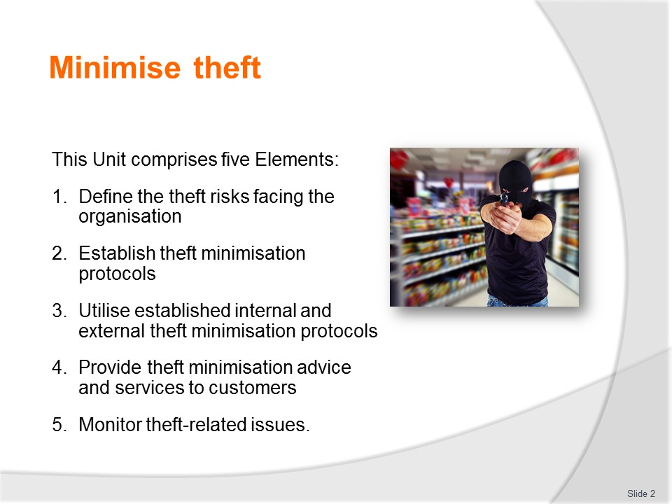
Slide No | Trainer Notes
Trainer advises trainees this Unit comprises five Elements, as listed on the slide explaining:
- Each Element comprises a number of Performance Criteria which will be identified throughout the class and explained in detail
- Trainees can obtain more detail from their Trainee Manual
- At times the course presents advice and information about various protocols but where their workplace requirements differ to what is presented, the workplace practices and standards, as well as policies and procedures must be observed.

Slide
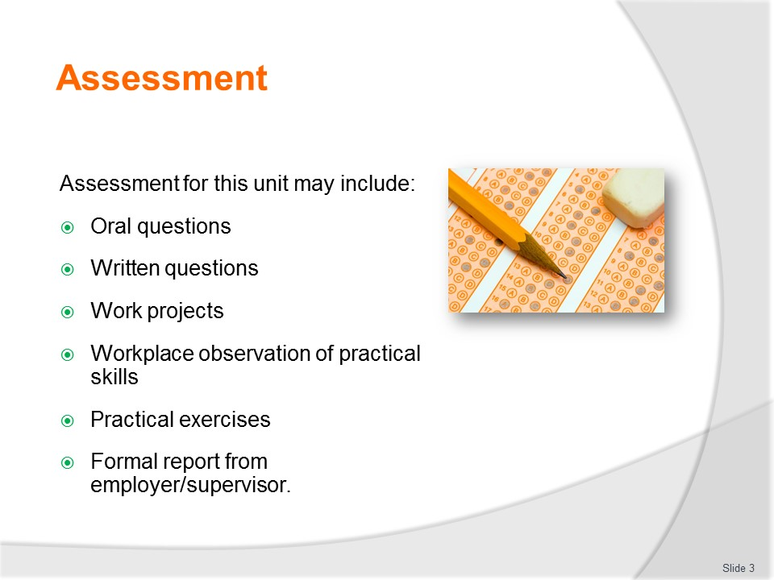
Slide No | Trainer Notes
Trainer advises trainees that assessment for this Unit may take several forms, all of which are aimed at verifying they have achieved competency for the Unit as required.
Trainer indicates to trainees the methods of assessment that will be applied to them for this Unit.

Slide
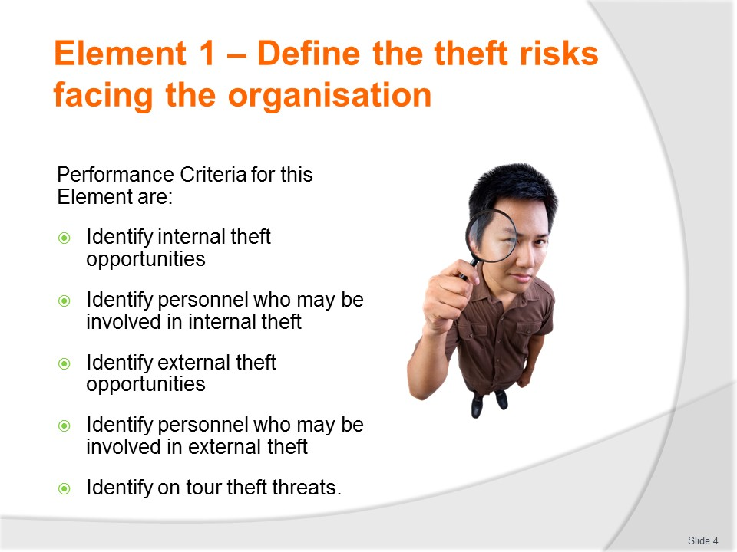
Slide No | Trainer Notes
Trainer identifies for trainees the Performance Criteria for this Element, as listed on the slide.
Class Activity – General Discussion
Trainer leads a general class discussion by asking questions such as:
- Why do organisations need to identify the theft risks/threats they are facing?
- What is internal theft?
- What is external theft?
- What examples do you know of?
- What experiences do you have of internal and external theft?

Slide
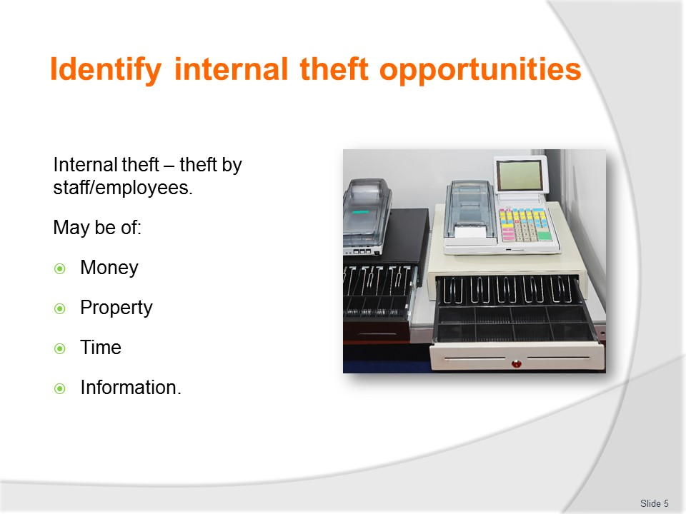
Slide No | Trainer Notes
Trainer explains internal theft is stealing by those who are employed by the business and Internal theft is also known as ‘Employee theft’.
The theft can be stealing of:
- Money – cash
- Property and resources
- Time
- Information and identity’.

Slide
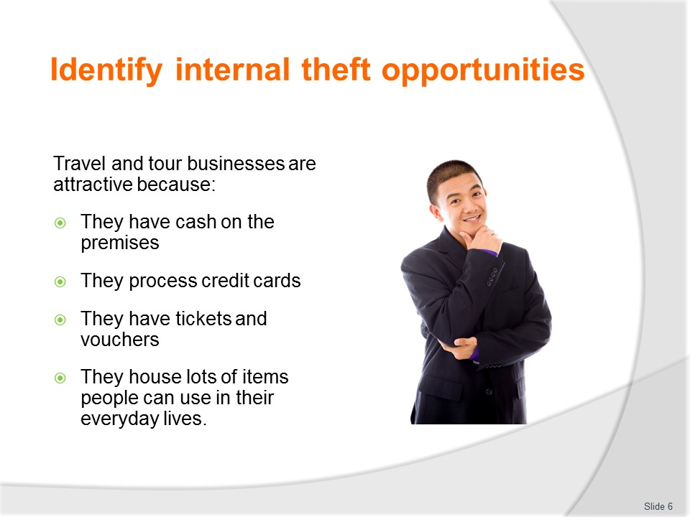
Slide No | Trainer Notes
Trainer explains Travel and tour businesses are attractive to thieves because:
- They often have cash on the premises – and hard cash is an attractive commodity
- They commonly process credit cards – and this data can be used to fraudulently purchases goods and services
- Tickets and vouchers – relating to travel, entry or access to goods and services
- Agencies and businesses can house a range of items which people find useful for their private/domestic lives – such as stationery, merchandise, food and beverages – and they can save money by taking these from the workplace.
It is said by many in the industry that internal theft can often account for more than 50% of the theft from a business.
In many cases, internal theft can turn an otherwise profitable and sustainable business into one which fails.

Slide
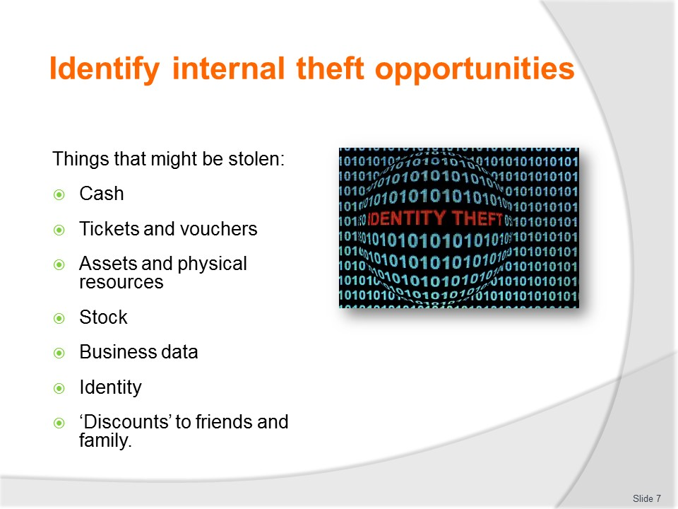
Slide No | Trainer Notes
Trainer notes internal theft opportunities (items which are likely to be stolen) include:
- Cash – which can take the form of:
- Stealing cash from POS registers/terminals and/or other locations such as petty cash boxes, safes, bank bags
- Making of false claims for reimbursement of expenses
- Tickets and vouchers – which can take the form of:
- Taking for personal use
- Theft for conversion to cash by selling them to others at a discounted price for private gain
- Assets and physical resources of the operations – which can take the form of:
- Taking home furniture, fixtures, fittings and sundry property items
- Using utilities at the workplace for personal (non-business) use – such as making private phone calls using the workplace telephone
- Using company vehicles for personal use within and outside working hours
- Stock – which can take the form of:
- Taking home food, beverage and touring supplies
- Deliberately damaging stock so it becomes ‘unsaleable’ and can be taken home or purchased at a discount price
- Eating/drinking items at work which are not authorised for staff consumption
- Business data – which can take the form of:
- Using business data for personal gain
- On-selling of this data to others
- Identity – identity theft which can take the form of:
- Organisational identity theft
- Theft of the identity of clients.
- Charging family friends a lower price than they are entitled to – by, for example, applying a discount to which they are not entitled.

Slide
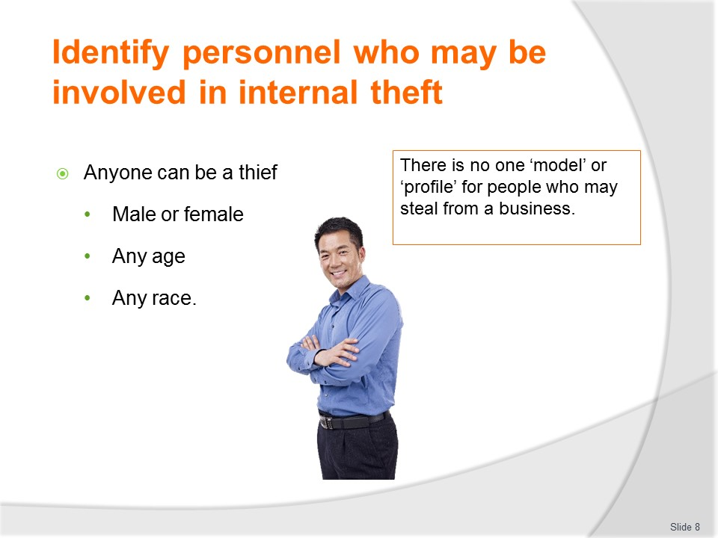
Slide No | Trainer Notes
Trainer explains there is no model or ‘profile’ for internal thieves.
- They may be front-of-house or back-of-house staff.
- They may be male or female, young, middle-aged or more senior.
- They may be full-time/permanent staff, part-time staff or casual staff.
- They may be single or married.
- They may have a family or they may have no children.
- They may be employees or members of the family which owns and operates the business.
- They may be new staff or long-term employees.
- They may be staff from other branches or offices who are working on a temporary basis in your location.

Slide
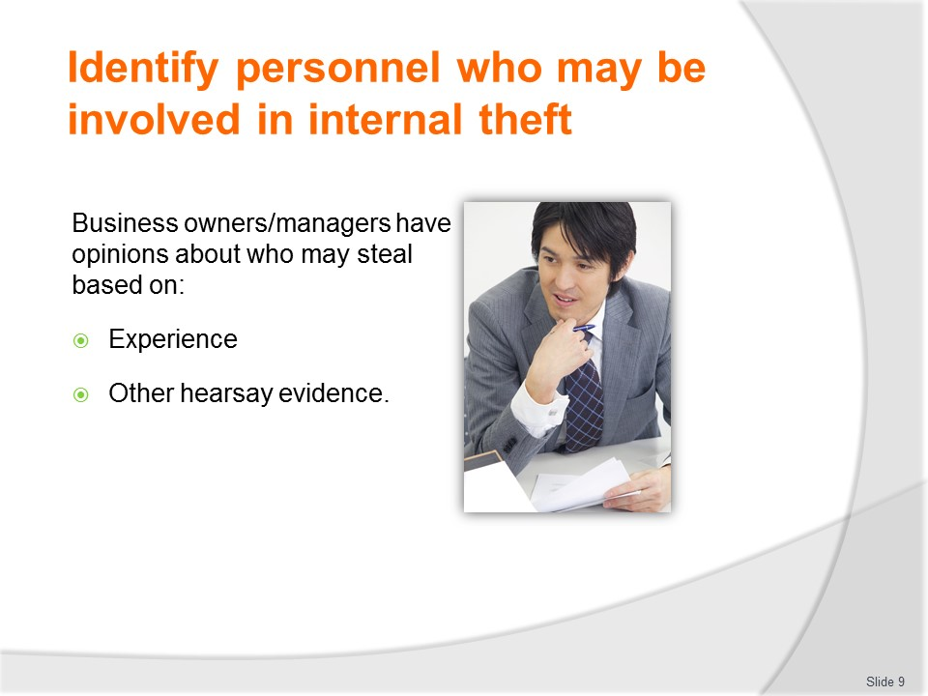
Slide No | Trainer Notes
Opinions of the owner
Trainer observes while there is no definitive description of an internal thief, many business owners usually have their own ideas on who/which type of staff may be a potential thief.
This perception is usually based on:
- Their previous experience
- Stories, articles and experiences they have heard of from others in the business community they trust and respect.
For example, a business owner may believe:
- Younger staff are more likely to steal
- Anyone who gambles is likely to steal
- Employees with families tend to steal.

Slide
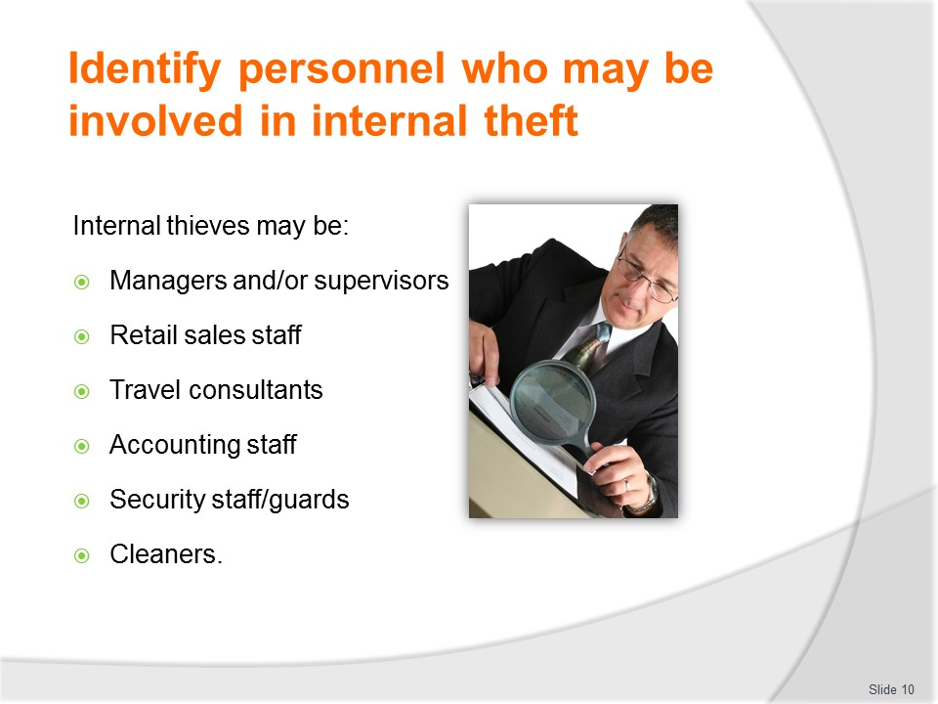
Slide No | Trainer Notes
Examples of who may be internal thieves
Trainer explains while there is no distinct set of characteristics which can be used to define or describe internal thieves, this means they may be:
- Managers
- Supervisors
- Retail sales staff
- Travel consultants
- Accounting staff
- Receptionists
- Security staff/guards
- Cleaners.
This said, most staff are honest and will not steal ‘anything of real value’ from their employer even where an opportunity to do so presents itself but most staff will admit to having stolen something from their employer.

Slide
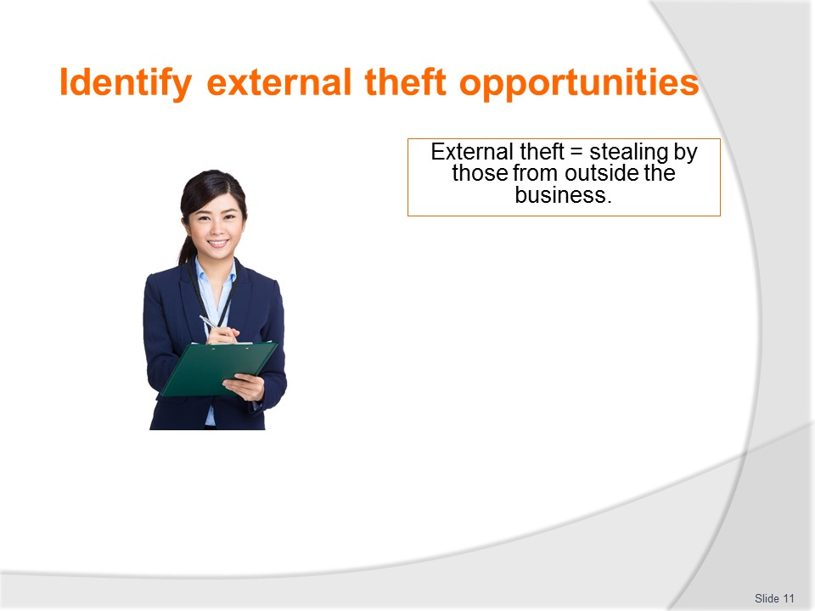
Slide No | Trainer Notes
Trainer states:
- External theft is stealing by those who are outside the business – that is the thieves are persons other than employees
- For our purposes we are not referring to people who break into the business when it is closed, and steal items.

Slide
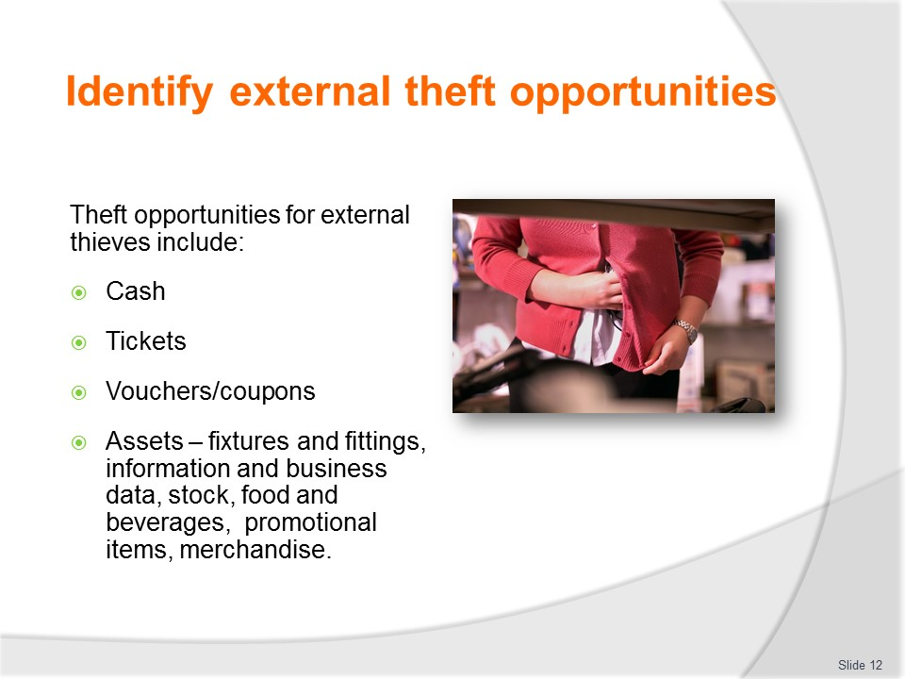
Slide No | Trainer Notes
Trainer identifies external theft opportunities:
- Cash – this can include:
- Theft of cash from POS registers; Theft of cash from staff belongings, bags, wallets, purses; Theft of cash from other customers
- Tickets – where customers:
- Steal travel tickets for air travel, cruises and/or rail – even though they may be worthless to the thief as they require validation or similar. These tickets may be domestic or international
- Steal transport tickets – for options such as local bus, taxis, hire cars, or other local transport options including transfers (such as transfers between accommodation venues and airports, cruise centres or other terminals)
- Steal entry tickets to destinations, attractions and others locations – for example theme parks, theatres, museums, concerts and events
- Steal tickets to entitle holders to participate in organised activities – such as scheduled and escorted tours, packaged tours, interactive displays, exhibitions, walks, ‘safaris’ and similar’
- Vouchers – which can include:
- Vouchers for accommodation at venues; Vouchers for nominated food and/or beverages; Vouchers for the supply of products and/or services to a nominated amount; Vouchers for tokens at a gaming venue/casino; Vouchers entitling the holder to discounts at certain other businesses; Gift vouchers; Travel vouchers
- Assets – these are resources of the organisation which can be classified, in this context, as:
- Physical fixtures and fittings of the business – office equipment, industry/association plates, furniture, signage, communications equipment, systems hardware; Information – such as business identity data, security and other operating and/or access codes, customer database information, confidential business details, private information on customers and organisations with whom the agency does business; Stock – this covers items such as Food and beverages provided by the business, Promotional items, Merchandise – which can include but is certainly not limited to clothing (hats, caps, T-shirts), pens, pencils, diaries, travel bags, luggage tags, ticket wallets, Travel books and videos/DVDs.

Slide
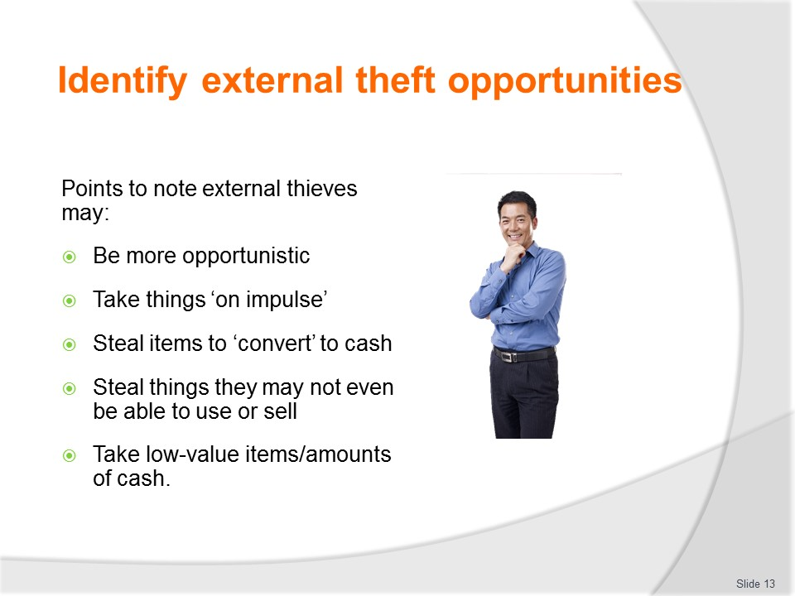
Slide No | Trainer Notes
Points to note
Trainer explains external theft tends to be much more opportunistic and un-targeted than internal theft.
Staff tend to target items they want and know can be used and/or sold for gain.
External thieves often act on impulse and take items which may be of no practical or other use to them. For example, an external thief may steal:
- Cash which they cannot convert into local currency
- Personal and/or business cheques which they are unable to convert into cash
- Documents which have not been fully completed and require (say) a specific imprint, stamp or code for validation to occur.
The external thief often simply ‘takes things’ and then works out whether what they have taken can be used or is of value.
They also do not always choose to steal only ‘high value’ items or large quantities of cash – they will often steal a single, inexpensive (or essentially valueless) item, or a relatively small amount of cash.

Slide
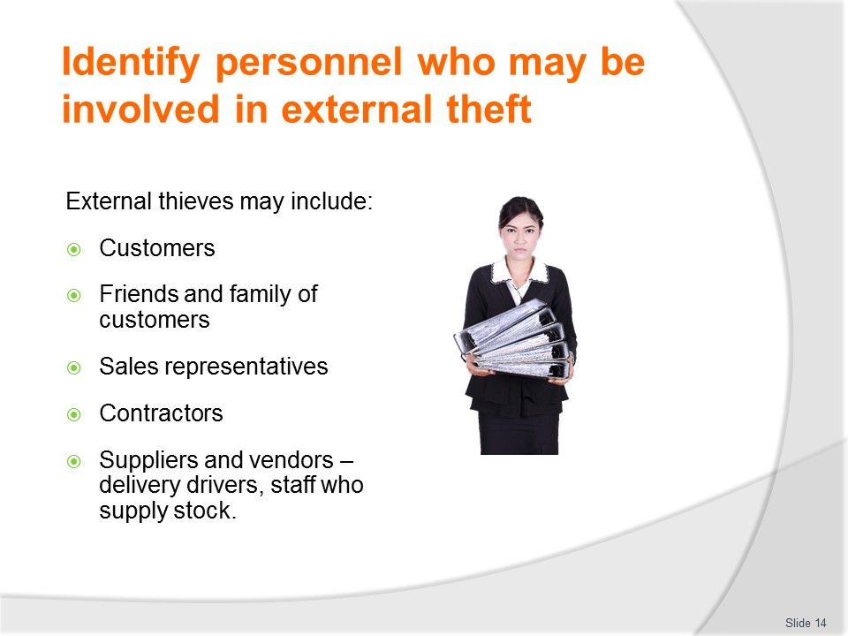
Slide No | Trainer Notes
Trainer identifies external thieves may be:
- Customers, clients or tour group members – these are the people you deal with in a face-to-face context and who:
- May call in to make an enquiry; Make a purchase or make a reservation/booking; Call in to make a payment
- Arrive to pick up tickets, vouchers or other items; Turn up to wait for a trip or tour to commence
- Friends and family of the above – sometimes the thief is not the actual, paying customer but can be a family members or simply a friend of the client. Many operators will attest that children are sometimes high on the list of external theft, sometimes because they know no better and/or sometimes because they do not have their own money to buy the things they want
- Visitors and members of the public – these are people who may come to the businesses for the purposes of:
- Participating in an activity organised by the business such as a presentation, a film night, guest speaker or an appreciation night for previous customers; Viewing the facilities and meeting the staff – a ‘getting to know you’ activity; Touring the business as part of an invitation to do so
- Sales representatives – these are sales staff from organisations the business deals with. They are also known as 'sales reps'. They come to your place of business and:
- Tell you about the products and services they can provide to you
- Negotiate prices and deals with you for their products and services
- Develop a rapport and relationship between you and their company
- Handle complaints you, or your customers, may have about the products and/or services they have provided
- Contractors – these can be people from:
- Organisations which Service, repair or maintain the premises in which you operate and/or the technologies and equipment you use; Joint-venture partners with whom you have a formal arrangement; Other businesses with whom you have legally-binding contracts for the supply of goods and services
- Suppliers and vendors – these are the businesses who provide you with the goods and services you require in order for you to keep doing business. The personnel who may steal from you in this case can be:
- Sales reps (see above) – who may steal when they come into the business
- Delivery drivers – who may short-deliver items ordered by your business
- Staff employed in the stores area at the supplier warehouse – who may supply incorrect stock and charge an inflated price for inferior products, or who may short-pack a delivery for the business
- Accounting staff – who may charge excessive prices for stock delivered to you, or fail to factor in special deals or negotiations on price: this highlights ‘external theft’ can occur even when it is not someone’s deliberate intention to steal from you.

Slide
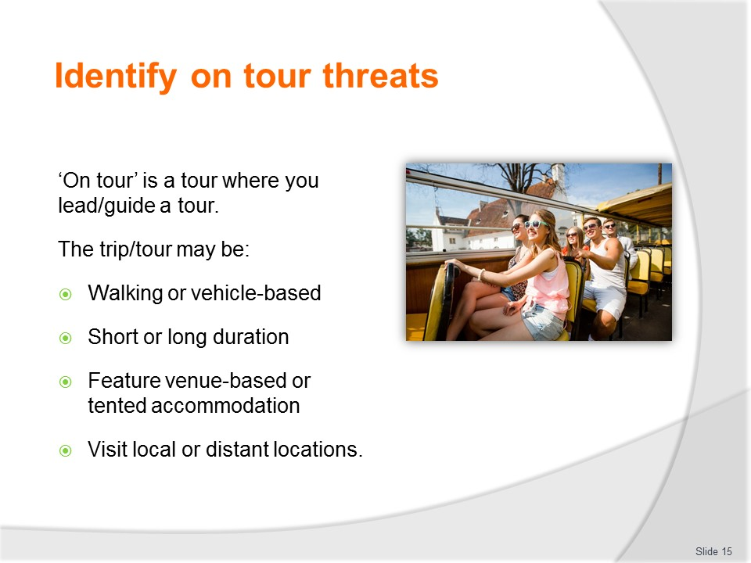
Slide No | Trainer Notes
Trainer notes ‘On tour’ refers to situations where tourist guide leads a group of visitors or tourists on a scheduled and/or escorted tour or trip.
The tour/trip may:
- Be a walking tour or a vehicle-based tour – commonly with activities included as part of the package
- Be of short duration (30 minutes to a couple of hours) or longer (half-day, full-day and multiple-day tours)
- Feature venue-based, ‘roomed’ accommodation or camp-based ‘tented’ accommodation
- Visit local or remote areas including other countries.

Slide
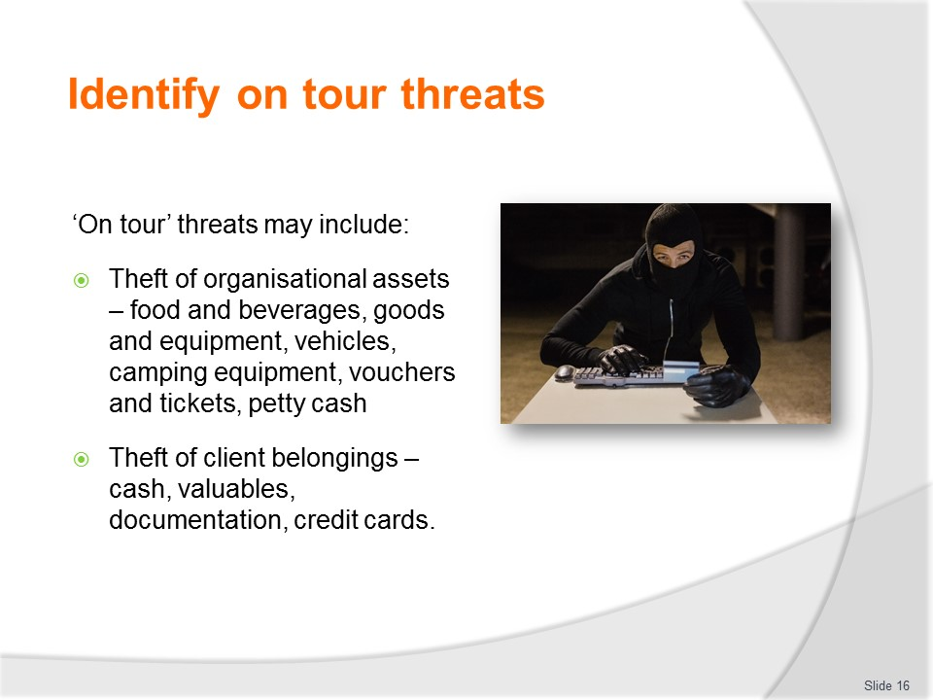
Slide No | Trainer Notes
Trainer highlights on tour theft threats relate to any situations that expose the organisation and/or tour/travel clients to the risk of theft. Common forms of theft which have taken place ‘on tour’ include:
- Theft of organisational assets – this is stealing of company resources. The theft may be perpetrated by clients or members of the public preying on the tour. Resources of the business which can be taken may involve;
- Food and beverages
- Goods and equipment – cooking equipment, PA gear, signs, materials used for activities, sports, demonstrations
- Vehicles
- Camping and associated supplies
- Vouchers and tickets
- Petty cash (for purchasing sundry items while ‘on tour’)
- Theft of client belongings – again the theft may be undertaken by other tour group members, or by members of the public. Items involved in this type of theft usually include:
- Cash – of any country, any denomination, as well as travellers’ cheques; Valuables of any type – but commonly cameras, cell phones, electronic equipment, wallets, purses, hand-bags and suitcases; Documentation – such as driving licenses and passports but also tickets and vouchers/coupons; Credit cards.
Slide
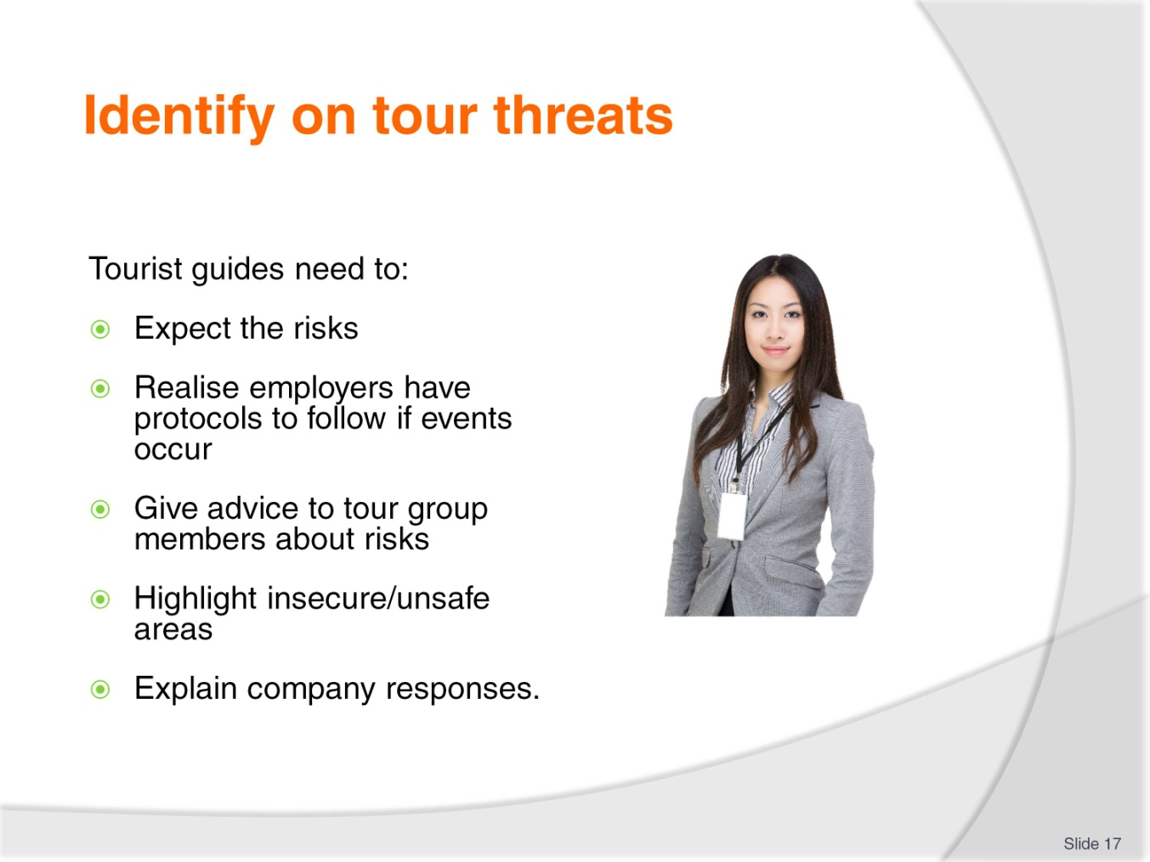
Slide No | Trainer Notes
Trainer urges students as a tourist guide they should:
- Expect any of these risks can possibly occur from the moment you brief the tour group prior to departure, throughout the tour and all the way back to the point where you de-brief and/or farewell the tour group
- Realise your employer (the organisation conducting the trip/tour) will usually have a suite of protocols/SOPs to deal with these situations should they occur – in most cases the authorities will need to be notified
- Advise tour group members to monitor the security of their cash, valuables and belongings at all times
- Highlight any activities, situations or locations which have proved to be insecure on previous tours/trips
- Explain company responses to instances of theft while ‘on tour’.

Slide
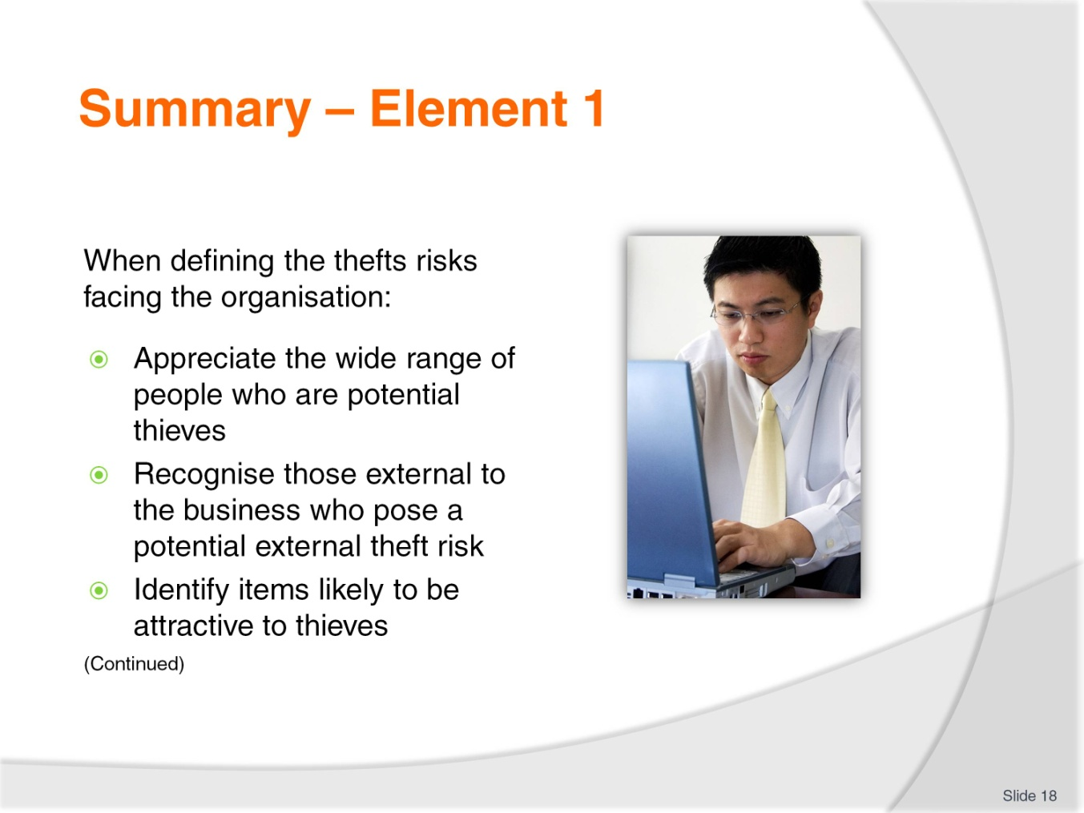
Slide No | Trainer Notes
 | Trainer provides a recap of the Element asking questions to check trainee understanding and responding to questions from trainees, as required.

Slide
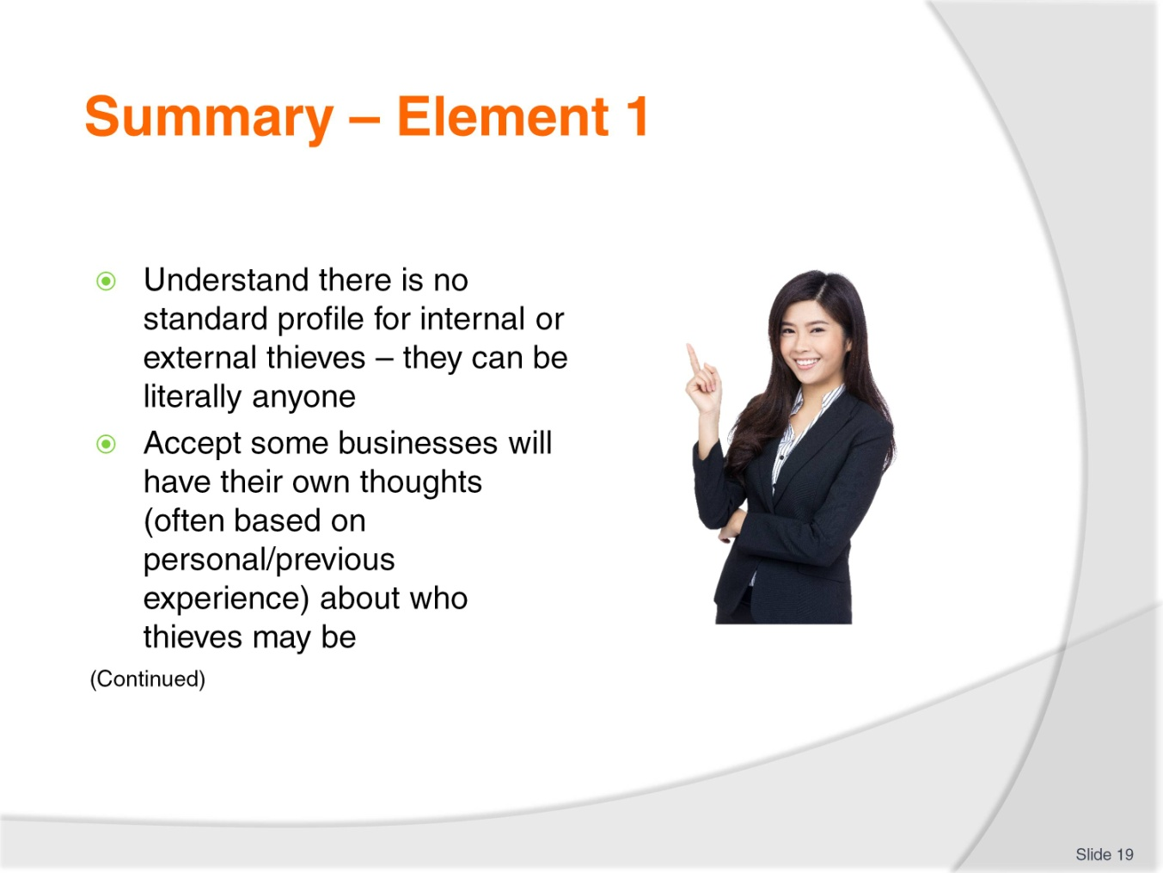
Slide No | Trainer Notes
 | Trainer provides a recap of the Element asking questions to check trainee understanding and responding to questions from trainees, as required.

Slide
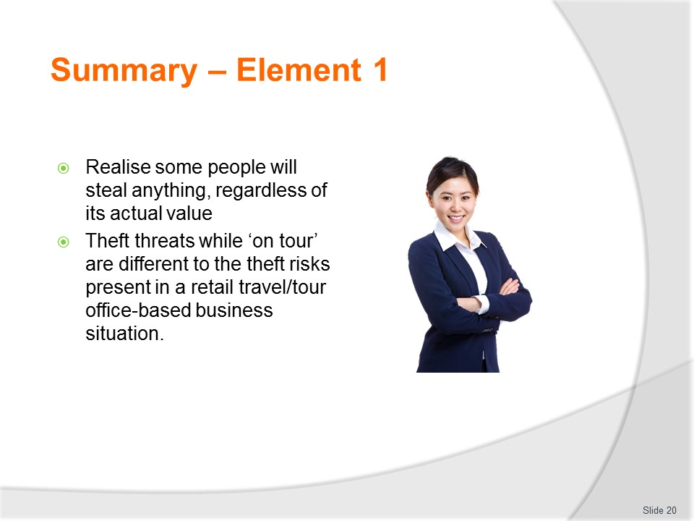
Slide No | Trainer Notes
 | Trainer provides a recap of the Element asking questions to check trainee understanding and responding to questions from trainees, as required.

Slide
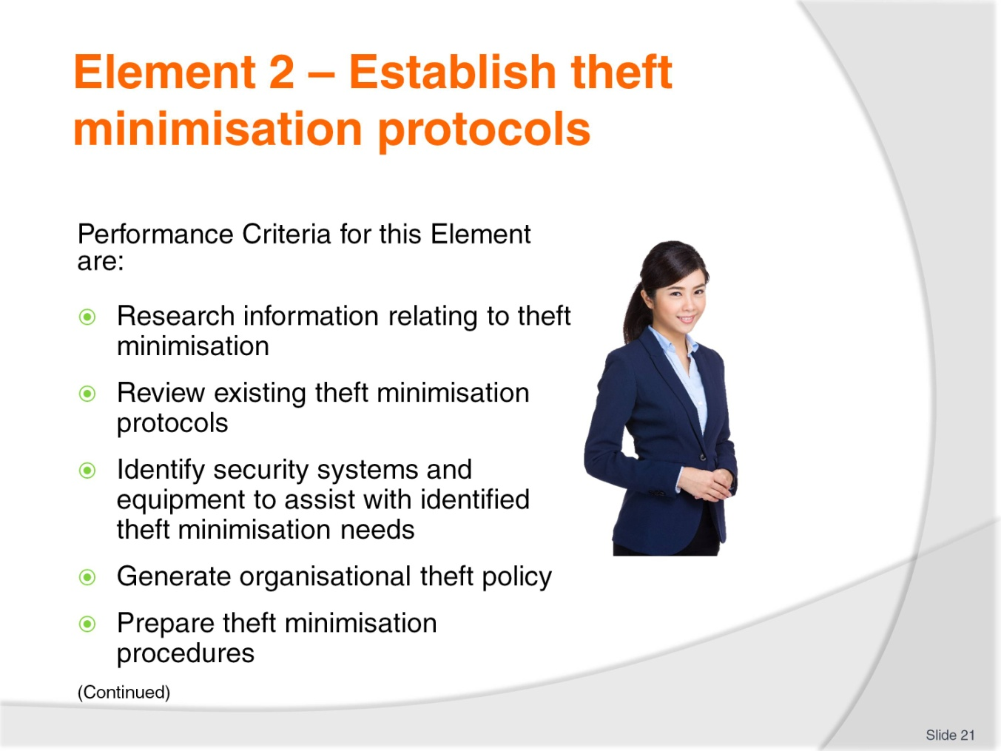
Slide No | Trainer Notes
 | Trainer identifies for trainees the Performance Criteria for this Element, as listed on the slide.

Slide
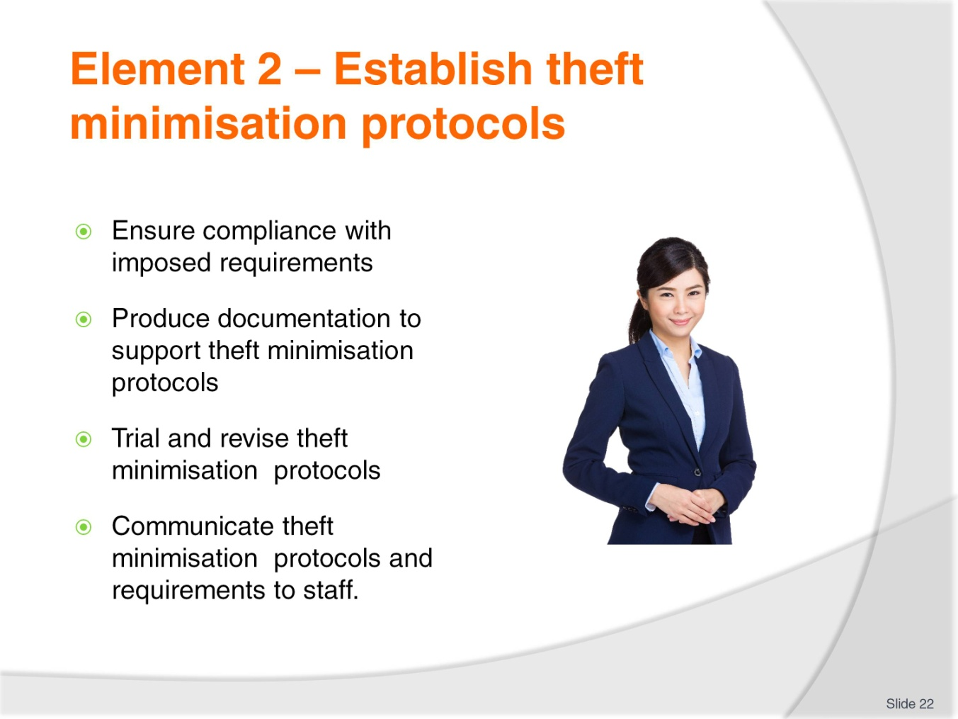
Slide No | Trainer Notes
Trainer identifies for trainees the Performance Criteria for this Element, as listed on the slide.
Class Activity – General Discussion
Trainer leads a general class discussion by asking questions such as:
- Why do businesses develop theft minimisation policies and procedures?
- What examples of theft minimisation protocols do you know of?
- How do organisations make staff aware of their theft minimisation protocols?
- What factors are taken into account when developing theft minimisation policies and procedures?

Slide
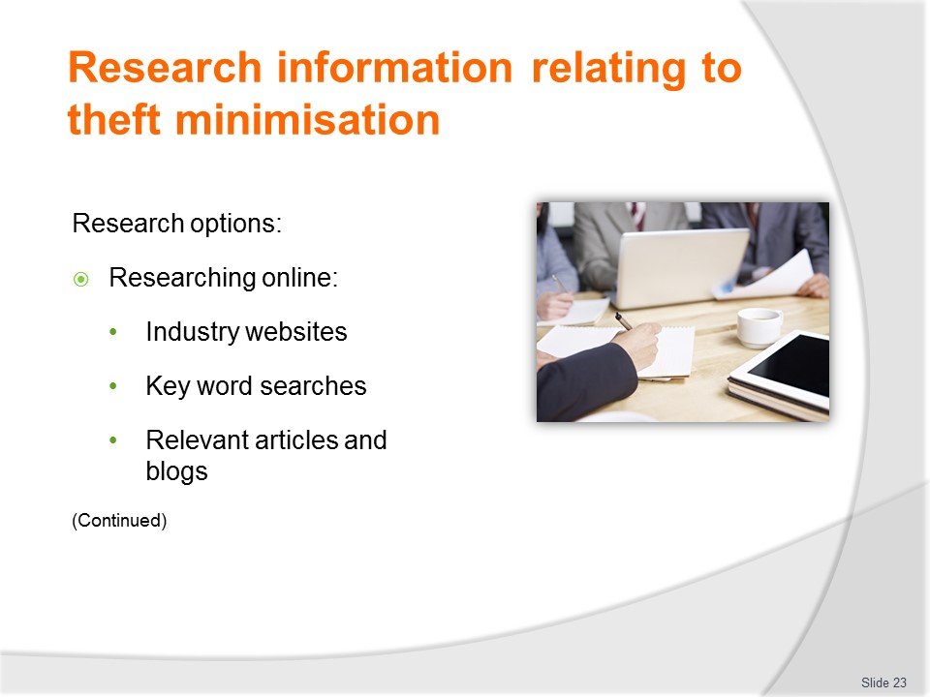
Slide No | Trainer Notes
Trainer presents research options:
- Undertaking internet research – this can include:
- Searching industry websites
- Undertaking key word searches (such as ‘theft prevention, travel and tourism’)
- Reading theft prevention and theft minimisation articles and blogs.
- Always make sure you:
- Bookmark helpful sites
- Download relevant material
- Print off hard copies of useful advice
- Subscribe to free newsletters.

Slide
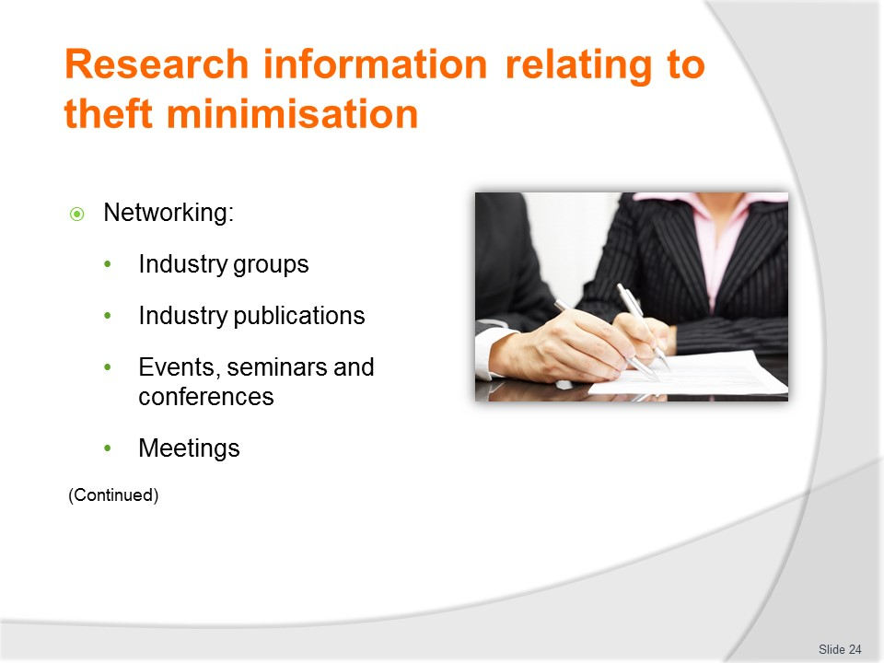
Slide No | Trainer Notes
Trainer gives more research options:
- Networking with other organisations in the industry – such as:
- Joining industry groups
- Reading industry journals and magazines
- Attending industry events, conferences, seminars and similar
- Being a regular participant in meetings.
- Be prepared to:
- Share your own theft-related and security-related experiences
- Talk to other businesses about what they have experienced so you can learn from them
- Share copies of theft-minimisation strategies, policies, procedures and protocols.

Slide
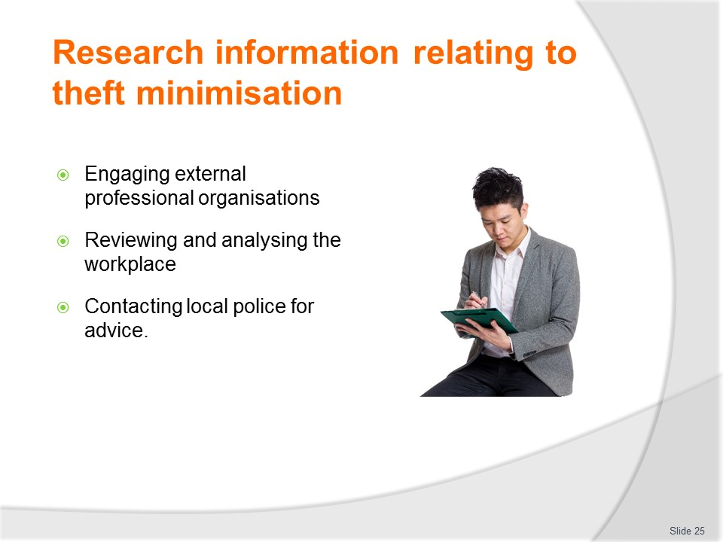
Slide No | Trainer Notes
Trainer gives more research options:
- Engaging the services of professional security organisations – to:
- Analyse and evaluate the threats faced by the business
- Benefit from their experience with other similar businesses in the industry
- Obtain relevant resources to assist with theft prevention and detection
- Use their staff to help deter theft and identify thieves
- Reviewing and analysing the workplace – including:
- Actual instances of theft which have previously occurred
- Previous attempts at theft which have been thwarted
- Identification of high-risk areas
- Identification of vulnerable targets (products, stock, cash and/or other items)
- Contacting local police – and:
- Seeking their input about possible theft prevention and minimisation protocols which may be able to be implemented
- Working cooperatively with them
- Gaining the benefit of their experience and advice in this area.

Slide
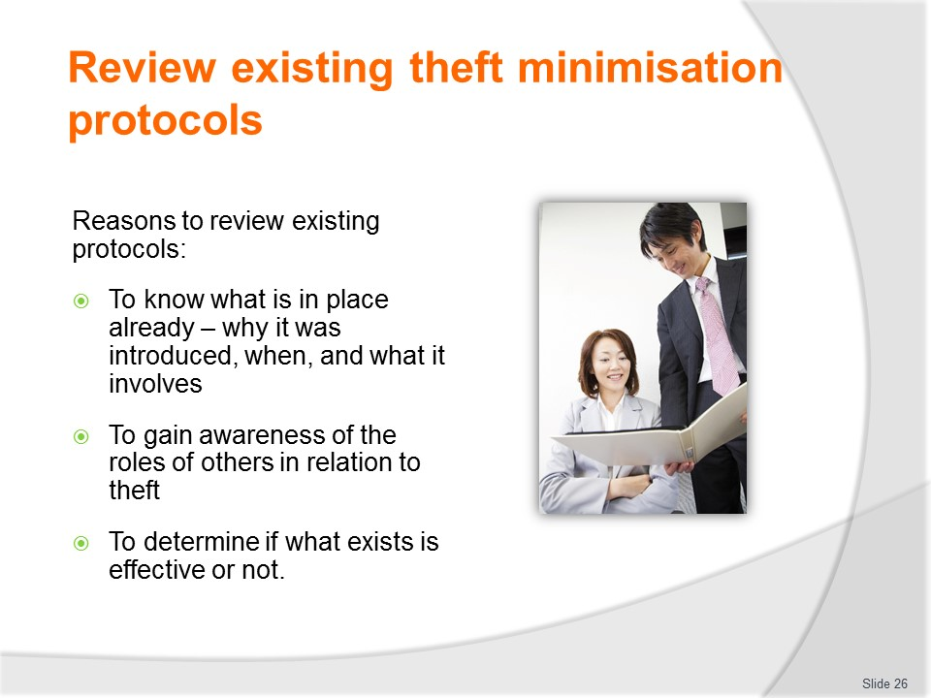
Slide No | Trainer Notes
Trainer states reasons it is important to review existing theft minimisation protocols – in order to:
- Know what is already in place and understand the details – and why it was developed, when it was introduced and how it has worked
- Be aware of what other staff are doing/are expected to do to prevent theft – it is important everyone functions as part of an integrated team
- Determine if the protocols are effective – and are able to deal with now what may be different circumstances to when they were developed.

Slide
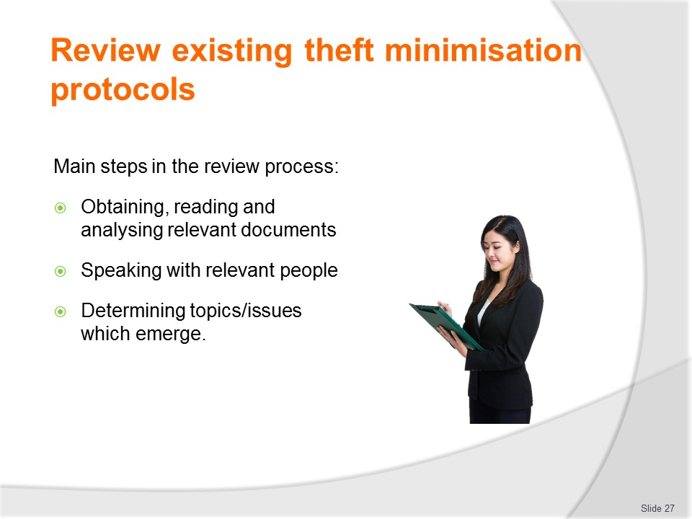
Slide No | Trainer Notes
Trainer identifies the three primary phases/steps in reviewing theft minimisation protocols:
- Obtaining, reading and analysing relevant documents – such as, for example:
- Company policies regarding theft prevention and minimisation
- Standard operating procedures for theft minimisation
- Internal documentation – which is used to support the efforts of the organisations regarding theft minimisation.
- Document examples include:
- Operational checklists
- Inspections schedules
- Training materials for staff in relation to this topic
- Speaking with relevant people – to gain their input and opinion regarding the type of theft minimisation protocols in place and their effectiveness. These ‘relevant people’ should include:
- Management and owners
- Operational staff
- Security staff, including internals ad external security operatives/consultants
- Any staff who have been involved with actual acts of theft prevention, or of theft from the business
- Determining common issues and/or topics of concern which emerge from the review process – such as:
- Identification of certain days/times when theft appears to be most common
- Identification of items which are most commonly stolen
- Description of the profile of known thieves
- Description of methods used by offenders to steal
- Identification of protocols which have proven effective in preventing attempts at theft from the business
- Identification of protocols which appear likely to prevent recurrence of previous instances of theft.

Slide
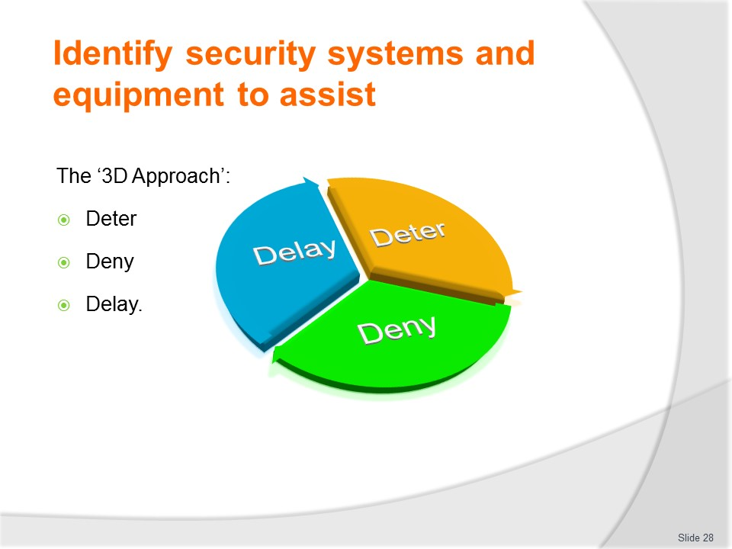
Slide No | Trainer Notes
Trainer explains the basic approach to addressing loss prevention and stock shrinkage revolves around a concept referred to as ‘3D’, or ‘the 3Ds’.
3D means the business will develop and implement systems and procedures intended to:
- Deter people from offending
- Deny them access to the product
- Delay them if they are intent on stealing the product.

Slide
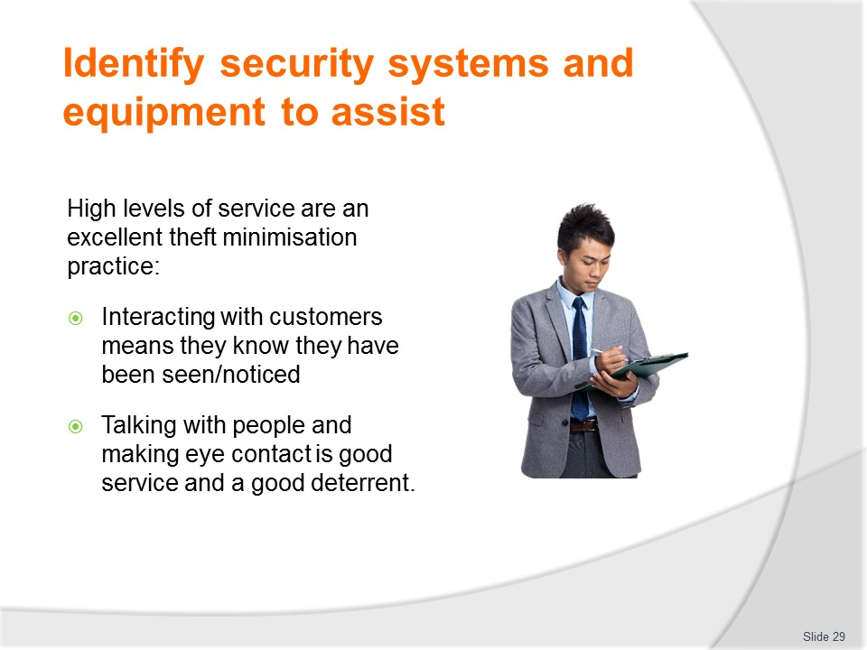
Slide No | Trainer Notes
Trainer highlights importance of good service as a theft minimisation practice:
- High levels of customer service are an excellent way of deterring thieves because good customer service means they have been noticed, and their presence on the premises has been registered
- Simply approaching a potential thief and asking if you can be of service, talking with them, asking them sales-related questions can be sufficient to see off many would-be thieves, especially those who gain confidence from being ignored
- Realise deterring a would-be thief may also just be a case of making eye contact with them when they enter the business, and maintaining visual contact with them while they are in the building
- Knowing they are being observed – or are likely to be observed – is sufficient to deter many people from offending because the chance of discovery is so high
- It is for these reasons that a clear ‘line of sight’ from counters and cash registers is considered an excellent anti-theft measure, where practicable and applicable.

Slide
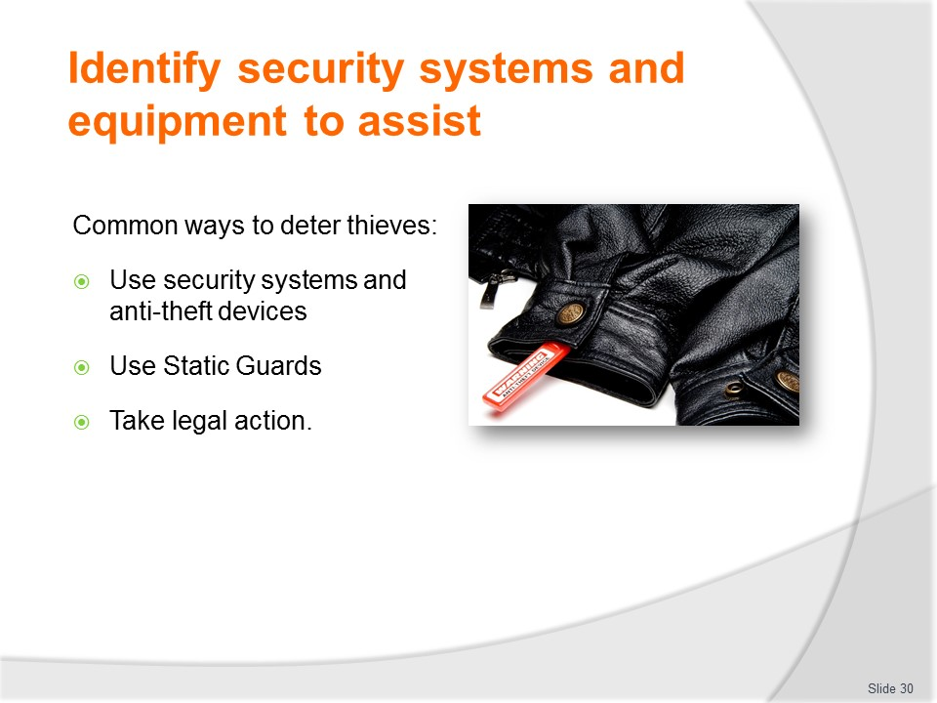
Slide No | Trainer Notes
Trainer presents common ways to deter thieves exist – some fairly basic, others more high-tech.
Use of security systems and anti-theft devices
This includes the use of:
- Surveillance devices/CCTV
- Mirrors
- Electronic Article Surveillance (EAS)
- Physical barriers
- Alarms.
Static Guards
Many places now engage the services of uniformed security personnel – known as Static Guards – during certain trading times, such as late night trading or other identified potentially troubled or dangerous times.
These guards not only help to minimise theft, but also serve as a physical deterrent to minimise things such as bad language, threatening and other anti-social behaviour.
Taking legal action
Another effective deterrent is to take legal action against anyone who is detected shoplifting – regardless of the item stolen, the amount involved or the circumstances of the offender.
This very quickly sends a message to those of like mind – especially those who are known to the offender – that shoplifting at your business is a high risk undertaking with serious consequences.
Classroom Activity (1)
Trainer shows and demonstrates use of above items.
Classroom Activity (2)
Trainer arranges for Static Guard to attend as Guest Speaker.

Slide
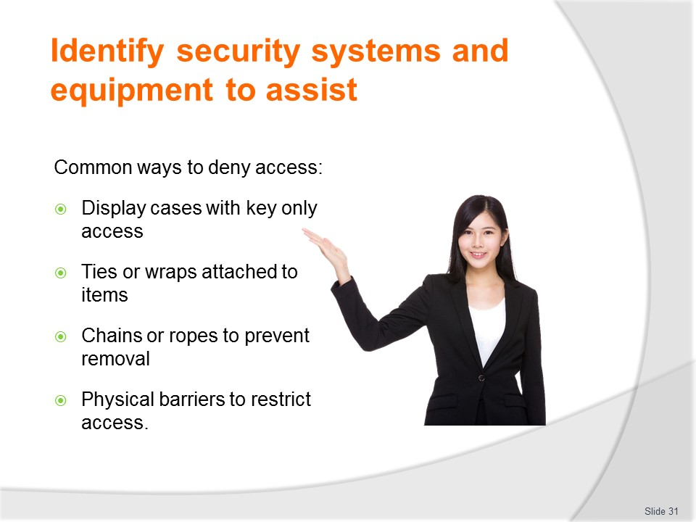
Slide No | Trainer Notes
Trainer advises in the majority of retail cases it is all but impossible to deny customers access to all your products – merchandising imperatives demand the product is ‘in the customer’s face’ so they can see it, feel it, smell it, touch it and pick it up and inspect it.
Protecting the stock
Nonetheless, there are instances where many retail businesses do protect their stock – admittedly only a portion of it – by physically placing it behind some form of barrier, usually a glass-fronted or glass-topped cabinet of some sort.
Items displayed in this way commonly include expensive, unique, desirable, attractive and easily hidden articles.
Key access is usually required to some of these sliding door displays, otherwise, rear of counter access makes goods readily accessible to sales staff.
In a limited number of cases, stock may be physically tied down in some way to help prevent its loss.
Ties or wraps may be used which do not impinge on the aesthetic appeal of the product or display but which prevent its ready removal by thieves: problematic with this approach is that it requires staff to assist the customer when a genuine purchase is being made.
Larger items can be chained/roped together, sometimes using a padlock – it is all part of the Deny phase.
Physical barriers may also be used – see section 3.3 for more information.
Slide
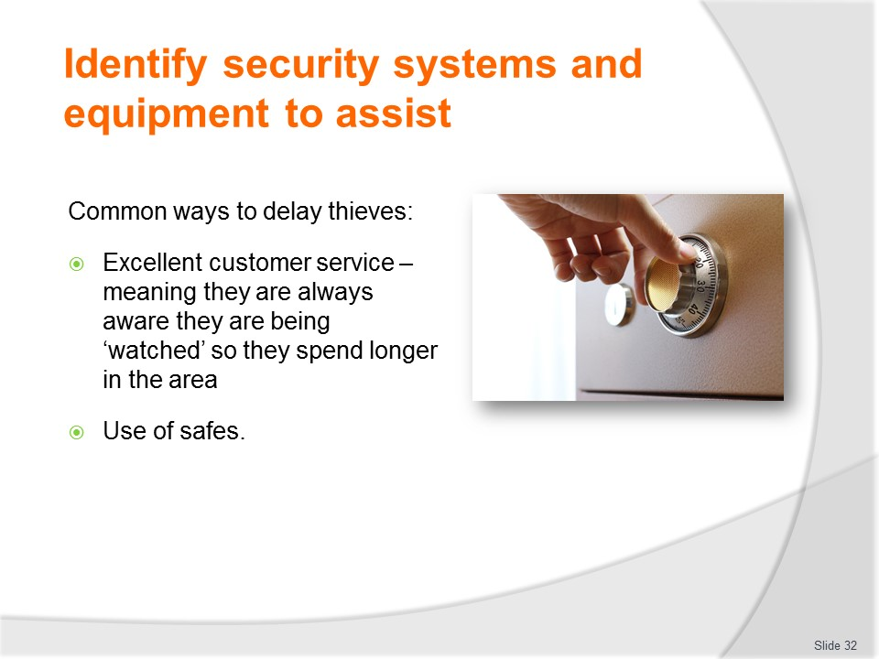
Slide No | Trainer Notes
Trainer presents information on the ‘Delay’ phase stating it seeks to make the theft as inconvenient as possible and ensure it takes as long as possible for the thief to actually take the item.
The longer the actual process of stealing takes, the greater the chance of the thief being seen and apprehended, so the less likely they are to risk it
Safes
It is for this reason, safes have time delays fitted to them and why this fact is readily and visibly advertised in the business using prominent signs.
It is for this reason safes are designed to be difficult to break into or remove – it is not just to protect the contents but to increase the amount of time the criminal has to spend on the premises.
Most insurance companies insist businesses use only ‘TDR’ safes (Torch and Drill Resistant), or in-ground safes in order to achieve this.
Excellent service - again
Good customer service also impacts here – if you are talking to/helping the would-be thief, they are unable to steal: you are delaying them.
If they are aware they are being observed, you are delaying them.
If you are making offers of assistance, you are delaying them.
Hopefully they will become so frustrated they will give up, leave and go somewhere else.
Slide
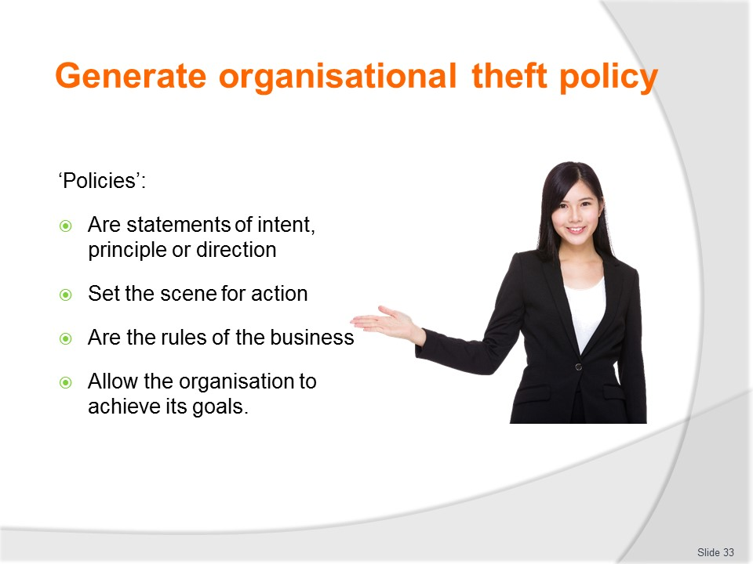
Slide No | Trainer Notes
Trainer explains a policy is a statement of intent, principle or direction regarding a specific area of activity within the organisation.
Policies set the scene for action to be taken by the business and the staff in their day-to-day operations.
In this way policies can be seen as indicating how the business intends to achieve the objectives it has set for itself.
By providing direction these policies are the rules of the business.
While it not necessary for all policies to be reduced to writing there is an expectation all ‘important’ policies do exist in written form.
Classroom Activity
Trainer distributes and discusses several examples of relevant policies.

Slide
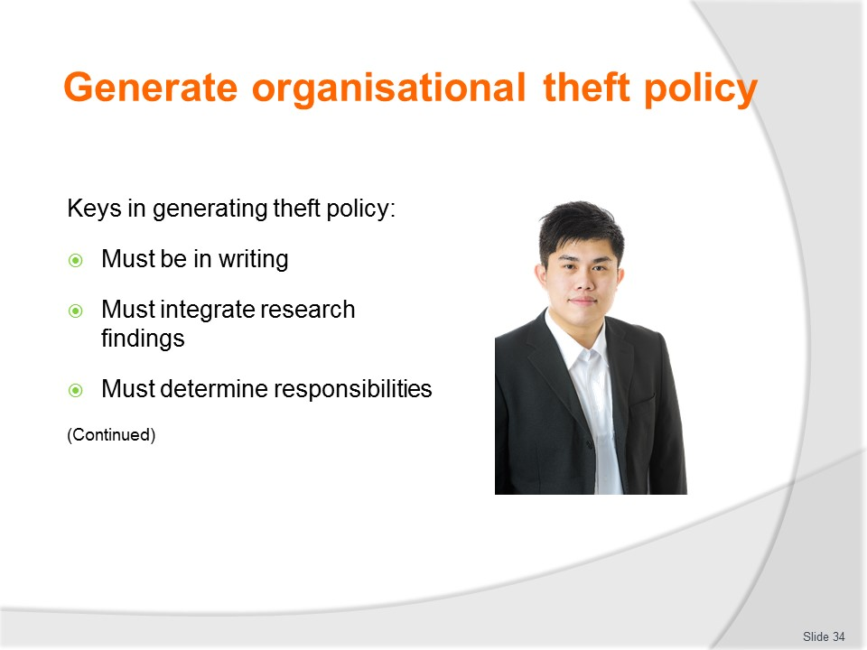
Slide No | Trainer Notes
Trainer explains considerations when generating theft policy:
Preparing a written policy – it is vital all policies are in hard copy form.
- They must be ‘reduced to writing’ so there is surety about what is meant, what is covered, what protocols apply and who has responsibility for what. Having formal, written policies also facilitates their regular review and up-date
- Integrating research findings into the development of policy – this means you need to:
- Include viable suggestions from staff and managers/owners and consultants as well as police
- Integrate intelligence you have gathered by virtue of your personal knowledge of the business, its layout, previous thefts, stock, trading hours and customer profiles
- Adapt and up-date previous policy so it reflects and addresses emerging and/or changed circumstances or threats
- Determining responsibility for theft management – every policy must specify:
- Management (by name or job title) who has overall responsibility for a policy – this includes responsibility for making operational decisions in relation to a theft or attempted theft, calling the police, writing a report on the event, interviewing staff and witnesses, securing a scene

- Operational staff (by name or job title) who have day-to-day responsibility for implementing, policing and applying the specifics of the policy – the staff who are identified will normally include a mix of internal staff as well as external security staff employed from a security company

Slide
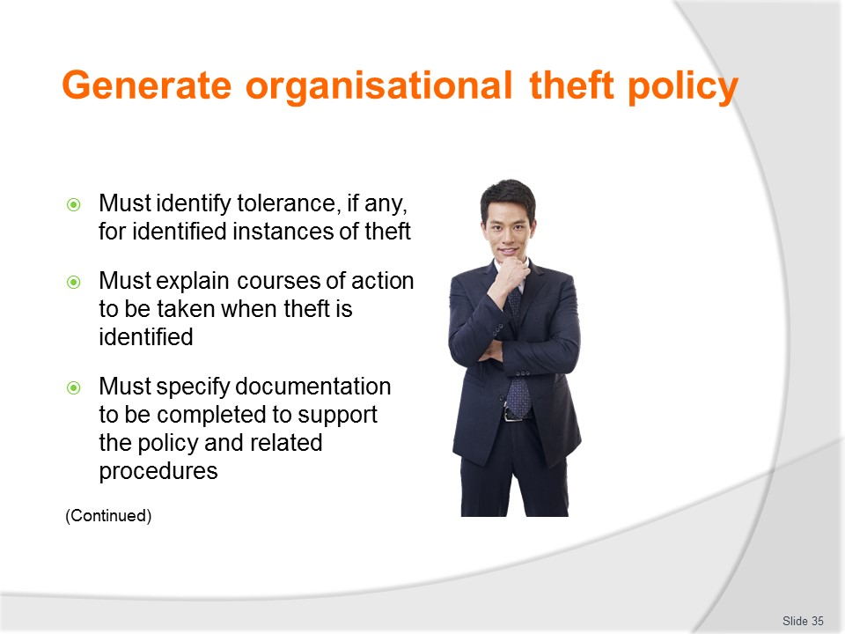
Slide No | Trainer Notes
Trainer continues explaining considerations when generating theft policy:
- Identifying tolerance, if any, for identified instances of theft – it is a reality of workplace life there is always some degree of tolerance for theft
- The exact nature and degree of this leniency will vary significantly between businesses
- Some have a ‘zero tolerance’ approach and some do not
- The important aspect of this point is there must be clear and complete specification of exactly what staff (and nominated others) are entitled to use free-of-charge and/or as part of the acceptable standards of operation of the business.
- For example, private use of office stationery by staff is usually accepted by most businesses unless it becomes ‘excessive’. Likewise, some businesses allow staff to use workplace telephones to make (some) private. The business may also supply limited refreshments for staff which they are free to use as they see fit, but not allowed to ‘take home’.
- Describing and explaining the courses of action to be taken when theft is identified – so staff and the organisation functions in a consistent and reasoned manner when an event occurs. This may address:
- Treatment of offenders – where and how they are to be detained, or specification of other action (such as banning them from the property but taking no further action)
- Identification of internal persons to be notified and external bodies to be contacted
- Details of the incident to be captured and recorded
- Containment of the scene
- Reporting for the purposes of police reports and/or insurance claims
- Specifying documentation to be completed to support the policy and related procedures – which may require completion of:
- Insurance claim documentation
- Internal ‘Incident reports’
- Witness statements by staff and any customers willing to give a statement
- Loss adjustment sheets – to record and accommodate stock losses.
Classroom Activity
Trainer distributes and discusses sample documentation identified on this slide.

Slide
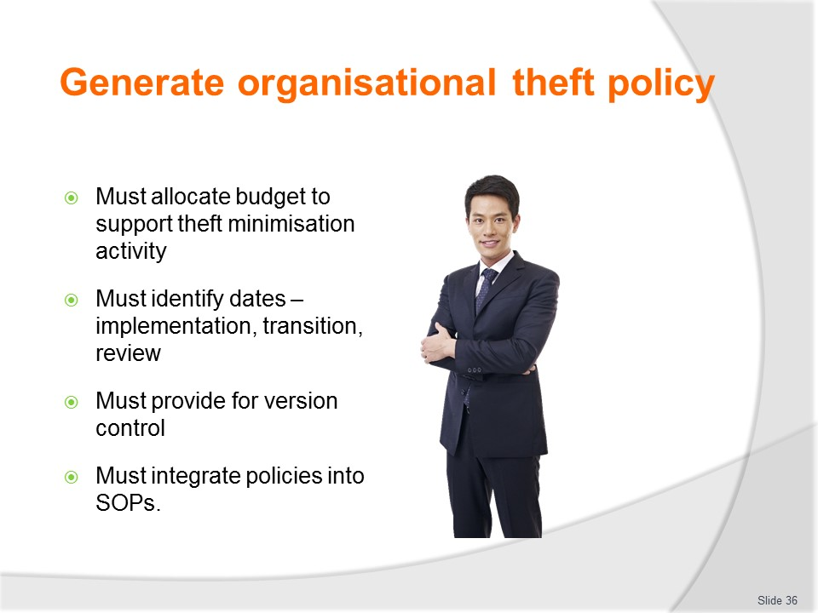
Slide No | Trainer Notes
Trainer continues explaining considerations when generating theft policy:
- Allocating budget to support theft minimisation activity within the business – this may address:
- Payment for consultants to analyse the business and prepare a report/recommendations for action
- Purchase of security equipment, devices and technology
- Implementation of identified security and anti-theft measures
- Labour required to underpin implementation of approved strategies
- Identifying relevant dates relating to the policy – these should cover:
- Dates for initiating implementation
- Dates for transition to full implementation
- Dates for periodic review of protocols
- Dates for policy review
- Providing for version control of the policy – to allow:
- Updates to be made and tracked
- Easy reference to the most current version of the policy
- Control over currency of the document/s
- Integrating theft policy/policies into standard operating procedures for the business – this should include:
- Inclusion of policy into standard induction and orientation procedures for new staff
- Insertion into the organisational policy manual – in hard copy and electronic format (that is, in paper form, and on the intranet)
- Coverage of policy in formal in-house training
- Creation of workplace-based operational checklists and site inspection documentation.
Classroom Activity
Trainer asks students to identify topics for theft policies.

Slide
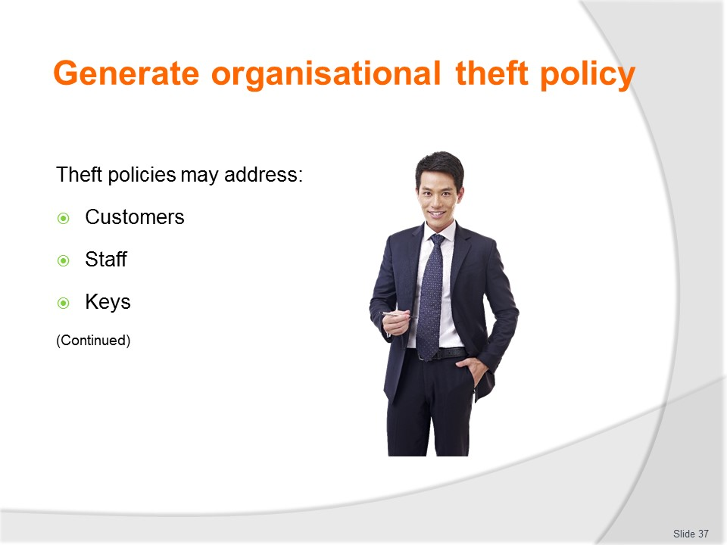
Slide No | Trainer Notes
Trainer identifies possible topics for theft policies:
- Customers – covering issues such as:
- Bag checks
- Action to take when a customer is suspected of stealing
- Action to take when a suspicious customer is identified
- Greetings and farewells to customers to deter thieves
- Staff – providing direction on issues such as:
- Storing of staff property/belongings while at work
- Points of entry on arriving at work and points of exit on leaving work
- Notification to staff of workplace surveillance that exists
- Keys – addressing issues such as:
- Security and issuing of keys to staff
- Protocols for use of keys
- Authorisation for key distribution.

Slide
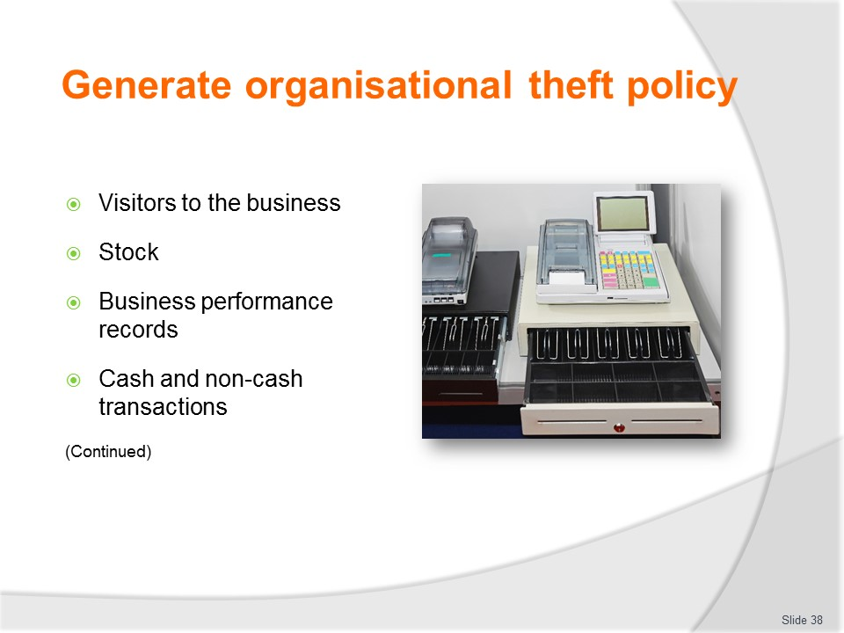
Slide No | Trainer Notes
Trainer continues identifying possible topics for theft policies:
- Visitors to the organisation – taking into account:
- Signing in, monitoring and signing out of sales representatives, contractors and vendors
- Issuing and wearing of identification tags
- Stock – looking at:
- Identification of authorities and limitations for the placement of orders on behalf of the business
- Stock management protocols for the stock control system being used
- Stock taking procedures
- Security of stock while in storage
- Security of stock when it is on display
- Business performance records – addressing issues such as:
- Identification of relevant stock control documentation (electronic and paper-based), including authority to complete and/or responsibility for completion
- Signatures required on specified documents to validate their authenticity
- Alignment of specified forms/documents with nominated stock control (or other) activities
- Cash and non-cash transactions – specifying:
- Procedures for secure keeping of cash on the premises
- Procedures for movement of cash into and out of the business
- Cash handling protocols
- Procedures for accepting payment by the non-cash options available in the organisation
- Banking procedures.
Classroom Activity
Trainer shows copy of Visitor sign-in register and demonstrates use of same.

Slide
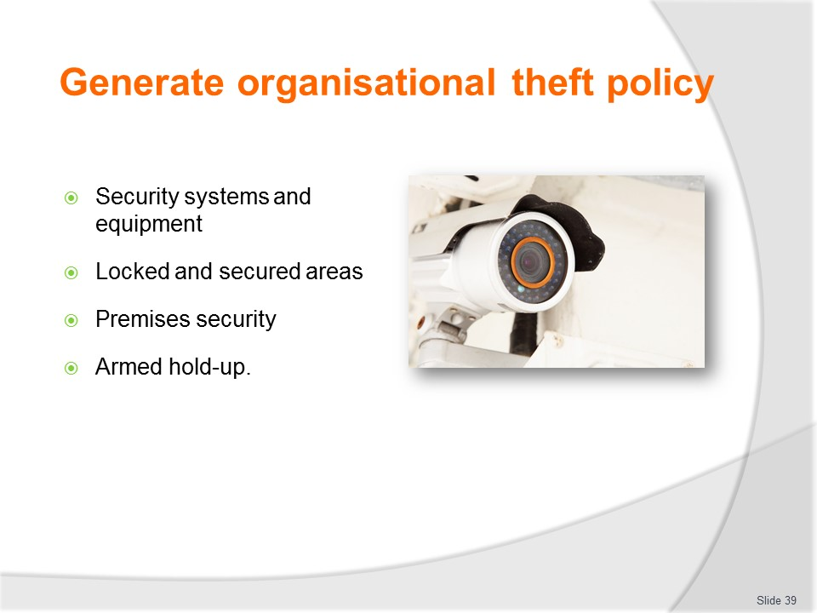
Slide No | Trainer Notes
Trainer continues identifying possible topics for theft policies:
- Security equipment and systems – embracing operational procedures relating to(as appropriate):
- Alarms
- Video surveillance
- Mirrors
- Security tags
- Locked and secured areas – identifying:
- Description of restricted areas
- Identification of persons authorised to enter restricted areas
- Identification of any time limitations that apply to entry to restricted areas
- Premises security – addressing issues such as:
- Lock-up procedures at end of trade
- Use of Static guards and Loss Prevention Officers
- Armed hold-up – giving detail about:
- Standard procedure for staff in the event of an armed hold
- Notification protocols following an armed hold-up
- Other procedures to follow after a hold-up – which will usually be contained in the Emergency Management Plan for the business.
Classroom Activity
Trainer arranges Guest Speaker to talk to students about various theft policies used by their organisation, and share sample policies with the group.

Slide
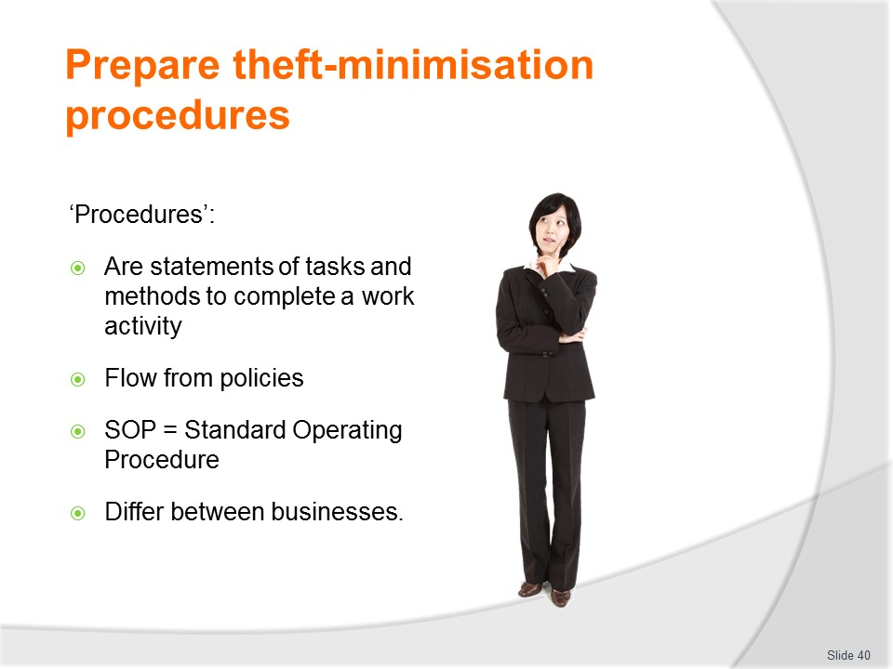
Slide No | Trainer Notes
Trainer explains a procedure is a statement of tasks and associated methods for the conduct of specific work activities.
They can vary enormously in format ranging from detailed step-by-step instructions through to very generic and quite simplistic ‘checklists’.
Classroom Activity
Trainer distributes and discusses samples of SOPs.

Slide
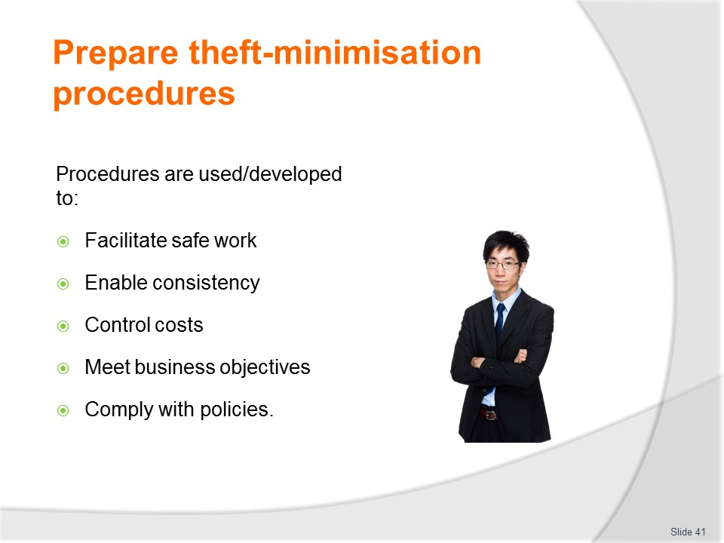
Slide No | Trainer Notes
Trainer states preparing detailed, written procedures enables critical operational activities to be controlled so:
- Workers can work safely
- A consistent product or service is delivered to customers
- Costs can be controlled
- The objectives of the business can be met
- Policies can be complied with.

Slide
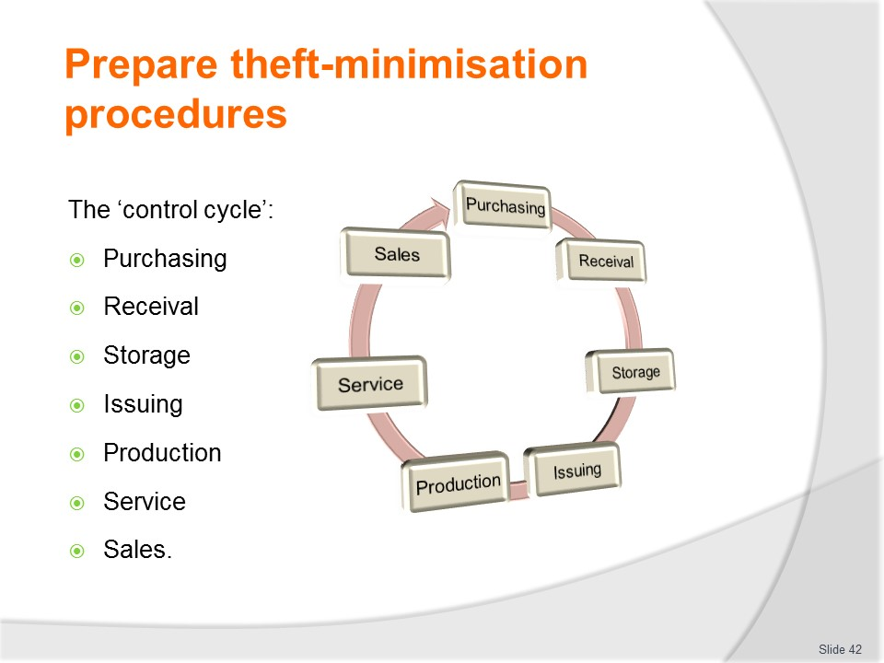
Slide No | Trainer Notes
Trainer advises the control cycle is a number of processes/functions which combine to help protect the financial viability of the establishment by putting in place control protocols (which embrace the concept of theft minimisation and loss prevention at various points) at each stage of the cycle. To be fully aware of the potential for theft/loss to occur within a business, it is vital to have an appreciation of the ‘control cycle’ concept and its elements. The full control cycle comprises seven component parts:
- Purchasing – this is the starting point of the control cycle and is covered to ensure no unauthorised purchases are made on behalf of the business (such as purchases made by staff for their own private use/consumption) and no unnecessary goods/services are bought
- Receival – refers to the time when products are delivered to the business. It is included, and important, because there is a need to ensure all deliveries into the premises are checked to ensure they are suitable for use/sale, match the orders placed, there are no short-deliveries and the business only pays for products it has ordered and has received
- Storage – where products need to be stored before use, display or sale there is a need to ensure goods are correctly and appropriately stored to protect against theft and to guard against loss of quality or damage
- Issuing – as products are taken from storage and issues to departments for their use or sale it is critical to ensure items are issued to individuals and departments only when they are legitimately able to be issued, and they are handed out only in such a way that allows the accounting function to track what and how much was issued, where it was issued to and when it was issued. Correct issuing helps avoid a situation where staff can gain access to products to which they are not otherwise entitled
- Production – where goods are used to produce items (meals, drinks etc for use [say] on tours) adequate control must be exercised to ensure usage/production conforms to pre-set standards (such as recipes) which will guarantee/control the cost of goods sold: control over production helps to ensure that requisitioned products are only used for the purposes intended and are not diverted into private use/theft
- Service – when goods are provided to customers it is necessary to ensure all items served (merchandise, drinks and meals) comply with pre-determined quantities/serve sizes and to ensure complimentary products provided are limited to set numbers: this helps guard against staff feeling they can help themselves to what they may regard as unimportant give-aways
- Sales – at the point of sale control is necessary to ensure the item is priced correctly, the correct price is charged. Only legitimate discounts are applied and payment is only taken by methods accepted by the business.

Slide
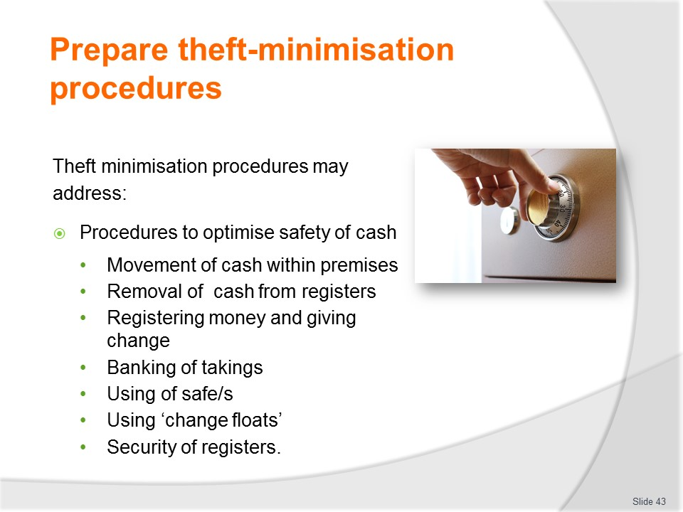
Slide No | Trainer Notes
Trainer discusses theft minimisation procedures.
Procedures to optimise the security of cash
The security of cash may cover:
- Moving cash within the premises
- Removing notes from cash register
- Procedures for registering money and giving change to customers
- Banking of takings
- Use of the on-premises safe
- Procedures relating to ‘change float’.
Classroom Activity (1)
Trainer demonstrates registering money and giving change and conducts role plays giving students an opportunity to practice same.
Classroom Activity (2)
Trainer distributes and discusses examples of SOPs listed on slide.

Slide
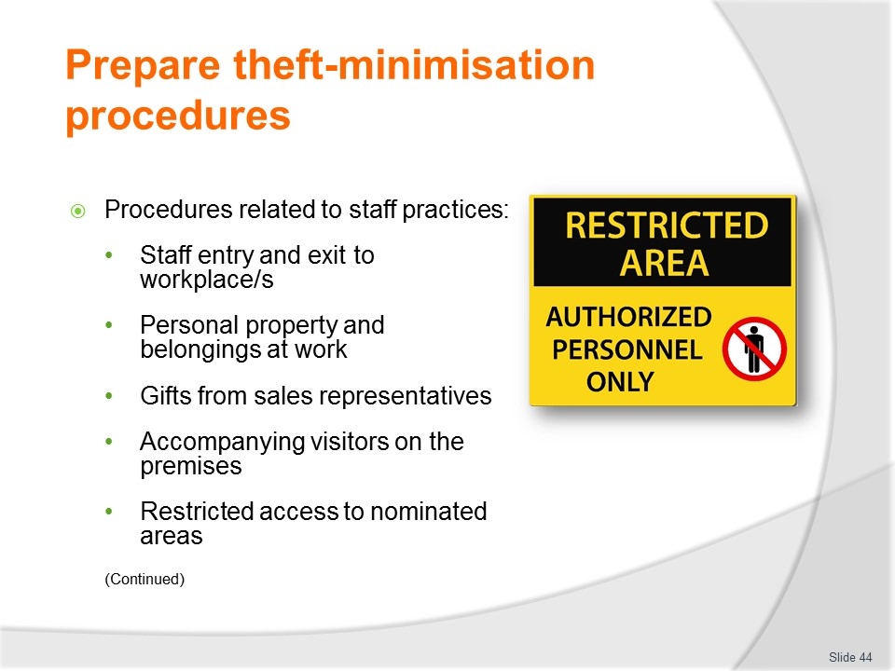
Slide No | Trainer Notes
Trainer continues discussing theft minimisation procedures.
Staff practices
- Staff entry and exit
- Personal property/belongings
- Gifts from reps
- Accompanying visitors
- Restricted access.
Classroom Activity
Trainer distributes and discusses examples of SOPs listed on slide.

Slide
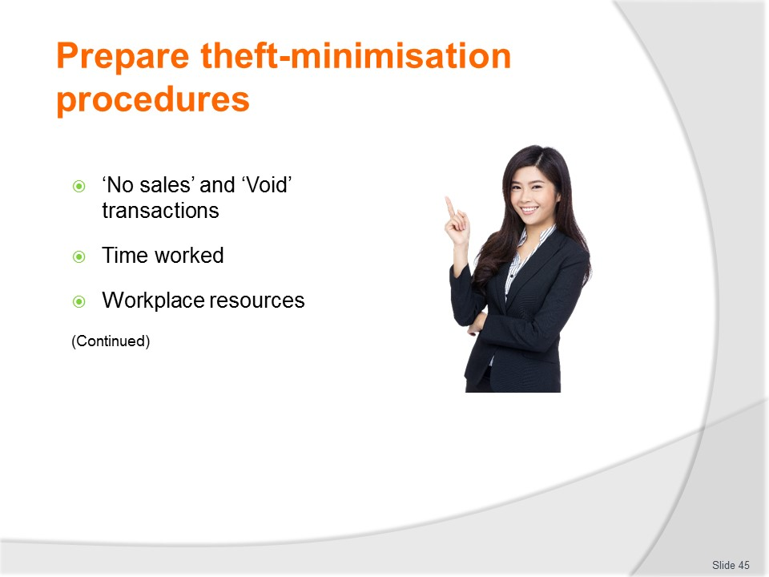
Slide No | Trainer Notes
Trainer continues discussing theft minimisation procedures.
Staff practices (Continued)
- ‘No sales’ and ‘Voids’ transactions
- Time worked
- Workplace resources.
Classroom Activity
Trainer splits class into small groups and asks groups to prepare procedures to address topics listed on slide.

Slide
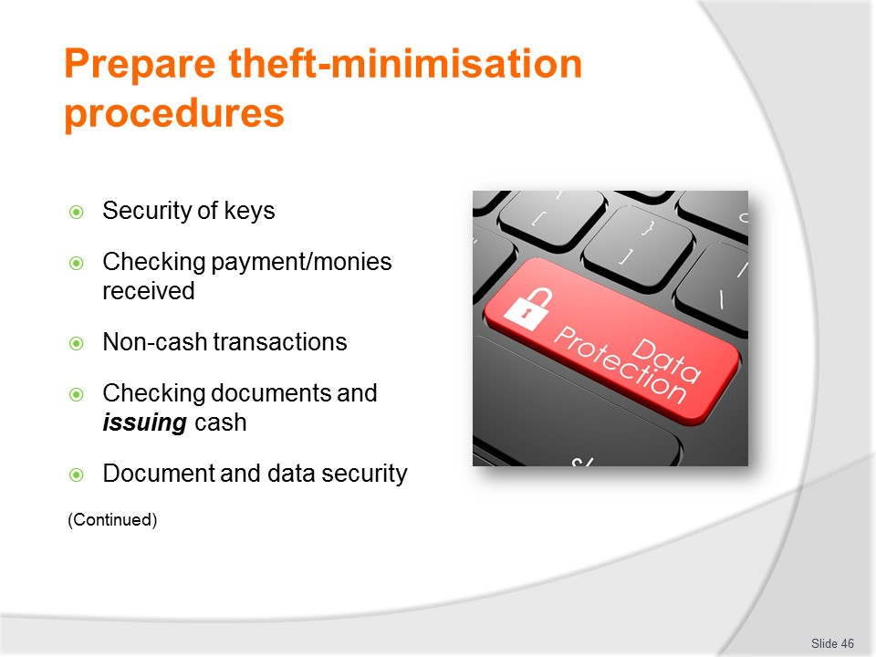
Slide No | Trainer Notes
Trainer continues discussing theft minimisation procedures.
- Security of keys
- Checking payments received from customers
- Non-Cash transactions – personal cheques, accounts, gift vouchers
- Checking documents and issuing cash
- Document and data security.
Classroom Activity (1)
Trainer demonstrates checking payments received from customers and conducts role plays giving students an opportunity to practice same.
Classroom Activity (2)
Trainer splits class into small groups and asks groups to prepare procedures to address topics listed on slide.

Slide
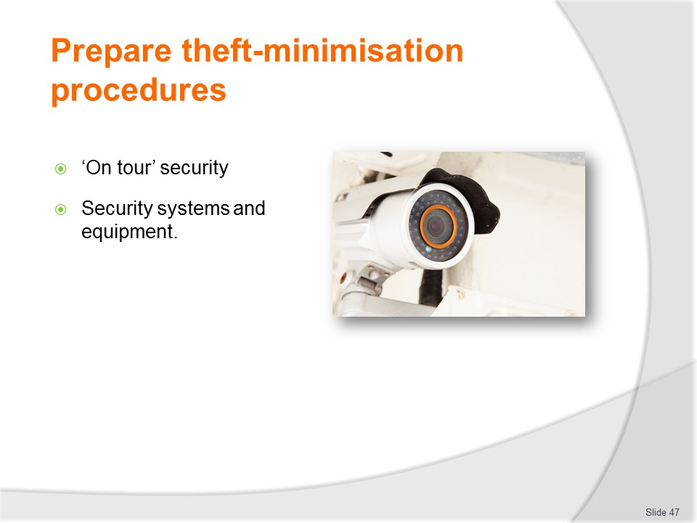
Slide No | Trainer Notes
Trainer continues discussing theft minimisation procedures.
- ‘On tour’ security – in relation to organisational assets, customer property
- Security systems and equipment.
Classroom Activity
Trainer arranges Guest Speaker to talk to students about various theft minimisations listed on slide, share sample SOPs and provide advice on development and implementation of policies and procedures.

Slide
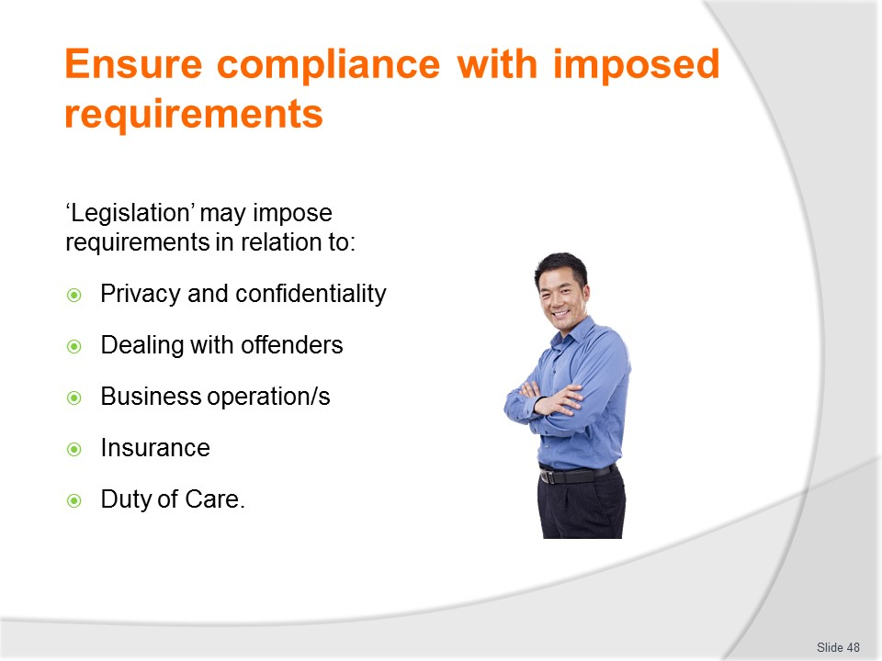
Slide No | Trainer Notes
Trainer explains requirements imposed by laws of a country may include:
- Need to take prescribed action to protect the privacy of customers and clients
- Need to take prescribed action to maintain identified confidentialities
- Need to observe and implement prescribed actions when apprehending a suspected offender
- Need to operate the business in a certain way such that it meets (for example) fair trading legislation, workplace safety requirements, anti-harassment and discrimination obligations, financial management and accounting protocols, taxation obligations, superannuation and workers compensation responsibilities
- Need to take out stipulated insurance policies (such as public liability insurance) to protect the public/customers from accident and injury caused while on the premises/on tour
- Need to meet ‘duty of care’ obligations – by taking necessary action to prevent causing foreseeable harm, damage or injury to customers.

Slide
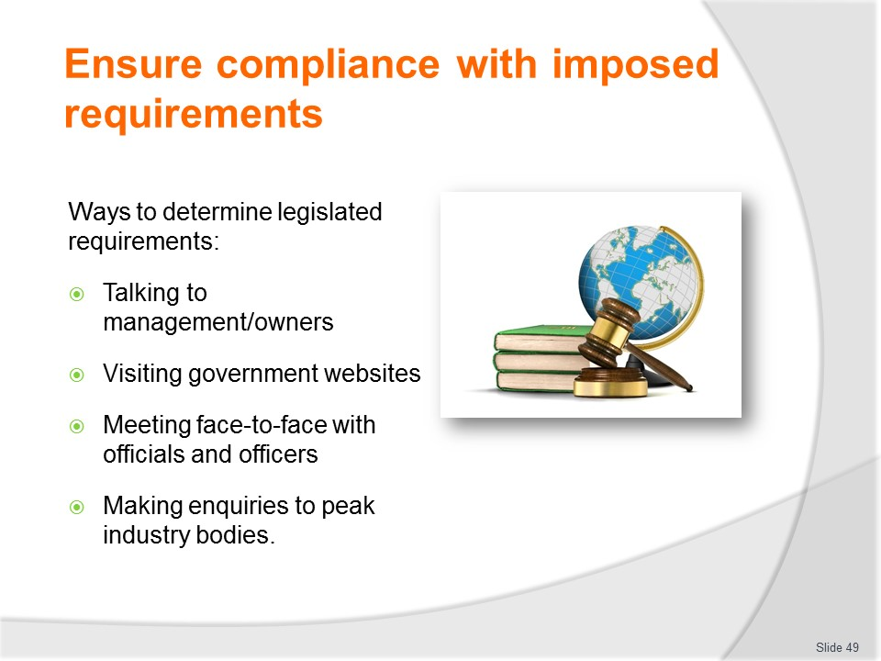
Slide No | Trainer Notes
Trainer You can determine the requirements of host country legislation by:
- Talking to management and owners of the business
- Visiting relevant government websites and reading the obligations imposed on businesses and employers
- Meeting direct in-person or over the telephone with officers from relevant government departments and asking them questions about the legal requirements imposed on you by the legislation they are responsible for administering
- Making enquiries to peak industry bodies/associations who represent your business or industry sector.
Classroom Activity
Trainer arranges for a group of officials from government departments/agencies to attend and present/discuss relevant industry obligations imposed on operators by in-country legislation.

Slide
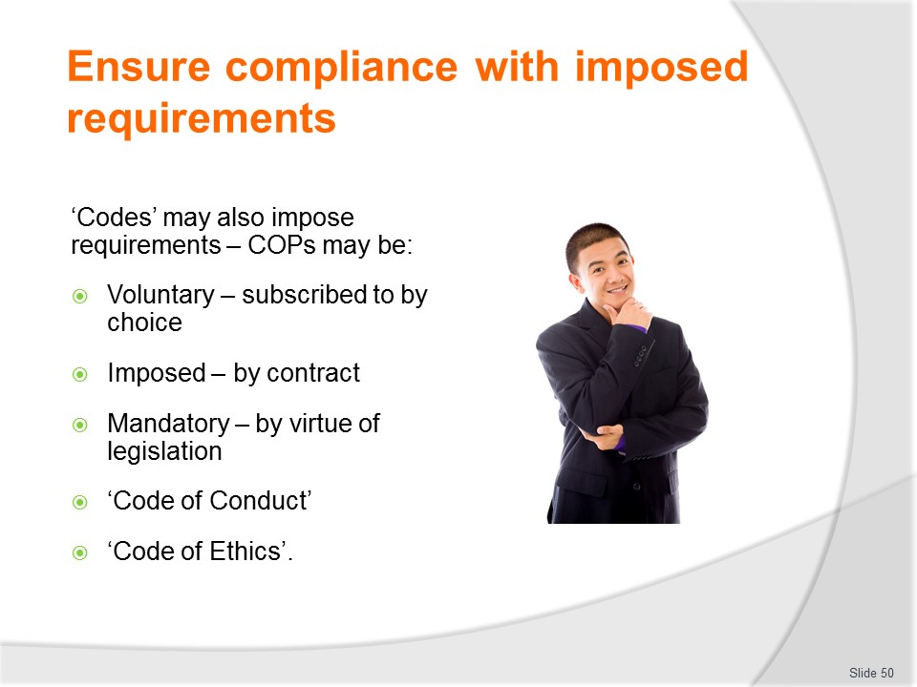
Slide No | Trainer Notes
Trainer discusses range of Codes which may impose requirements when theft-related policies and procedures are being formulated:
- Voluntary – meaning your business can elect to sign up to them
- Imposed by virtue of an arrangement or contract – for example, if you belong to an association or group it may be a requirement your organisation subscribe to a given code of practice as one of the conditions of being a member
- Mandatory – some COPs are imposed by law on the business and compliance with them is compulsory, rather than optional.
Classroom Activity
Trainer distributes and discusses examples of Codes listed on slide and highlights their application and relevance to the industry.

Slide
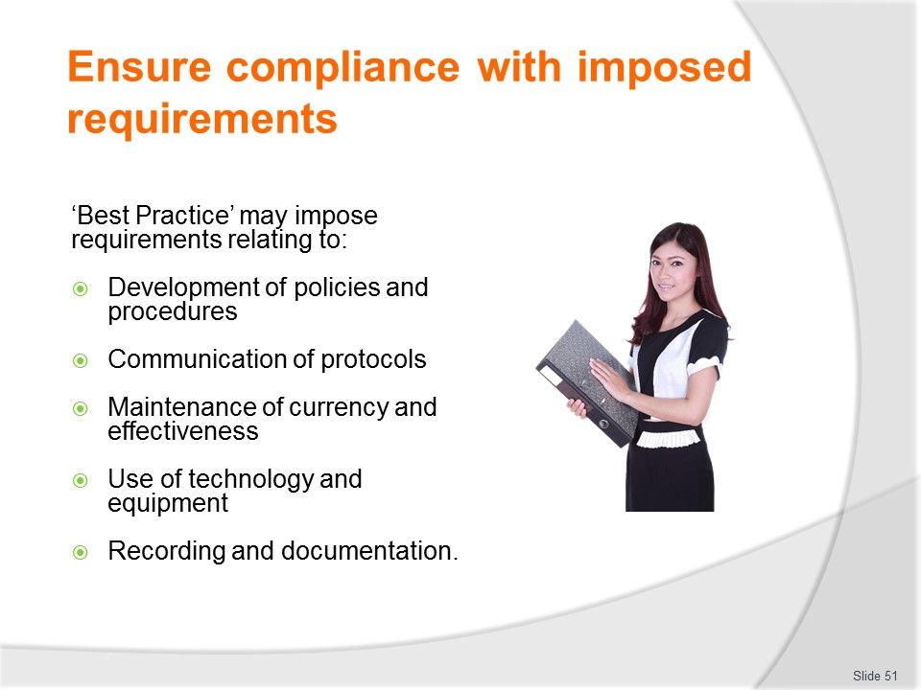
Slide No | Trainer Notes
Trainer explains ‘Best practice’ refers to practices and procedures which are regarded by the industry or an individual workplace as being the most applicable and effective. There is also a strong link between these protocols and the delivery of ‘quality’ products and services: adherence to ‘best practice’ results in quality outcomes.
The detail regarding best practice is always changing as inventions in technology take place and innovation occurs.
Individual organisations may set their own BP procedures, or adopt and/or adapt the BP procedures of other bodies, organisations or sources (such as the suite of ISO standards).
Best practice procedures relating to theft minimisation may include:
- Developing and formalising theft minimisation policies and procedures
- Conducting regular staff training relating to the prevention and detection of theft
- Undertaking regular workplace inspection to identify possible suspicious circumstances and/or potential threats or targets for theft
- Using technology and equipment to deter and detect theft and fraud
- Maintaining comprehensive and accurate records and documentation relating the theft minimisation activities and theft events.
Other BP action often relates to issues such as:
- Sustainability; Marketing; Communication; Service recovery; Emergency management.
Classroom Activity
Trainer distributes and discusses examples of Best Practice for the industry and highlights their application and relevance to the industry.

Slide
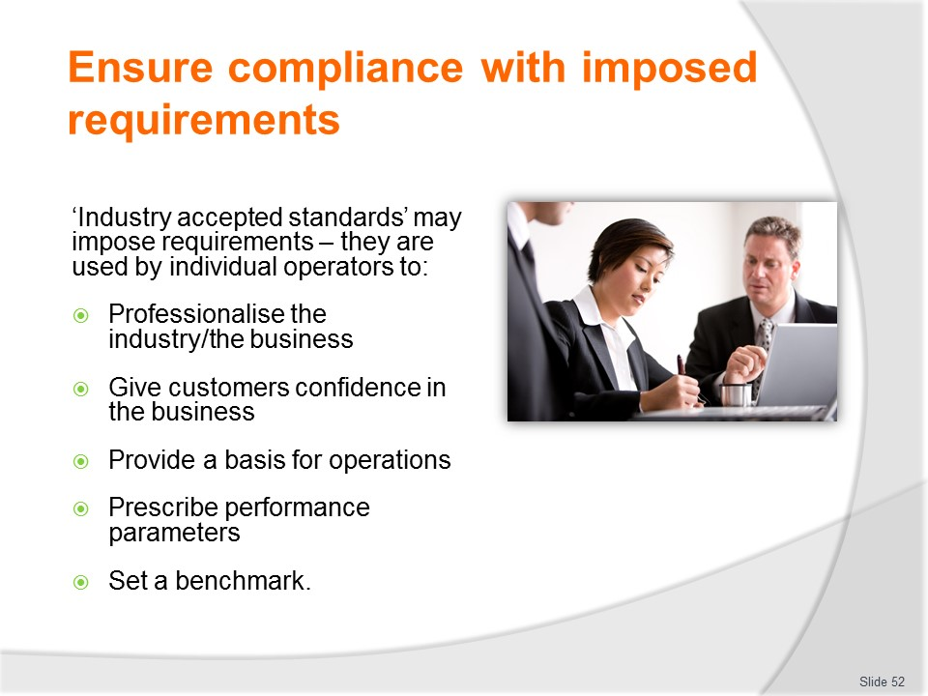
Slide No | Trainer Notes
Trainer highlights ‘industry accepted standards’ may also impose requirements.
The standards are established in order to:
- Professionalise the industry by prescribing minimum standards
- Give customers confidence in the industry by demonstrating their core concerns have been addressed by operators
- Provide a basis for business operation for those who exist and function within the industry
- Prescribe specific parameters for aspects of industry performance and some or all of the products and services provided by it
- Set a benchmark level for improvements to the basic delivery of products and services within the industry.

Slide
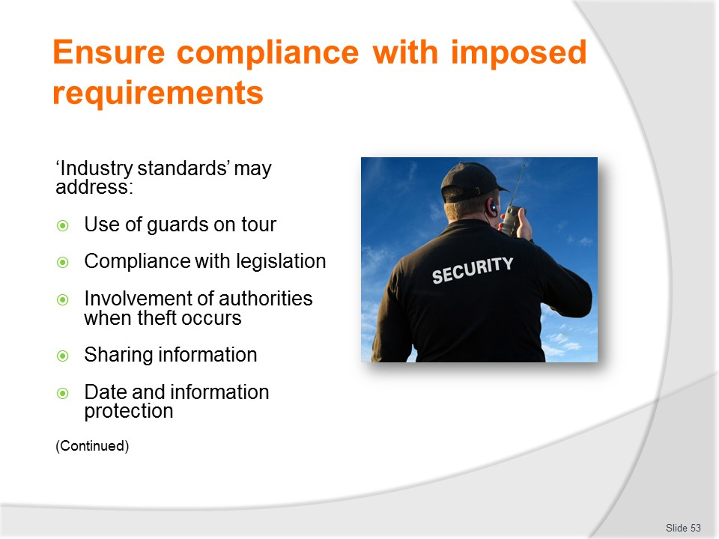
Slide No | Trainer Notes
Trainer gives examples of topics to which industry accepted standards may apply in relation to theft minimisation:
- Using security guards when on tour
- Complying with host country legislation relating to identification of people seeking to purchase travel/tickets – all accepted industry standards support/reinforce the need for businesses to comply with their legislated obligations
- Involving police/authorities whenever (without exception) a customer is detected committing a theft – in order to act as a deterrent to other would-be thieves
- Sharing theft-related intelligence and experiences with other operators
- Implementing nominated protocols to protect business and customer information/data.
Classroom Activity
Trainer splits class into small groups and asks groups to identify legislation, Codes and other sources which may ‘impose requirements’ on the development and content of theft minimisation policies and procedures.

Slide
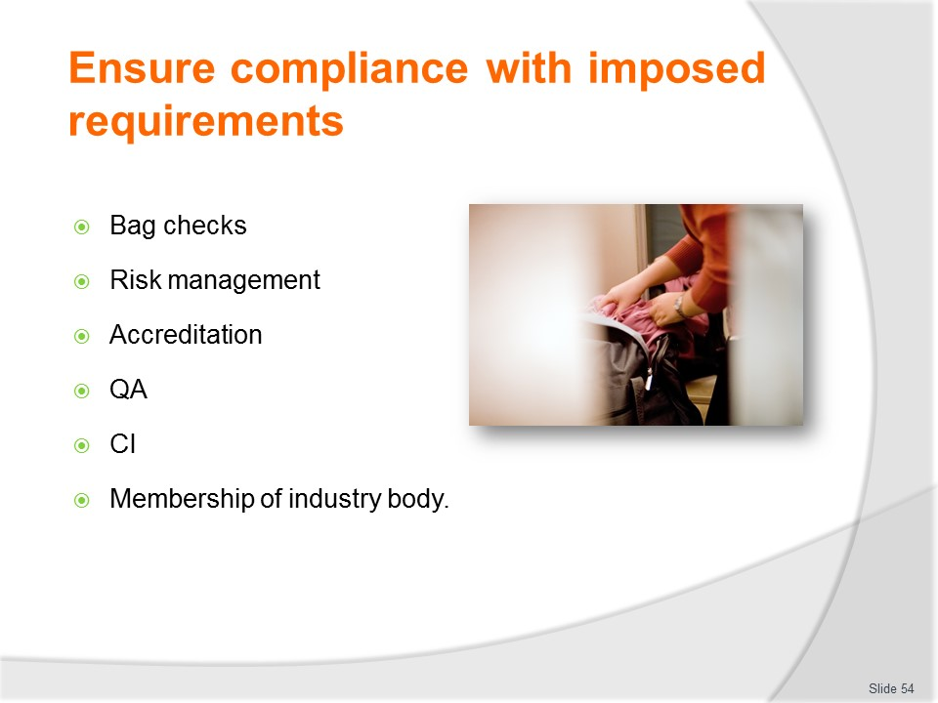
Slide No | Trainer Notes
Trainer continues giving examples of topics to which industry accepted standards may apply in relation to theft minimisation:
- Protocols to be followed when checking customer bags and/or detaining suspects
- Risk/threat identification, assessment and control procedures
- Accreditation of the organisation by a nominated body
- Implementation of a nominated Quality Assurance scheme
- Commitment to continuous improvement
- Membership of relevant peak industry body.
Class Activity (1) – Demonstration and Practical Exercise
Trainer demonstrates how to conduct a bag check and provides opportunity for students to practice same.
Class Activity (2) – Guest Speaker
Trainer arranges for Guest Speaker from an accreditation or QA body to attend and discuss requirements for, and benefits of, joining.
Class Activity (3) – Guest Speaker
Trainer arranges for Guest Speaker from a peak industry body to attend and discuss reasons organisations should join and participate in activities and events.
Slide
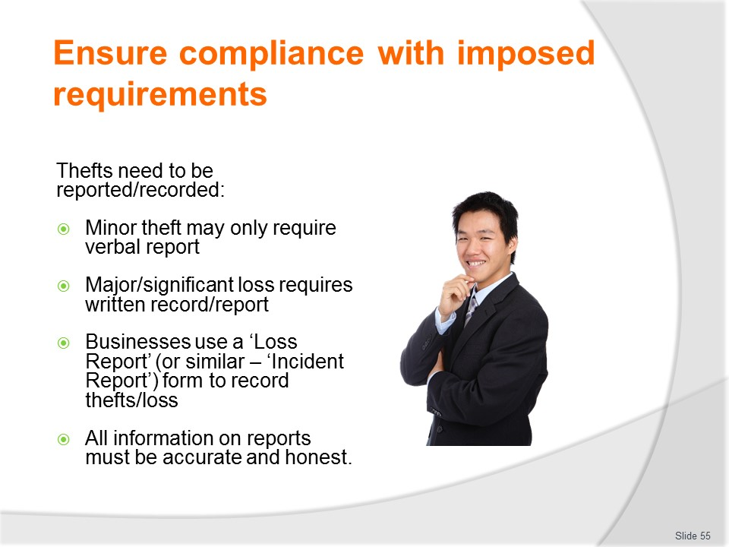
Slide No | Trainer Notes
Trainer notes thefts need to be reported and/or recorded.
- Most establishments require thefts or other loss events to be reported and/or recorded in some way.
- The immediate need for this reporting means verbal notification (in person or by phone/two-way radio) is the initial and preferred reporting option: often, a written, follow-up report may have to be prepared.
- In some instances (such as minor losses where the cause of the loss has been identified and remedied) notification may be permitted via internal email.
- You may have to complete a ‘Loss report’ form, or you may be asked to complete details in a ‘Security register’.
- Regardless of the format of the written report you will need to ensure you supply full and honest details of the event to the best of your knowledge and ability to do so.
- It must be remembered there is no room in these reports for supposition, only facts.
Classroom Activity
Trainer distributes and discusses sample forms used to record/report thefts.

Slide
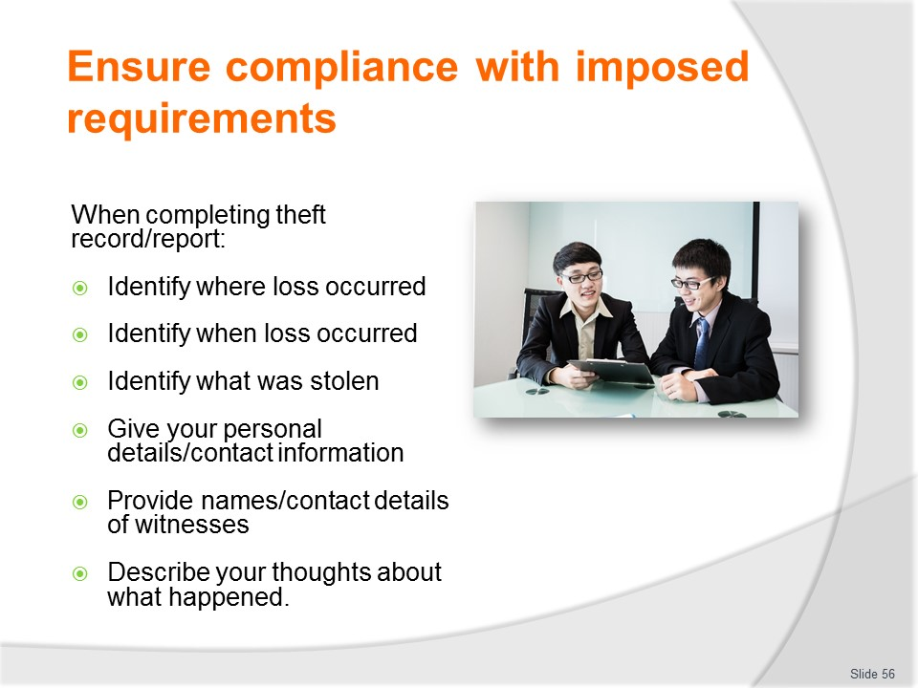
Slide No | Trainer Notes
Trainer discusses information supplied when reporting/recording theft stating notification should include, where it is possible to do so:
- Where the loss occurred from – stating the department and the exact location of the cash/product stolen (such as ‘Merchandise display adjacent to main entrance; lower shelf’)
- At what time it occurred – this may be a precise time (such as ‘3.45 PM Friday 23/11/2016’ or a time-range such as ‘Between the hours of 01.00 AM and 09.00 AM on Friday 23/11/2016’)
- What was stolen – this may be a very exact description such as ‘1 carton [24] of 600ml Evian still bottled water’ or a general statement such as ‘an unidentified amount of complimentary merchandise including caps, T-shirts, pens and shoulder bags’: you should also attempt to place a monetary value on what has been lost
- Your details – including your name, position and contact details
- Name of any witnesses (if applicable) and their contact details – these may be staff and/or customers: customers cannot be compelled to provide a statement
- Your thoughts on what happened – including who may have been involved and what occurred/how the loss happened: be sure to make sure your thoughts are clearly identified as such and not able to be confused with ‘the facts’.
Class Activity - Practical Activity
Trainer describes a theft event and asks individual students to prepare a Theft Report to record all relevant details.
Slide
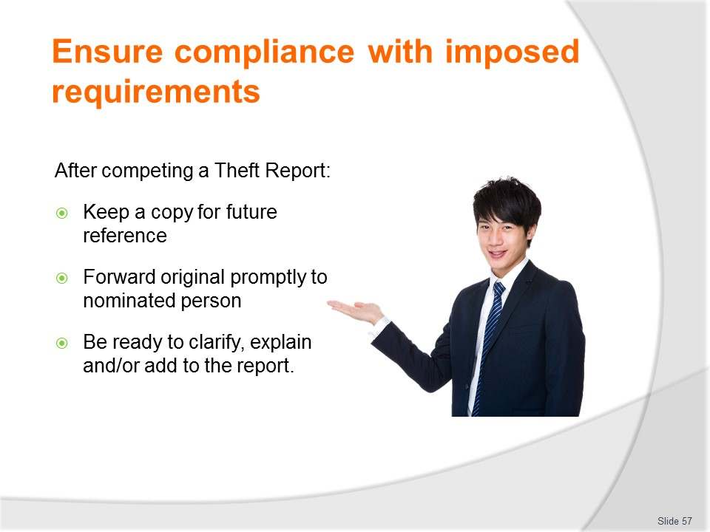
Slide No | Trainer Notes
Trainer explains when the theft record/report has been completed:
- Keep a copy for your reference/records
- Forward it promptly to the nominated person
- Be prepared to explain and/or clarify points addressed.

Slide
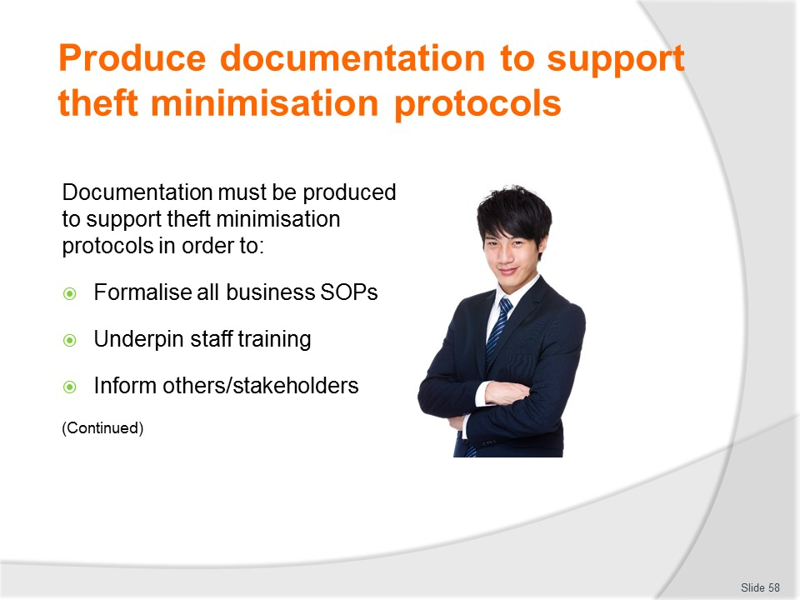
Slide No | Trainer Notes
Trainer states documentation to support theft minimisation protocols is/may be necessary to:
- Formalise agreed procedures – so there are written copies available
- Underpin staff training – so staff are trained in the correct/current procedures
- Inform others (customers, members of the public, media, partners, service providers) of the procedures which apply.

Slide
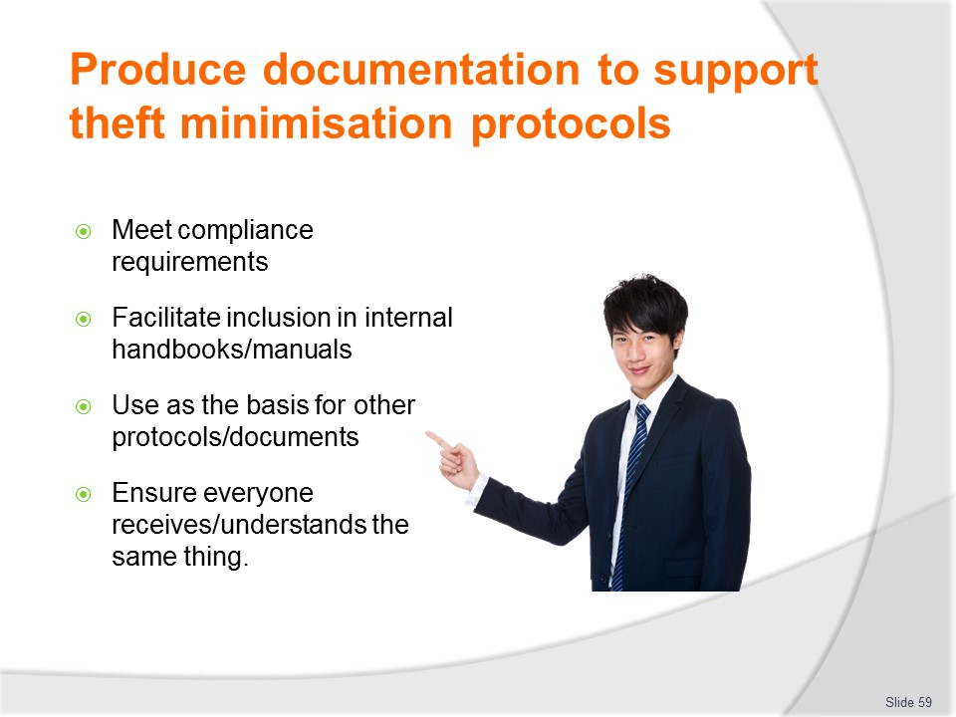
Slide No | Trainer Notes
Trainer continues explaining need for supporting documentation:
- Comply with internally and/or externally imposed compliance requirements
- Facilitate their inclusion in staff manuals and similar
- Provide the basis for the formulation of other workplace documents such as operational checklists, reports or forms
- Ensure everyone is informed of the same thing/s so there is uniformity and consistency in relation to this topic.

Slide
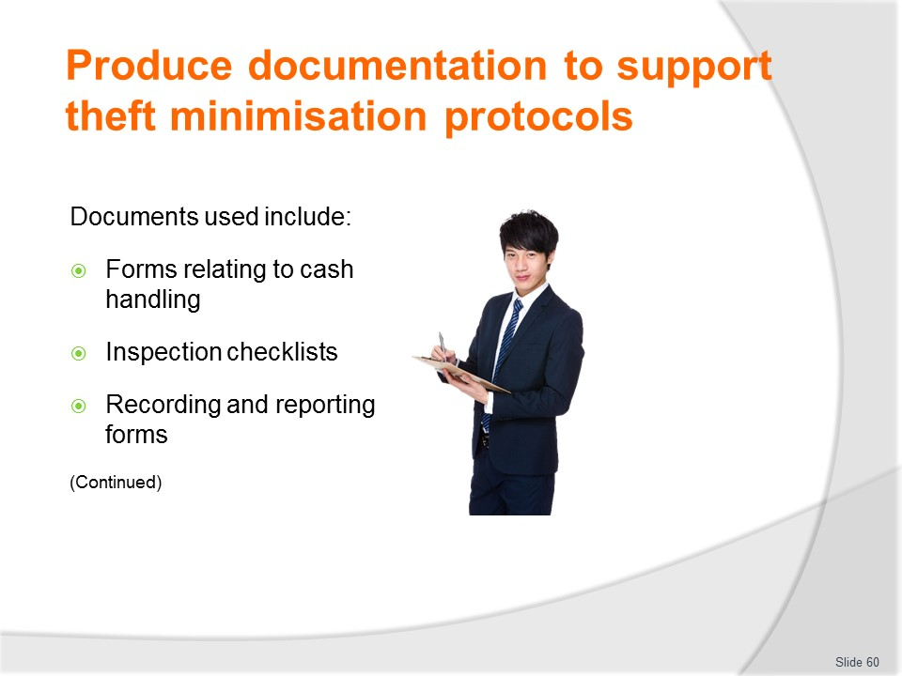
Slide No | Trainer Notes
Trainer gives examples of documentation used and the role it plays in the operation and theft minimisation processes of the business:
- Cash handling and transaction forms – which help reduce or deter the potential for theft or fraud by providing a paper-based (or electronic) trail of transactions such as:
- Refunds to customers; Exchange- of products, tickets, seats, options, tour inclusions and similar; Voids – where a transaction or sale was made in error and needs to be erased/removed from the cash register/control system; Sales – by providing details of the sale such as products/services purchased, time and date, methods of payment, identity of person making the sale, discounts or other price variations applied to the sale
- Inspection checklists – used in terms of theft minimisation to:
- Guide inspections of the business when seeking to identify potential for theft; Provide a hard-copy record of inspections for future reference; Prove the checks were undertaken; List issues which were identified as requiring action so as to prevent future theft
- Recording forms and theft reports – to be used in the event a theft event occurs, providing necessary details of:
- What occurred; When and where it took place; Who was involved – offenders and staff/authorities who responded; Value and description of items damaged or stolen; The immediate action taken by staff/the business in response to the event; Suggestions/recommendations to prevent recurrence.
Class Activity – Handouts
Trainer distributes and discusses documents identified on slide.

Slide
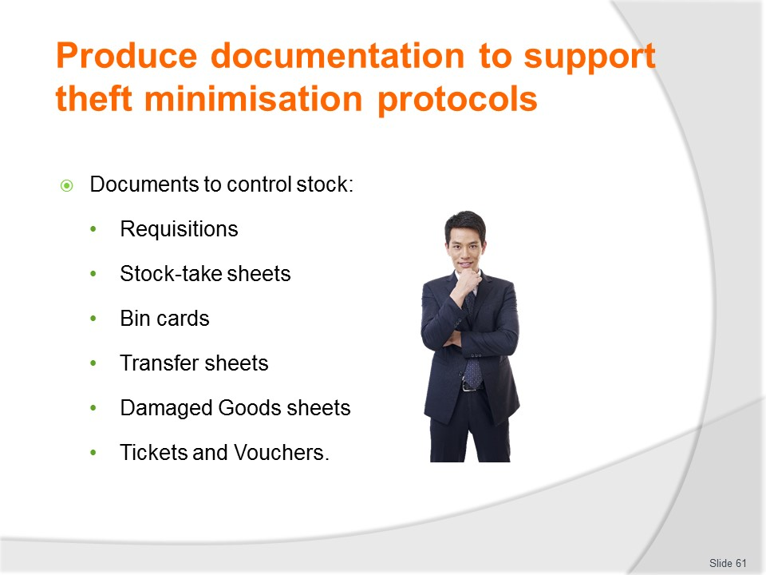
Slide No | Trainer Notes
Trainer continues presenting examples of documentation used and the role it plays in the operation and theft minimisation processes of the business:
- Forms to support and track stock and stock movement – these will include paper-based or electronic forms such as:
- Requisitions – for requesting stock for a department from the storage area of the business
- Stock take sheets – to record stock-on-hand when a stock-take/stock count is done
- Bin cards – to record the quantity of individual items in the stores area and track its movement/status in terms of when and how much stock was delivered into the business, amount of product on-hand, issue of items to departments
- Transfer sheets – used to record stock (by type, number, date) when one department transfers items to another department/area
- Damaged goods – recording stock items which may be unsaleable (and hence thrown out, resulting in zero revenue for that item), returned to a supplier for credit, or given away as a complimentary item, or sold at a discounted rate
- Tickets – so there it is possible to track sales and verify physical tickets on-hand
- Vouchers – so there is a process to track/record their issuance, verify stock on-hand and ensure they are completed correctly and voided/invalidated correctly as and when required.
Class Activity (1) – Handouts
Trainer distributes and discusses examples of documentation identified on slide.
Class Activity (2) – Demonstration and Practical Exercise
Trainer demonstrates how to complete a range of documents on the slide and provides opportunity for students to practice same.

Slide
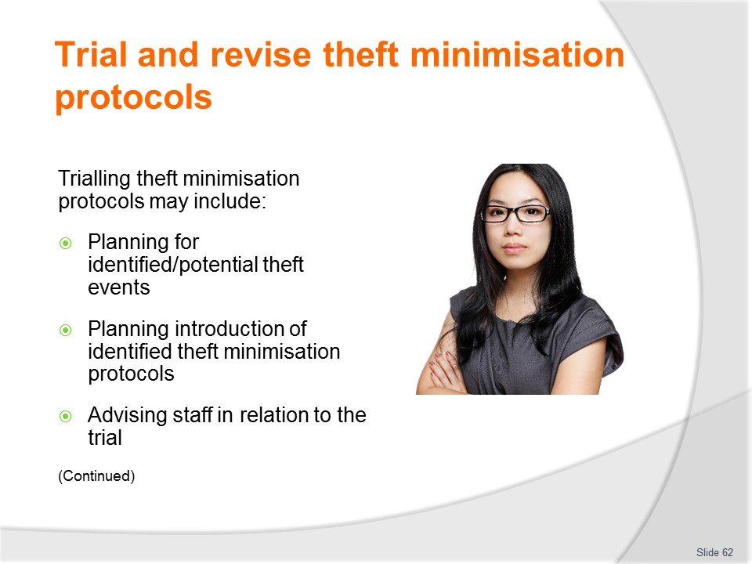
Slide No | Trainer Notes
Trainer states trialling theft minimisation protocols may include:
- Planning for identified/potential theft events – which requires you to:
- Use the scenarios or situations (threats) identified from inspections, feedback, personal observation and/or experience as the basis for planning
- Creating within the business a simulated situation embodying the identified threats so this can be tested as the basis for evaluating your proposed theft minimisation protocols
- Making the simulated scenario/situation as realistic as possible
- Planning the introduction of identified theft minimisation protocols – this may require you to:
- Prepare a formal written plan
- Involve staff and management in the planning process
- Allocate roles and responsibilities
- Schedule the trial/test
- Provide the necessary resources
- Obtain management approval
- Advising staff in relation to the trial – which you can achieve by:
- Holding a formal meeting or briefing with staff
- Introducing and explaining proposed protocols to be trialled
- Providing staff with hard copies of the plan for the trial
- Advising staff of their role/s and responsibilities under the plan
- Asking staff to commit to the trial and treat it seriously as a realistic event
- Requesting they note what happens during the trial/test and provide relevant feedback after the event.

Slide
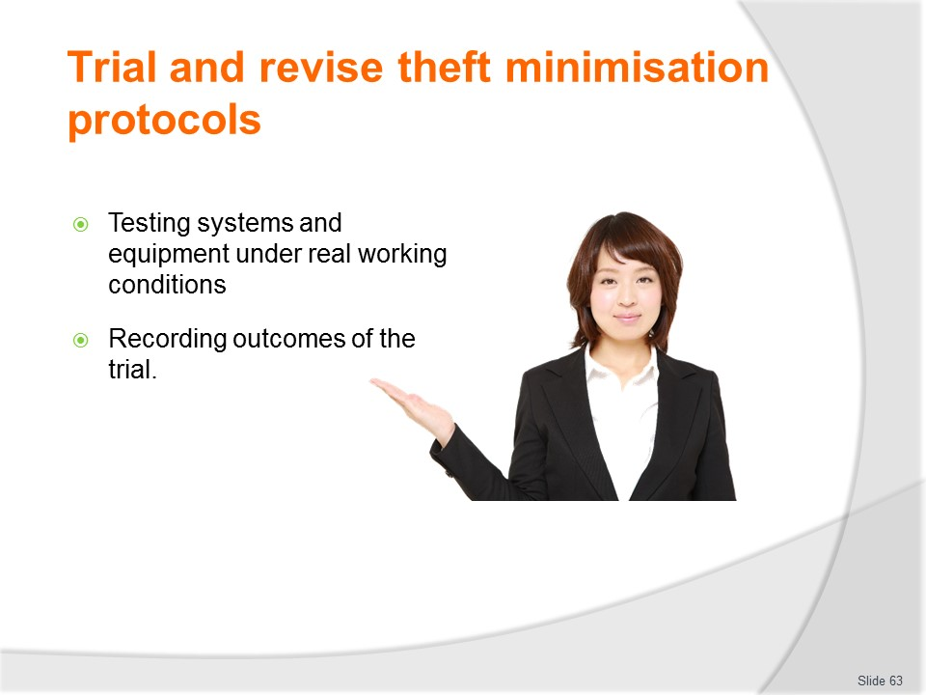
Slide No | Trainer Notes
Trainer continues advising regarding trialling theft minimisation protocols:
- Testing the systems and equipment under real working conditions – which will require you to:
- Conduct the trial/test as planned and scheduled
- Create and maintain realism for the activity
- Ensuring the trial reflects exactly the planned actions and responses
- Recording the outcomes of the trial – by:
- Monitoring/watching what happens
- Taking notes
- Recoding events, reactions, responses using a combination of means such as video, photographic, audio, paper-based records, CCTV footage. This must be done to provide data/the basis for the evaluation (see later slides).

Slide
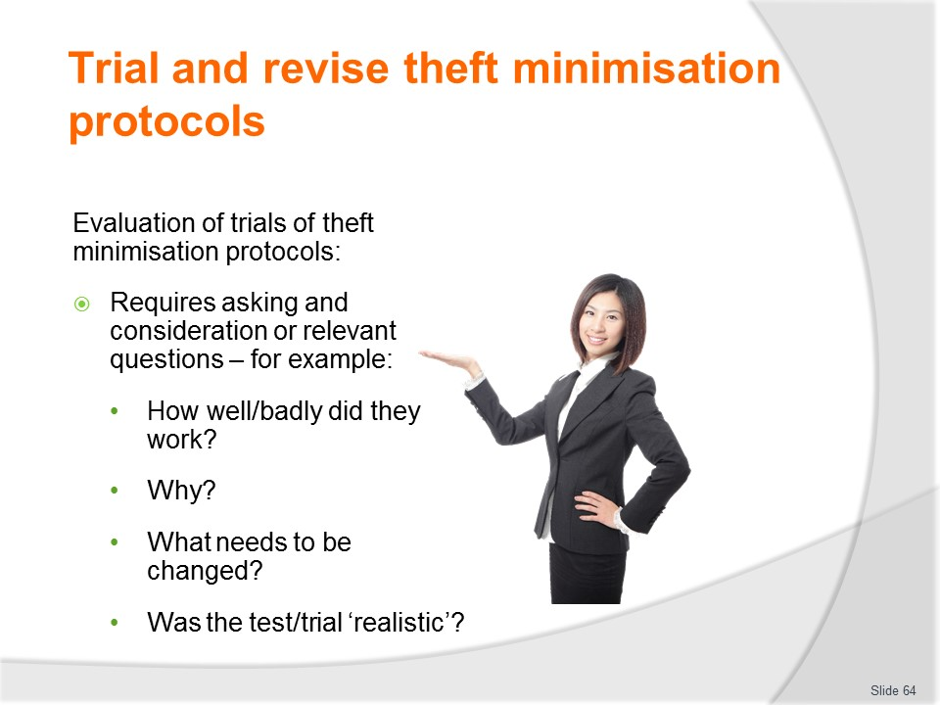
Slide No | Trainer Notes
Trainer discusses evaluation of trials of theft minimisation protocols:
- It is an essential part of the trialling process to evaluate the results/outcomes of the trial, determine the effectiveness and viability of the trial initiatives (the protocols which were tested/trilled) and revise them, if necessary, before cementing them in place as part of standard operating procedure. The process should embrace:
- Evaluating the detection and prevention outcomes achieved – by asking and considering the responses to series of questions such as:
- How well/badly did the plan work?
- Was it successful/effective?
- What could/should be changed or improved on the basis of the outcomes/trial?
- Did staff perform/react/respond as required or anticipated? Why? Why not?
- On reflection, after the trial and with the benefit of hindsight, was the test a realistic representation of the theft problem the initiative was designed to detect or thwart?
- Can the plan be introduced ‘as is’ to SOP for the business. Or are changes required? What are the changes needed?

Slide
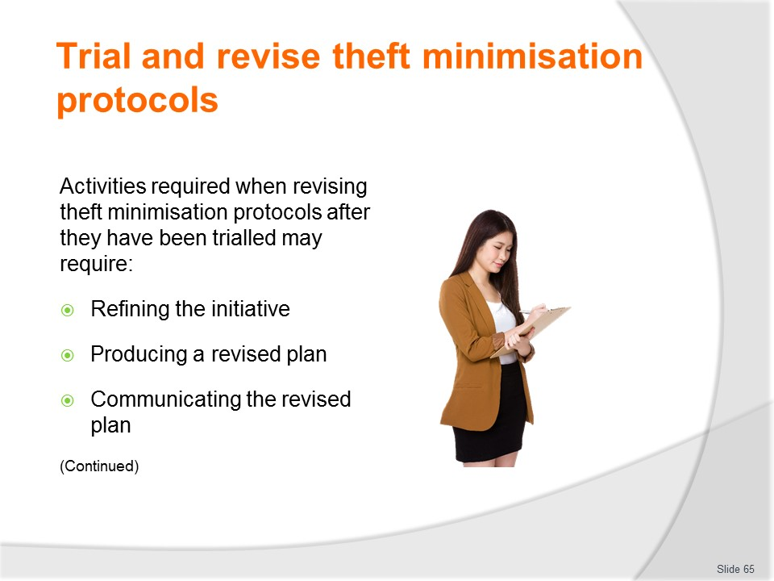
Slide No | Trainer Notes
Trainer discusses revision of theft minimisation protocols after trials stating revising the intended theft minimisation protocols on the basis of evidence obtained during the trial – this may require:
- Refining the initiative on the basis of the experience gained and feedback received
- Producing a revised plan – and having it approved by management
- Sharing the revised plan/initiative with staff.

Slide
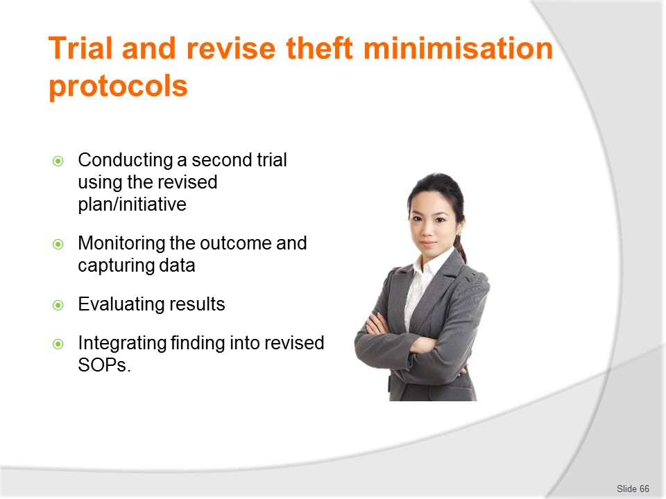
Slide No | Trainer Notes
Trainer continues discussing revision of theft minimisation protocols after trials:
- Conducting a second simulated event
- Monitoring and capturing information on the effectiveness of the revised test/trial
- Evaluating the results/outcomes
- Integrating the revised and approved protocols into SOPs for the organisation.
Class Activity – Major Practical Activity
Trainer asks students to:
- Identify a theft minimisation protocol to trial
- Develop plan and scenario for trialling the protocol
- Conduct the trial
- Monitor and record outcomes
- Evaluate results
- Generate recommendations for change/improvement.

Slide
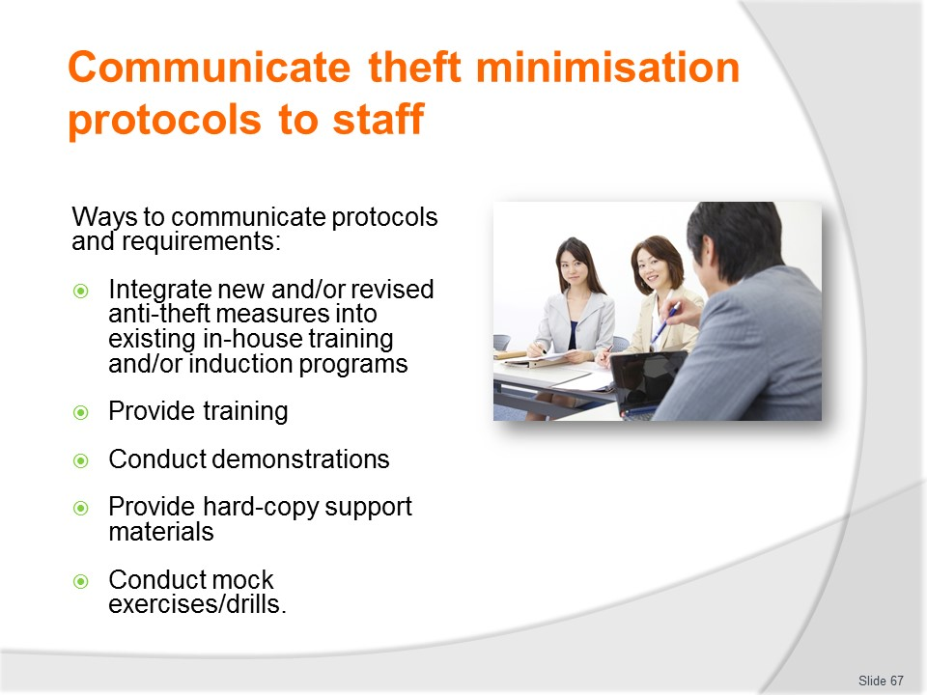
Slide No | Trainer Notes
Trainer identifies ways to communicate theft minimisation protocols and requirements to staff:
- Integrating new and/or revised anti-theft measures into existing in-house training and/or induction programs – this is important so new staff:
- Are made aware of their role and responsibilities for preventing, detecting and responding to theft
- Know the action/s they are expected to take to prevent theft
- Understand the function/s of security systems, technology and equipment
- Providing training – this may address:
- Theory – including advising about and explaining policies and procedures, legislation, case studies, analysis of previous events, discussion on theft-related matters
- Practice – including role plays, practice with security systems, technology and equipment, simulated exercises, model inspections and checks, completion of relevant forms and documents
- Conducting demonstrations – relating to:
- Operations of security systems, technology and equipment
- Monitoring customers
- Detaining suspects
- Providing new and/or revised hard copy support material – such as:
- Policies and procedures – integrated into SOP manuals, staff handbooks, internal training
- Instructions and directions – on how to operate security systems, technology and equipment, how to implement workplace-specific protocols relating to application of the 3Ds
- Conducting mock exercises – this refers to the conduct of workplace drills which simulate identified/expected theft situations.
- Staff are evaluated on their response to the drills, and the protocols being tested are also analysed to determine if they remain effective or require revision.

Slide
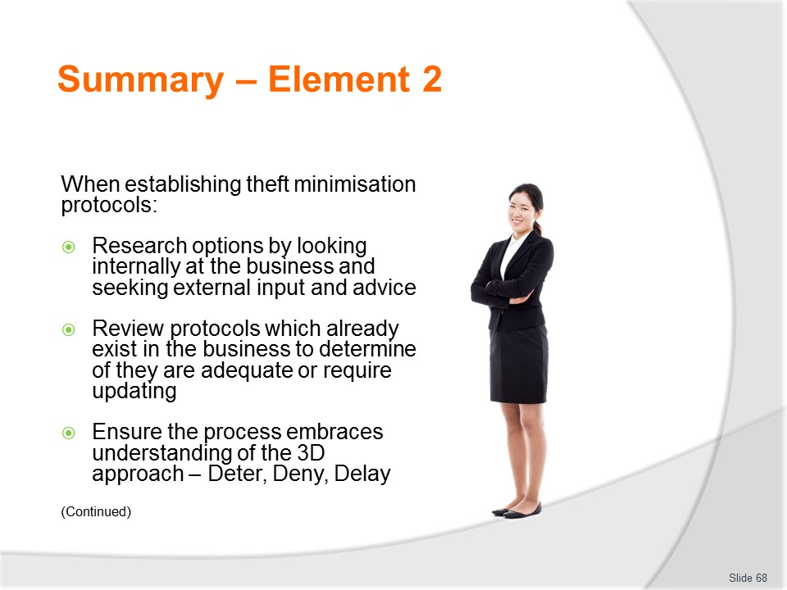
Slide No | Trainer Notes
 | Trainer provides a recap of the Element asking questions to check trainee understanding and responding to questions from trainees, as required.

Slide
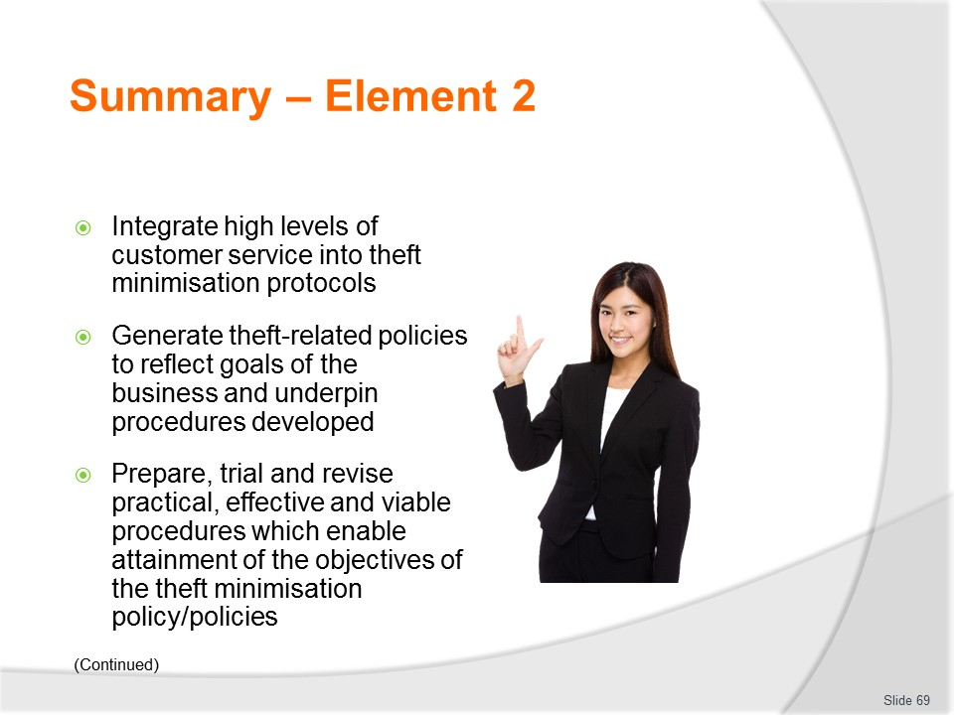
Slide No | Trainer Notes
 | Trainer provides a recap of the Element asking questions to check trainee understanding and responding to questions from trainees, as required.

Slide
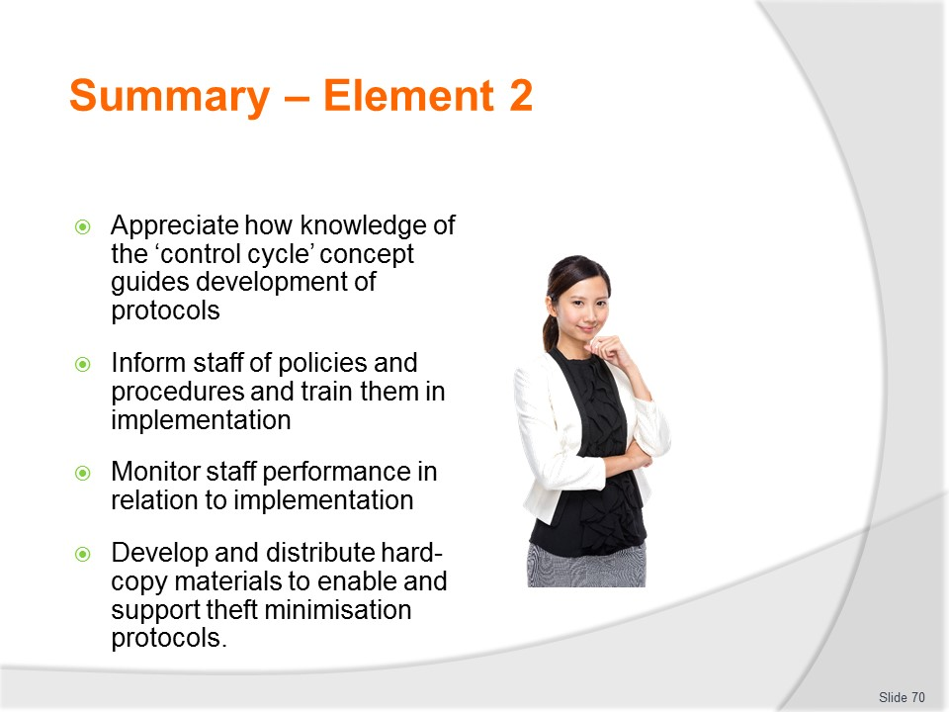
Slide No | Trainer Notes
 | Trainer provides a recap of the Element asking questions to check trainee understanding and responding to questions from trainees, as required.

Slide
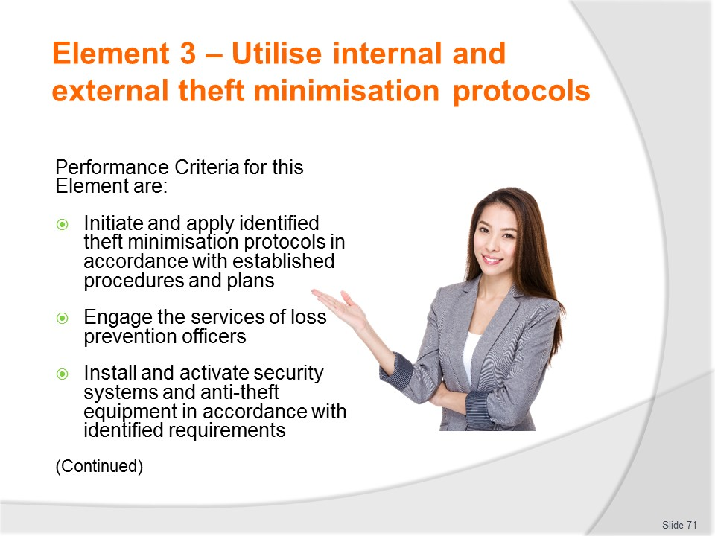
Slide No | Trainer Notes
 | Trainer identifies for trainees the Performance Criteria for this Element, as listed on the slide.

Slide
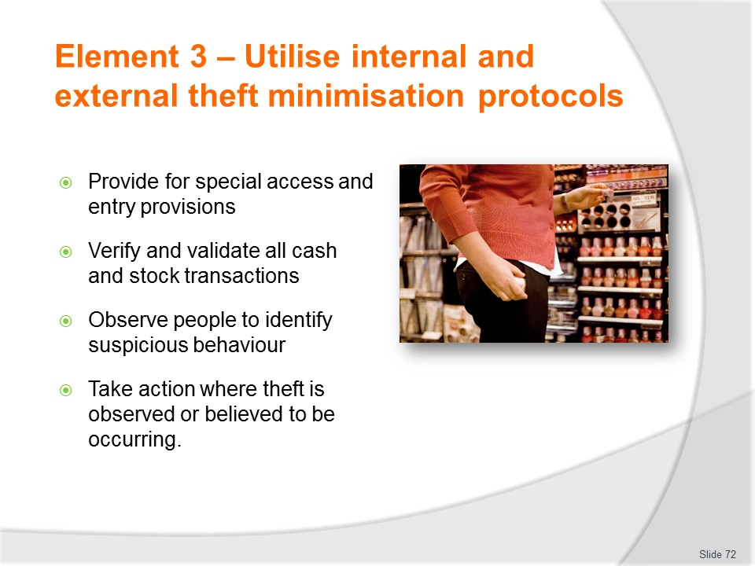
Slide No | Trainer Notes
Trainer identifies for trainees the Performance Criteria for this Element, as listed on the slide.
Class Activity – General Discussion
Trainer leads a general class discussion by asking questions such as:
- What do you think is involved in implementing and using theft minimisation/prevention policies and procedures?
- Why is it important to implement/use protocols exactly as they have been developed?
- How might you make sure implementation of these protocols actually reflects their intention/objectives?

Slide
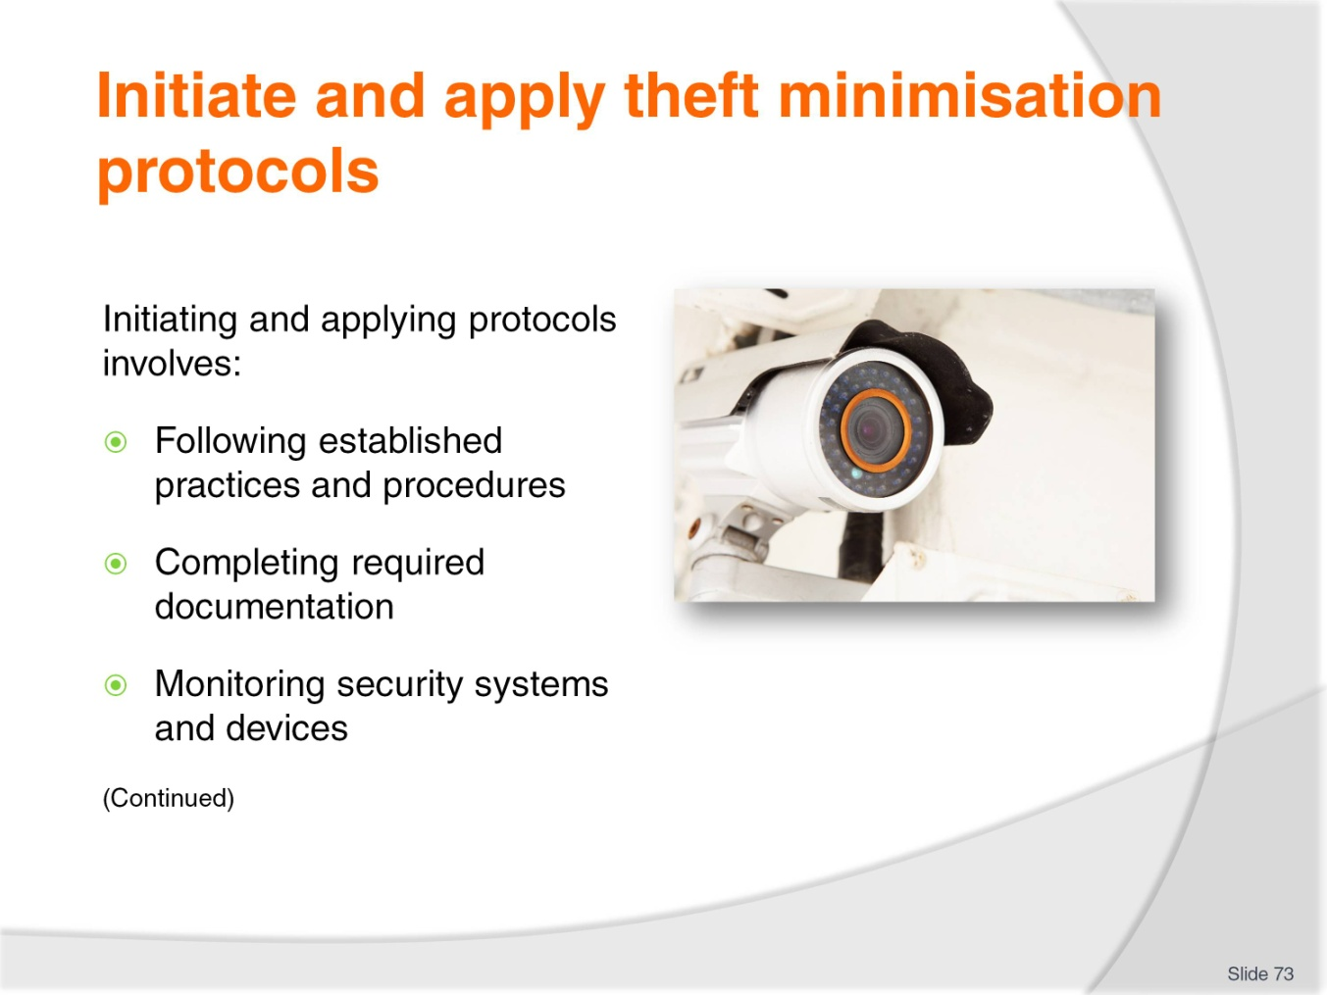
Slide No | Trainer Notes
Trainer advises theft minimisation protocols may address on-site and on-tour procedures and implementation may include:
Following the established enterprise practices and procedures
- Learning what the required practices and procedures are by referring to them in their approved, written form
- Participating in formal training on these established practices and procedures
- Taking part in drills and practical exercises using these practices and procedures
- Learning where relevant workplace references (posters, staff handbooks, operational checklists – to remind staff about what to do) are located – and referring to them when needed
- Talking about requirements at staff meetings and briefings to keep them uppermost in the minds of staff
- Helping review these practices and procedures on a regular basis to ensure they remain practical and relevant to what may be changing workplace conditions and/or imperatives.
Completing required documentation
- Learning which documentation needs to be completed for specific events
- Making sure there are copies of all required documentation/forms at workstations
- Referring to model ‘completed’ documents to help fill them in correctly and comprehensively
- Writing legibly
- Completing them honestly and accurately
- Participating in training in how to complete the documents
- Always completing them when and as required, without exception
- Forwarding completed documents to nominated persons when they have been properly filled in
- Helping review the documents regularly to maintain their currency and relevance.
Monitoring security systems and devices
- Participating in formal training on the use and operation of this equipment
- Practising with security systems and devices
- Watching screens and system indicators for signs of alerts/alarms or system problems
- Reading manuals and operating procedures for the systems and devices
- Learning what audible and visual alarms, alerts and signals mean
- Responding to and/or investigating alarms, alerts and system/device signals
- Reporting system v to nominated person/s
- Running required system checks and diagnostics to verify operational status of the systems and devices
- Reporting malfunctions for service, attention or other follow-up
- Never ignoring any alarm, alert or signal.
Class Activity – Question and Answer/Discussion session
Trainer asks students to identify/describe actions to take to implement protocols listed on the slide and uses dot points above to check and/or provide answers.

Slide
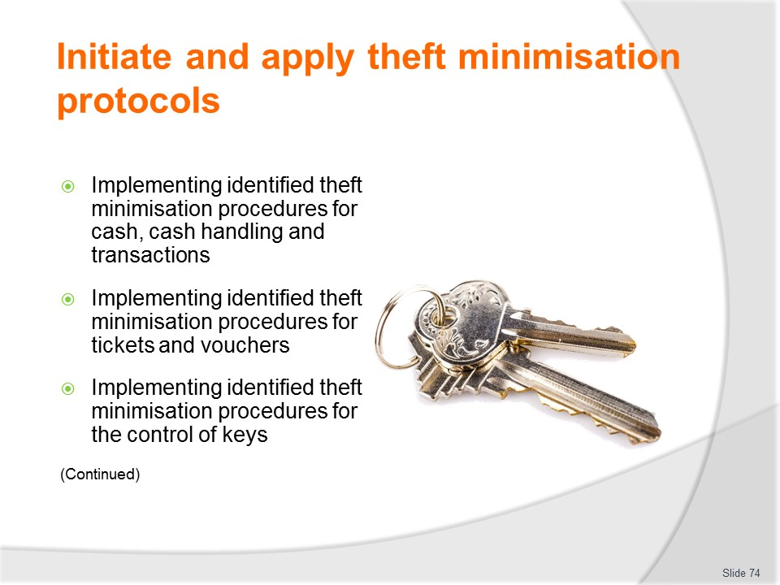
Slide No | Trainer Notes
Trainer continues advising about implementation of theft minimisation protocols:
Implementing identified theft minimisation procedures for cash, cash handling and transactions
- Never leaving any cash register unattended
- Always locking the cash register with the key when the register is not in use
- Never leaving the cash drawer in the register and locking the cash register at night
- Obtaining internal training on the operation of workplace registers
- Nominating (saying ‘out loud’) the money given you by customers when a cash payment is received
- Count out change into the customers hand
- Learning the SOPs which apply to all cash handling and transactions
- Counting all monies received – from customers and from other staff or management
- Protecting cash as a valuable asset and tempting target for thieves
- Completing internal paperwork when requesting change for register and/or when reconciling at the end-of-trade
- Counting daily takings out of public view and in a secure location
- Never discussing takings of the business with anyone outside the business
- Following house procedures for banking and transporting cash
- Securing cash in a safe when it is not in a register.
Implementing identified theft minimisation procedures for tickets and vouchers
- Recording identifying numbers/codes of all tickets and vouchers
- Treating tickets/vouchers as tempting targets: to many, they are the same as cash
- Participating in necessary training
- Recording required detail of all tickets and vouchers which are sold/processed
- Retaining unused tickets and vouchers in a secure location
- Removing tickets and vouchers to a safe at the end-of-trade
- Verifying validity and legitimacy of all tickets and vouchers tendered as payment or part-payment.
Implementing identified theft minimisation procedures for the control of keys
- Signing keys out at start-of-shift
- Never lending keys to anyone – without exception
- Returning keys at the end-of-shift
- Not using keys to open secure ore restricted locations for members of the public
- Storing keys in a key safe when not in use
- Completing ‘key register’ when taking and returning keys
- Keeping keys allocated to you securely on your person
- Never copying keys belonging to the business.
Class Activity n- Question and Answer/Discussion session
Trainer asks students to identify/describe actions to take to implement protocols listed on the slide and uses dot points above to check and/or provide answers.

Slide
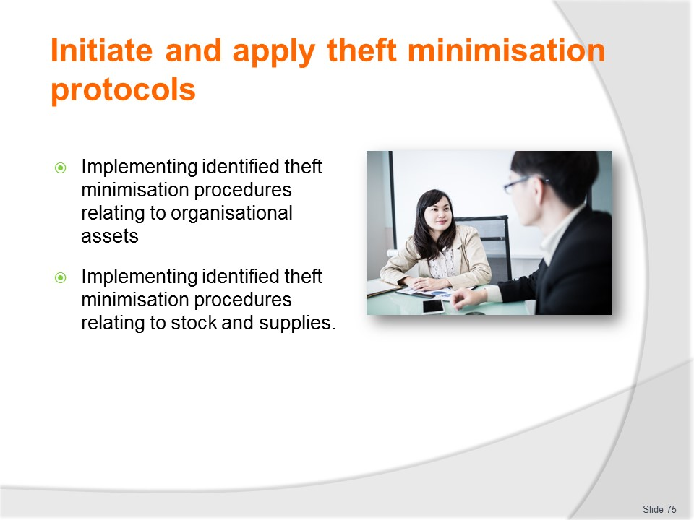
Slide No | Trainer Notes
Trainer continues advising about implementation of theft minimisation protocols:
Implementing identified theft minimisation procedures relating to organisational assets
- Learning what the business allows staff to do/use in relation to organisational assets and resources
- Never using business assets for personal gain
- Not stealing company assets or resources
- Maintaining asset registers of organisational assets
- Reporting damage to, or disappearance of, company assets
- Controlling public access to workplace assets
- Completing necessary documentation when there is a need to acquire or use workplace assets
- Never lending company assets to others
- Checking bags/vehicles leaving the business to deter and identify theft
- Actively monitor (‘keep an eye on’) all assets.

Implementing identified theft minimisation procedures relating to stock and supplies
- Securing all deliveries/supplies when they arrive and not leaving then ‘lying around’
- Not allowing customers/members of the public into the stores areas
- Storing stock in designated locations for each item as appropriate
- Making sure the appropriate paperwork (such as requisitions) are completed for all items taken out of the stores area
- Not using workplace stock and supplies for personal or private purposes
- Checking locks on doors and windows leading into stores areas
- Monitoring store room activity to identify breaches of security
- Conducting stock-takes and other stock control activities as required at the nominated times
- Actively managing stock
- Maintaining required workplace documentation to record and track use and movement of stock.
Class Activity – Question and Answer/Discussion session
Trainer asks students to identify/describe actions to take to implement protocols listed on the slide and uses dot points above to check and/or provide answers.

Slide
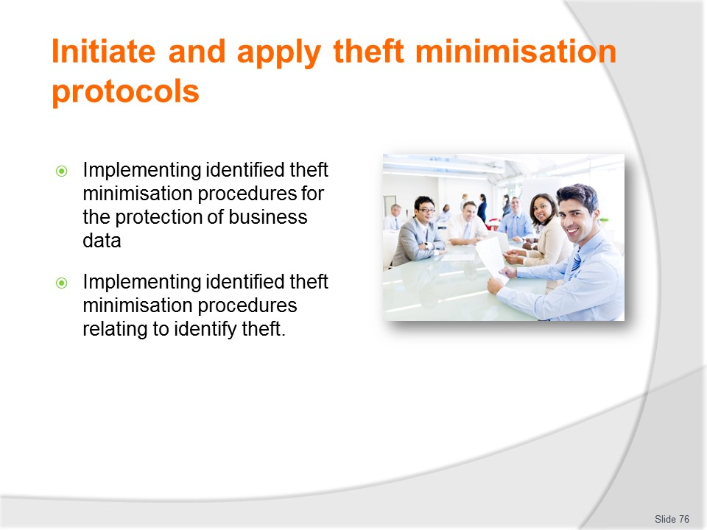
Slide No | Trainer Notes
Trainer continues advising about implementation of theft minimisation protocols:
Implementing identified theft minimisation procedures for the protection of business data
- Protecting internal business documents and data from the sight of customers or members of the public
- Never disclosing business information to anyone
- Maintaining confidentialities
- Closing computers/monitors when not in use
- Positioning screens and documents so they cannot be seen by customers or members of the public
- Using password protection and username protocols
- Using and updating anti-virus and computer protection software
- Changing passwords and usernames on a regular basis
- Not allowing others to use your password or username
- Not using business information/knowledge for personal gain.
Implementing identified theft minimisation procedures relating to identify theft
- Never disclosing internal codes or passwords to outsiders
- Controlling access to internal identity data
- Using authentication controls approved by the business
- Not responding to unsolicited emails requesting nominated information – such as bank details, account types and numbers, passwords, codes
- Creating powerful passwords to protect identity and access
- Not opening emails from unknown sources
- Using encryption technology (SSL and TSL)
- Monitoring business documents and banking on a regular/at least daily basis – so identity theft can be quickly identified if it occurs
- Following the prepared security strategy as developed for the workplace
- Reporting and cancelling lost credit cards (and similar) immediately
- Reporting suspicions regarding identity theft at the earliest opportunity.
Class Activity – Question and Answer/Discussion session
Trainer asks students to identify/describe actions to take to implement protocols listed on the slide and uses dot points above to check and/or provide answers.

Slide
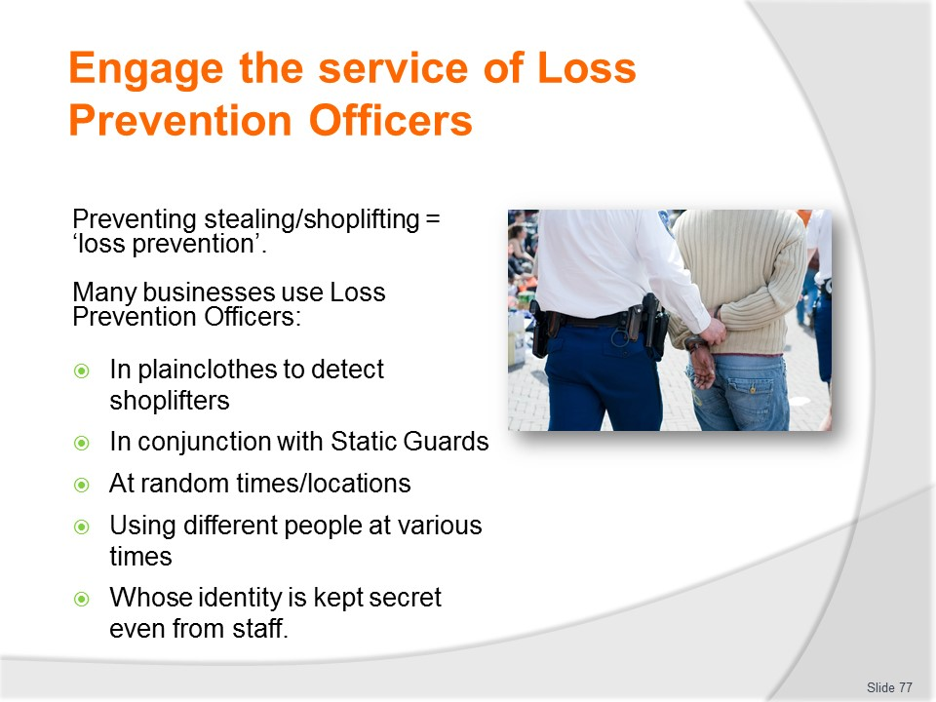
Slide No | Trainer Notes
Trainer discusses loss prevention and the role of Loss Prevention Officers:
- Preventing stealing/shoplifting is called ‘loss prevention’
- One method of dealing with theft is to use Loss Prevention Officers to patrol the premises in plain clothes to detect shoplifters
- LPOs are often used in combination with Static Guards
- Their role also includes identification of internal theft (that is, theft by staff, suppliers, and contractors) as well as by customers who are in the business
- Loss Prevention Officers are ‘plain clothes’ security people who commonly attend the premises (disguised as customers or as staff at the workplace) and focus on identifying shoplifters or thieves
- They may attend only one or two hours per day on a regular basis, at certain nominated times when theft is anticipated, or at random times
- The individual used for the role of LPO may also vary from day-to-day/over time to avoid easy identification of who is a Loss Prevention Officer, and to reduce the chance a thief will identify them and their role
- These officers may be employed directly by the business itself, or most commonly be engaged from a local security service
- Where LPOs are engaged from an external company you will not be introduced to them, as efforts are commonly made to keep their identity secret
- Loss Prevention Officers may also be integrated into normal workplace staff (that is, rostered to work as part of the normal roster) where the business believes they have identified staff stealing but need to gather more evidence about what is going on and who is involved.
Class Activity – Guest Speaker
Trainer arranges for an LPO to attend and describe and discuss their role with students explaining what they do and how they do it.

Slide
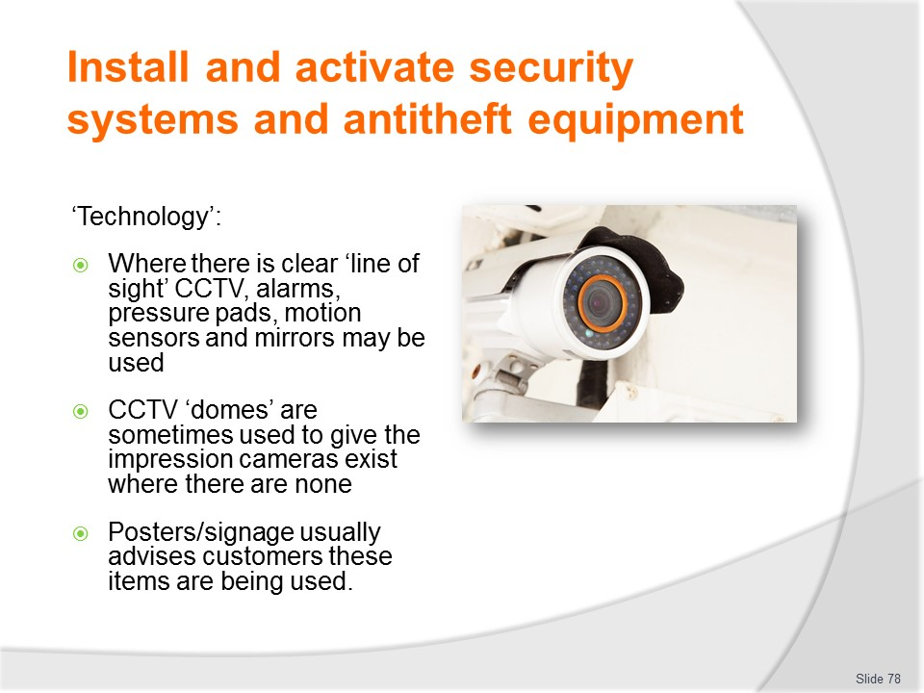
Slide No | Trainer Notes
Trainer discusses ‘Technology’ stating:
- Where a clear line-of-sight is unable to be maintained, technology in the form of surveillance cameras, alarms, pressure pads, motion sensors and mirrors may be employed to monitor activities and customers.
- In addition, it is advisable to publicly highlight the security devices and measures that are in place in the business: signs are a common way of letting customers know stock is being protected and the place is being proactive in dealing with shoplifting.
- High visibility positioning of cameras, or CCTV (Closed Circuit Television) domes, are another way – many of the CCTV domes are fake, but the customers rarely know this (or know which are bogus and which are real).
Class Activity – Guest Speaker
Trainer arranges Guest Speaker to talk t students about benefits of items listed on slide, and discuss installation, activation and operational protocols.

Slide
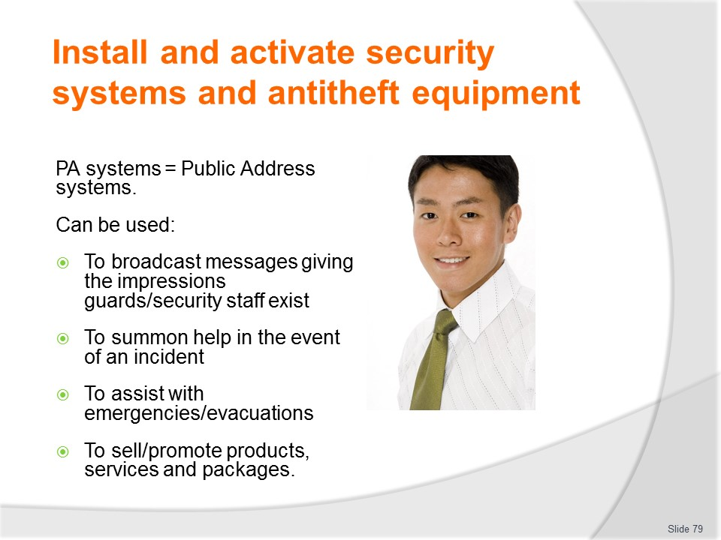
Slide No | Trainer Notes
Trainer explains about using ‘Public address systems’:
- Some environments regularly announce ‘bogus’ messages over their PA system for this very reason, ‘Security to Section C, Security to Section C, please.’
- This is simply designed to give those in the building the impression there are security staff present within the building when there probably are not
- It is all part of the Deter phase.

Slide
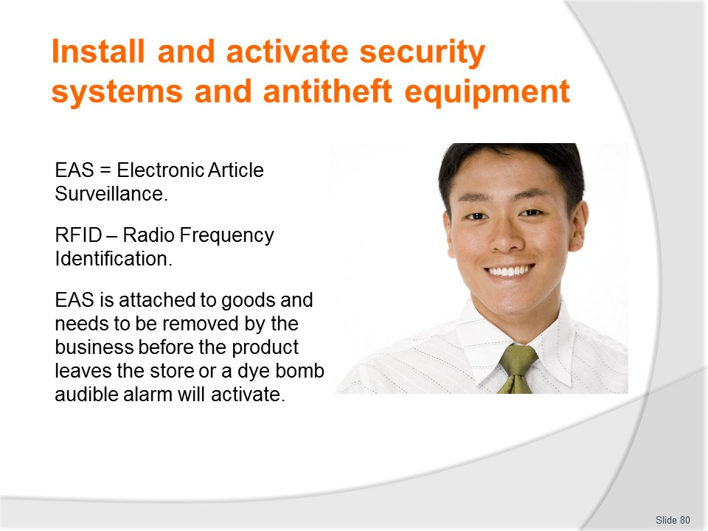
Slide No | Trainer Notes
Trainer talks about Electronic Article Surveillance:
- In addition, a variation is to attach electronic article surveillance (EAS) devices to items (colour dyes/bombs, RFID [Radio Frequency Identification] devices): while these – depending on the system used – may not prevent the theft of the article, they will deny the thief use of the product by making it unusable or ‘painting’ it so it is obvious what has happened when the thief tries to remove the security.tag/device
- Some systems will issue an audible alarm if the article is not de-sensitised (or de-activated) by the sales assistant as customers leave the business.
Class Activity – Guest Speaker
Trainer arranges Guest Speaker to talk t students about benefits of items listed on slide, and discuss installation, activation and operational protocols.

Slide
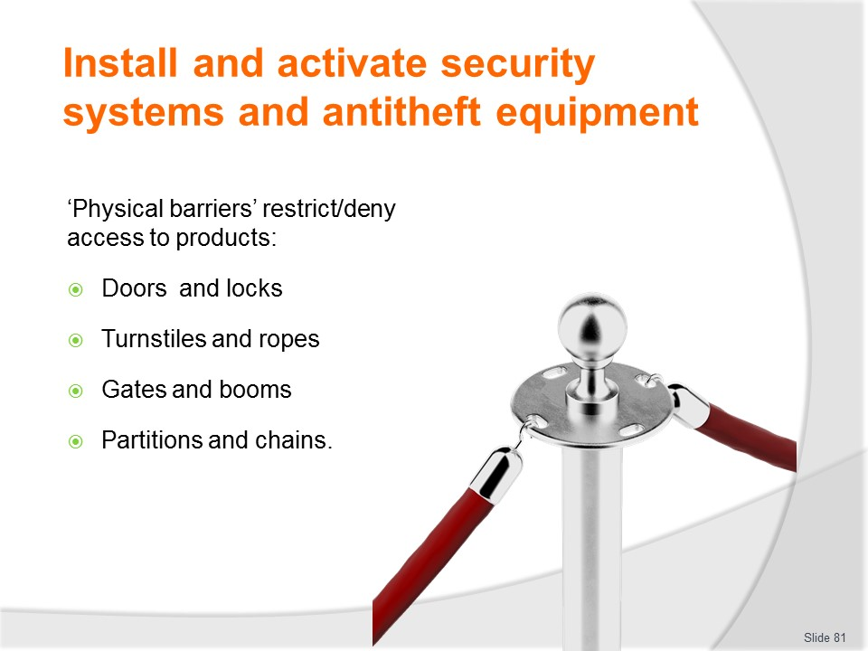
Slide No | Trainer Notes
Trainer presents information on use of physical barriers:
- A further method of denying access to products is to physically restrict access to certain areas: for example
- In many businesses it is common for customers not to be allowed in areas such as the storage area, offices, delivery bays and other back-of-house areas, and some form of signage coupled with a physical barrier usually accomplishes this job quite well
- Physical barriers can include:
- Doors
- Locks
- Turnstiles
- Booms
- Gates
- Partitions
- Races
- Chains.
- Physical barriers may be supplemented by audible alarms.

Slide
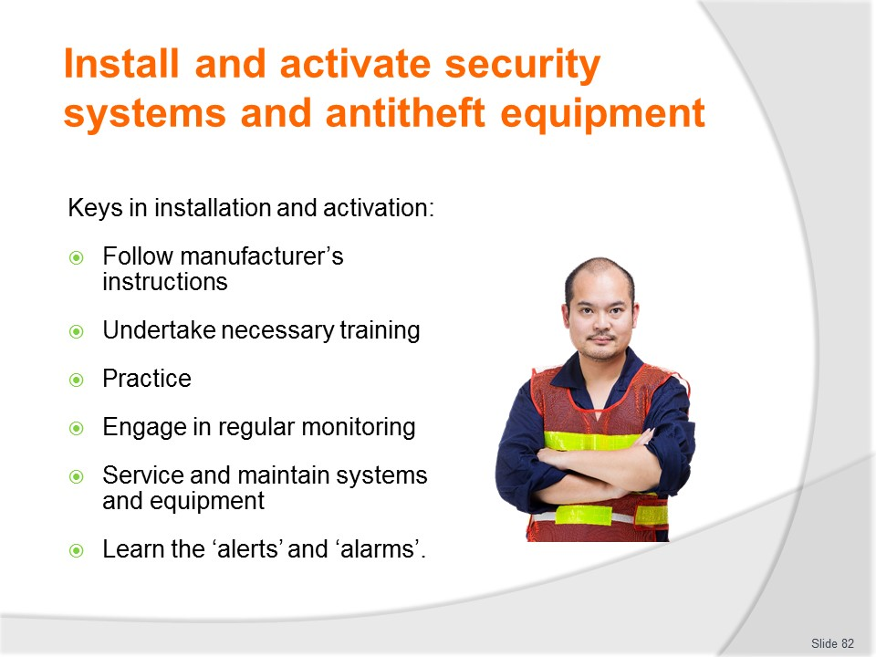
Slide No | Trainer Notes
Trainer presents keys in installing and activating items stating the following are essential:
- Follow manufacturer/supplier instructions for installation, commissioning and use of the items
- Undertake necessary on-the-job training to ensure competency with use of every item
- Practice with each resource to gain experience and confidence with using items, responding to alarms and alerts and implementing follow-up action
- Being fully aware there is a need to monitor all security systems and anti-theft devices – just having them in place will not necessarily result in a reduction in workplace theft
- Providing required service and maintenance to every system and device
- Knowing exactly what alerts and alarms (audible and visible) mean, and knowing exactly what action should be taken in response to each one.
Class Activity – Excursion
Trainer arranges excursion for students to view use of security/anti-theft systems, devices and equipment in business.

Slide
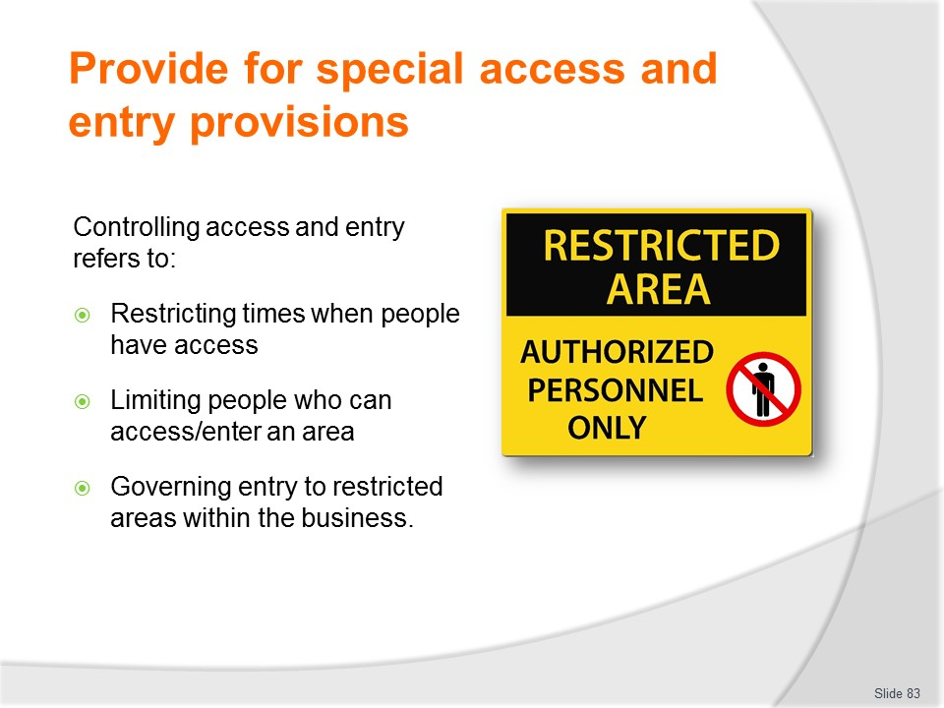
Slide No | Trainer Notes
Trainer explains protocols commonly apply to control access and entry to an organisation or area. In this context, ‘control’ refers to:
- Restricting times people may access to areas
- Limiting the persons who are authorised to enter areas
- Governing those who are given permission to enter restricted areas through the implementation of internal controls.

Slide
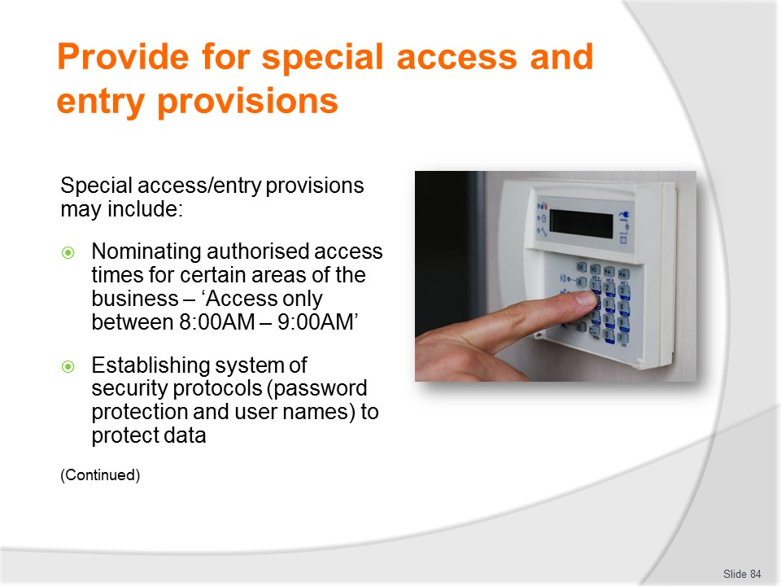
Slide No | Trainer Notes
Trainer explains in practice, these special access and entry provisions may include:
- Nominating authorised access times for specified areas – as opposed to allowing access to all areas at any time. Applying limited access times means:
- Management or security staff can moiré easily monitor activities in those areas
- Anyone found in those areas outside of the prescribed times is not authorised to be there and should be appropriately investigated
- Establishing security protocols (such as password protection and use of usernames) to control staff access to information and files – this will:
- Prevent members of the public from accessing confidential and private files and information
- Control which staff have access to certain types/classifications of business data and information
- Record staff use of databases and computers – because most computer security protocols will include a file which records who accessed which files/data, when they accessed it, how long they were there, and what they did when they were there.

Slide
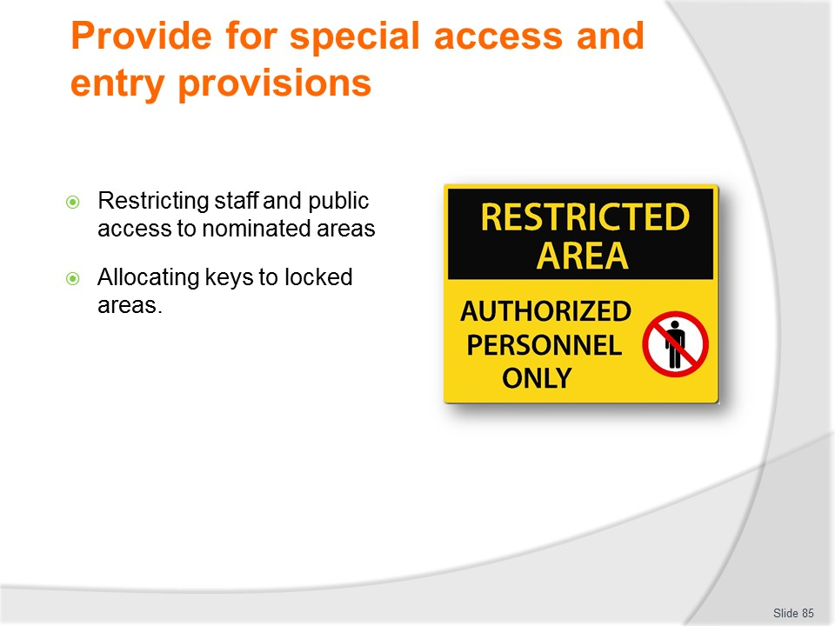
Slide No | Trainer Notes
Trainer continues giving examples of special access and entry provisions:
- Restricting staff and public access to nominated areas – in essence this will entail;
- Prohibiting members of the public from entering back-of-house areas
- Posting signage (‘Staff Only’, ‘Authorised Entry Only’) explaining where members of the public (customers and guests) are not authorised/allowed to enter
- Applying approved protocols to enable nominated persons to access normally prohibited areas – these protocols will be needed to allow delivery drivers, service technicians and authorised visitors to enter areas which are normally classified as ‘off limits’.
- Common protocols can include:
- Recording name and time of entry and departure in a log/register
- Recording approved ‘proof of identify’ for each person
- Accompanying all such persons while they are in the business
- Allocating keys to locked areas – meaning standard key control protocols are implemented:
- Only releasing keys to authorised staff
- Requiring keys to be signed ‘out’ – by day/date and time
- Requiring keys to be signed back ‘in’ – by day/date and time
- Requiring reason for allocation of keys to be recorded.

Slide
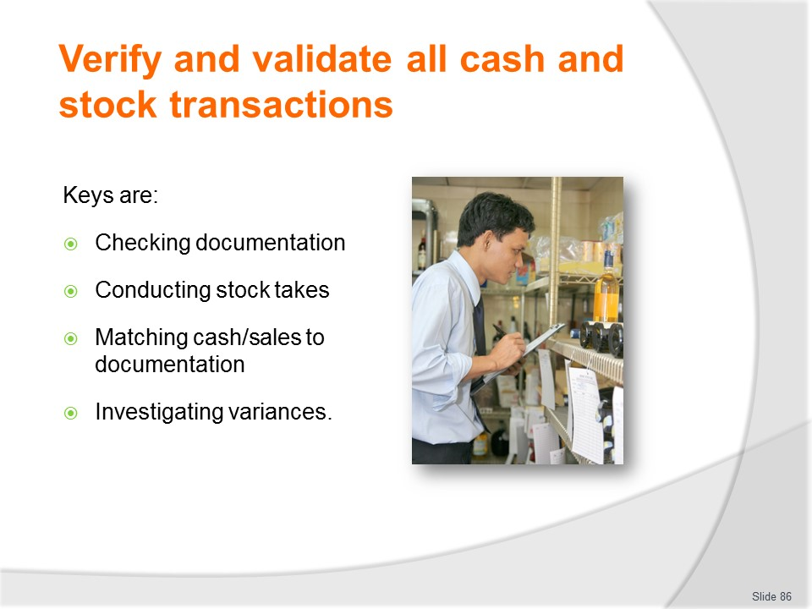
Slide No | Trainer Notes
Trainer advises the keys to verifying and validating cash and stock transactions are:
- Checking documentation
- Conducting stock takes
- Matching cash to transactions and related documentation
- Investigating variances.
Trainer reminds it is important to understanding this aspect of theft minimisation is to have a full appreciation of the ‘control cycle’ which comprises:
- Purchasing of goods and services from external suppliers
- Storage of products (and cash)
- Issuing of items (and cash)
- Production of whatever can be described as the goods and services of the business from the ‘raw materials’
- Service of the goods and services of the business to customers/guests
- Sales of goods and services.

Slide
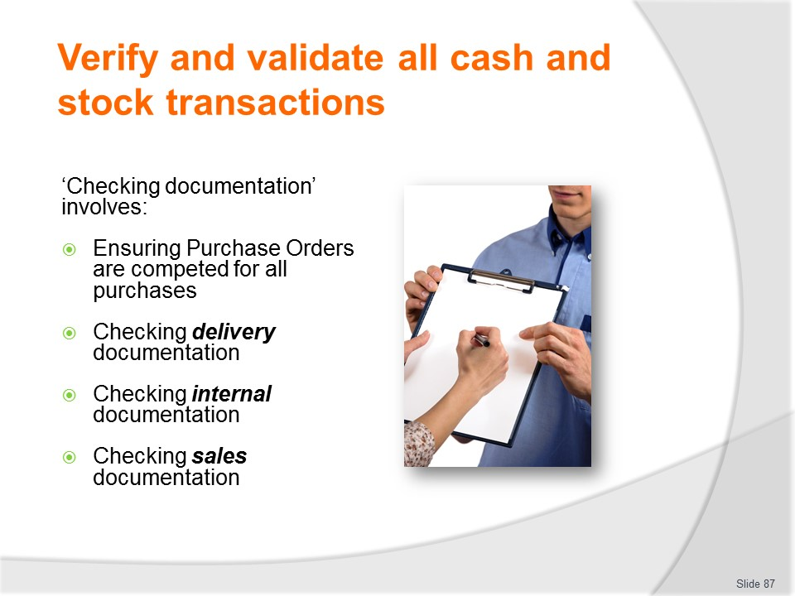
Slide No | Trainer Notes
Trainer explains ‘Checking documentation’ should address:
- Ensuring Purchase Orders are completed for all items and services required by the business
- Checking delivery documentation to ensure the business:
- Receives all the items it orders – in terms of required type, quality, size, quantity, price, brand, provider
- Only pays for the items it orders and the items it actually orders and actually receives
- Checking internal documentation – to ensure the actual stock-on-hand matches the expected level of stock-on-hand as indicated by system control
- Checking sales documentation – to ensure:
- Correct selling prices are being charged
- Discounts and other offers are being applied correctly
- Payments are being received to match sales in the methods accepted by the business in a timely manner.
Class Activity – Handouts
Trainer distributes and discusses examples of documentation identified on the slide.

Slide
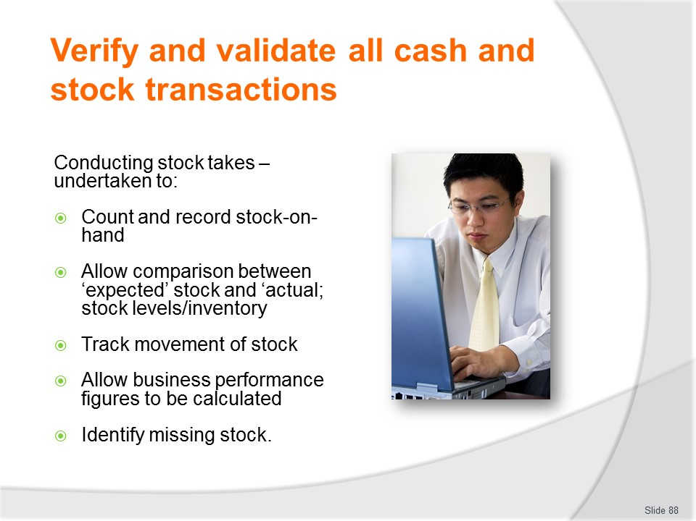
Slide No | Trainer Notes
Trainer discusses conducting stock takes:
Stock takes are conducted in order to:
- Count and record actual stock-on-hand
- Allow comparison of ‘actual’ stock-on-hand to ‘expected’ stock-on-hand as shown by internal stock control systems (electronic or manual systems)
- Track the movement of stock (by type and quantity/volume) within the business
- Form the basis of further calculations – to determine performance figures for the business
- Determine situations where stock is missing – and provide the basis for investigating what has happened to that stock (Has it been damaged and thrown out? Has it been used but not recorded? Has it been stolen?).

Slide
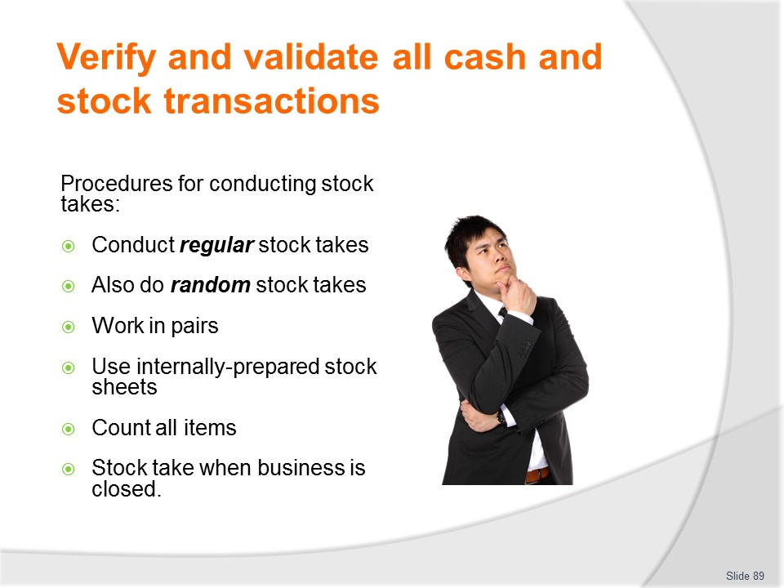
Slide No | Trainer Notes
Trainer presents details on performing stock takes stating businesses will have well established protocols for conducting stock takes in their operations – these include:
- Conducting regular stock takes – at pre-determined times such as every day, every week or every month
- Doing random stock takes at times when staff do not expect them to be conducted (in addition to the regular stock takes) – with the aim of catching out people who may be manipulating the schedule of regular stock takes to their own advantage
- Undertaking the stock take in pairs – where one person ‘counts and calls’ and the other person ‘records’.
- ‘Counting and calling’ refers to the process of counting the stock items on-hand and calling out the number present to the second person who then ‘records’ this number on the stock take sheet
- Using stock take sheets generated by the business – as the basis for recording the items counted during the stock take
- Counting and recording all items identified during the stock taken – even if they are not listed on the stock take sheets
- Performing the stock take when the business is closed – so items are not being used/decremented from stock during the stock take process: this often means doing the stock take early in the morning, late at night or on days when the business is normally closed.
Class Activity – Demonstration and Practical Exercise
Trainer:
- Demonstrates how to perform a stock take using a student to assist with ‘counting and calling’ and recording information
- Provides opportunity for students to practice conducting stock take.

Slide
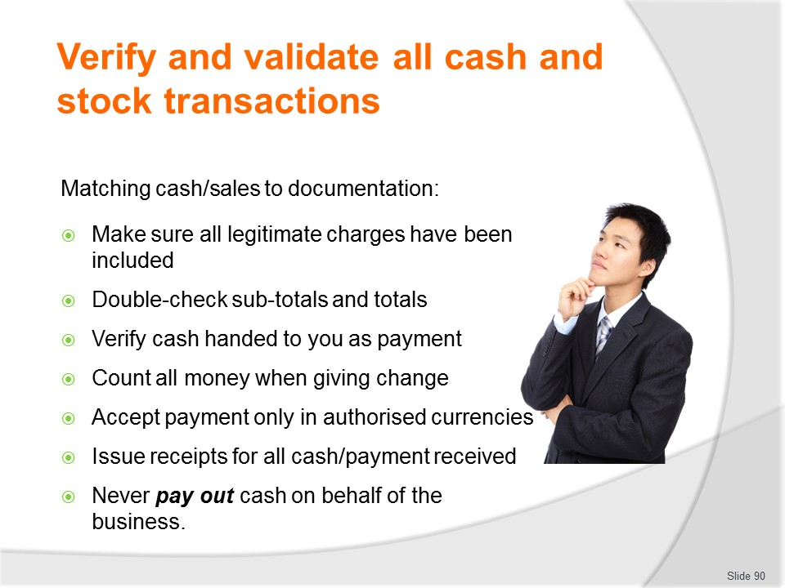
Slide No | Trainer Notes
Trainer advises practices to establish and follow in relation to matching cash/sales to documentation include:
- Double-check charges – to ensure all legitimate charges have been included
- Verify totals – double-check taxes, fees, commissions, sub-totals and totals
- Check/count all cash handed to you in payment for goods and services – state/repeat back to the customer the amount tendered to avoid error
- Count out all change given to customers – to avoid giving incorrect change
- Only accept payment in currencies authorised by the business – there may be a ban on certain currencies
- Issue receipts for all payment received – without exception
- Never pay out any cash on behalf of the business – unless specifically authorised to do so: always get a receipt for any monies paid out.
Class Activity – Practical Exercise
Trainer distributes range of internal documents with deliberate errors on them and asks students to verify and validate them identifying all errors and omissions.

Slide
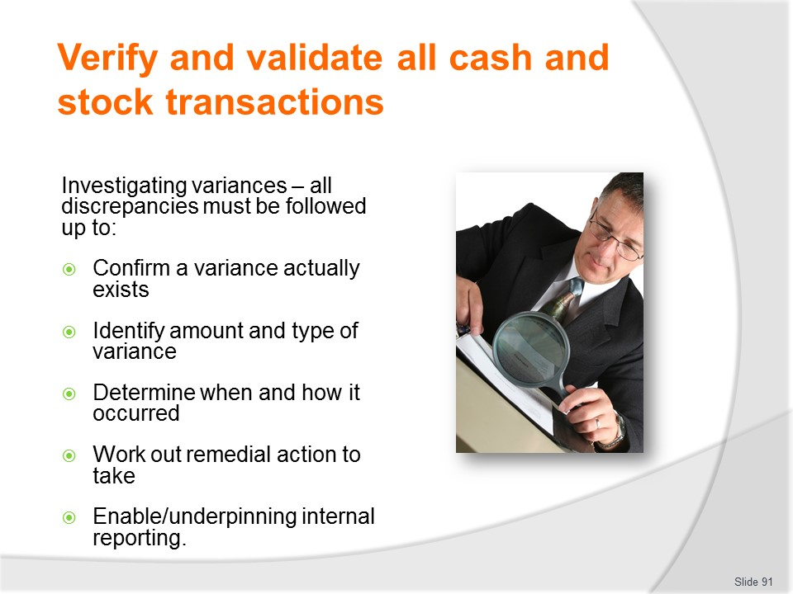
Slide No | Trainer Notes
Trainer discusses investigating variances observing:
- Variances can occur in relation to money and stock.
- They are also known as ‘discrepancies’.
- You must always investigate variances to:
- Confirm a variance exists – and you have not made a mistake or simply overlooked something
- Identify the amount and type of the variance
- Determine when and how it occurred
- Work out the action to take to resolve the situation – and prevent recurrence
- Enable an internal report to be made regarding the situation.
Class Activity – Guest Speaker
Trainer arranges Guest Speaker to talk to students about protocols used in their workplace to verify and validate sales/transactions and provide advice in relation to establishing and implementing same, and regarding general theft minimisation protocols in general

Slide
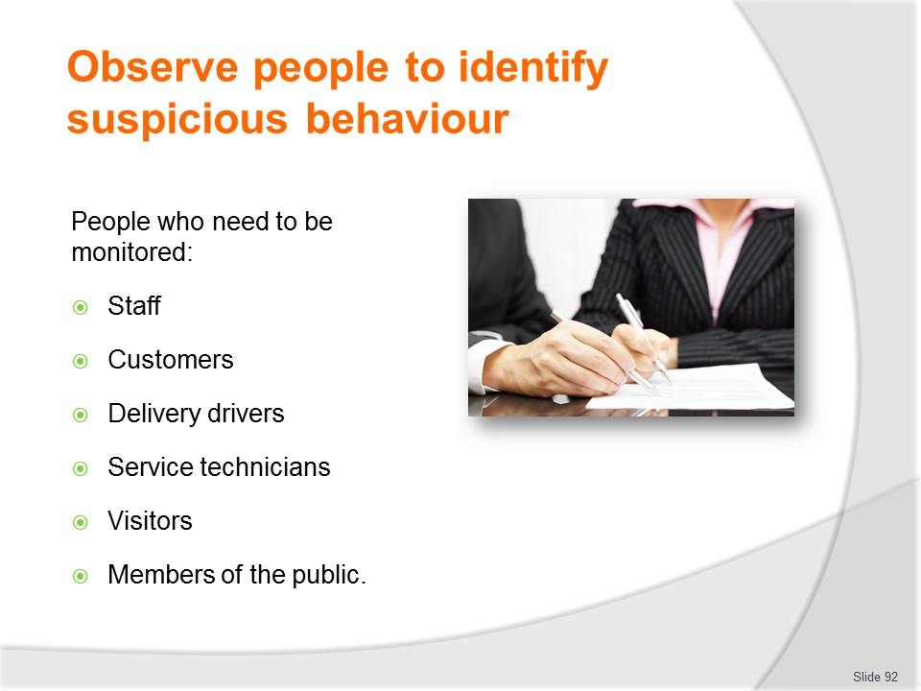
Slide No | Trainer Notes
Trainer states observing people relates to the monitoring of:
- Staff
- Customers/guests
- Delivery drivers
- Service technicians
- Visitors
- Members of the public.
All these categories need to be monitored as they are all potential loss sources.
This highlights (again) the need to focus on the potential for internal and external theft.

Slide
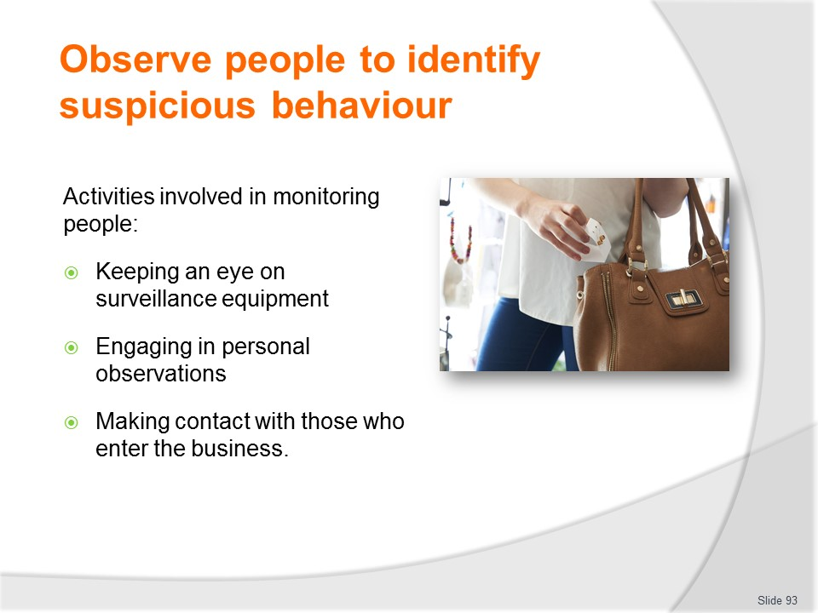
Slide No | Trainer Notes
Trainer identifies activities involved in observing /monitoring of people:
- Monitoring of surveillance equipment – which should include:
- Watching screens connected to CCTV cameras
- Checking mirrors to view hidden areas
- Listening for audible alarms – such as sirens
- Looking for visual alerts produced by security systems – such as flashing lights on consoles and strobe lights on ceilings or walls
- Integrating personal observations with data from security systems and surveillance equipment
- Assimilating personal experiences (past experiences, hunches, feelings and perceptions) with information provided by security systems and surveillance equipment.
- Personal observations – this relates to:
- Watching people while they are in the business – to identify if they appear to be there for genuine reasons or whether they are present with criminal intent
- Paying special attention to known thieves
- Giving more attention to those who do not appear to be ‘doing business’ in the business – such as asking questions of staff; meeting and talking with staff; making a purchase
- Noting everyone who enters the workplace
- Making personal contact with all people who enter the premises – in terms of:
- Welcoming and greeting them
- Making an offer of assistance
- Demonstrating to them you know they are in the business
- Providing excellent customer service.

Slide
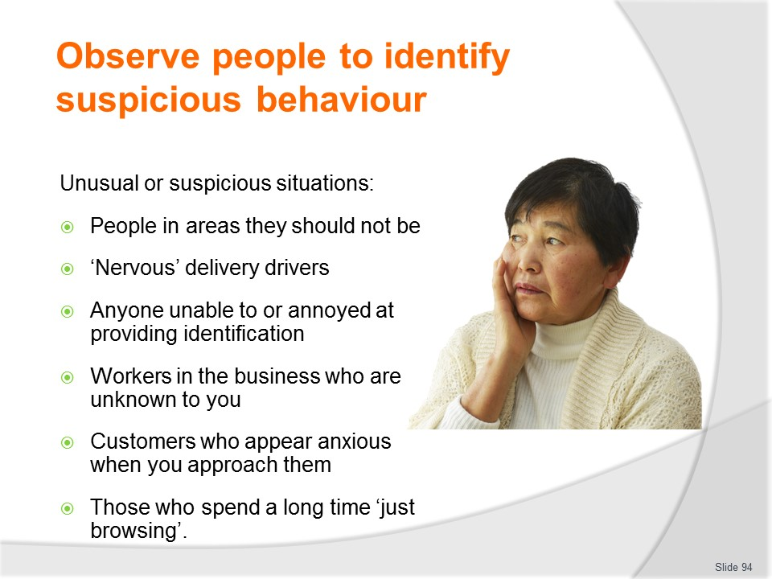
Slide No | Trainer Notes
Trainer gives examples of unusual or suspicious situations:
- The presence of people where they should not be – such as in restricted or back-of-house areas
- Drivers of delivery vehicles who get nervous when you say a vehicle search will be conducted of their vehicle before it is allowed to leave the business
- Any person who has difficulty providing proof of identify or is annoyed at having to provide it when asked to do so
- Workmen at the business in uniforms (or vehicles) not known to you – or attending to undertake some work/job you are unaware of
- Customers who appear anxious simply when you approach them or speak to them
- People who spend a long time in the one place and appear to be doing nothing but looking.

Slide
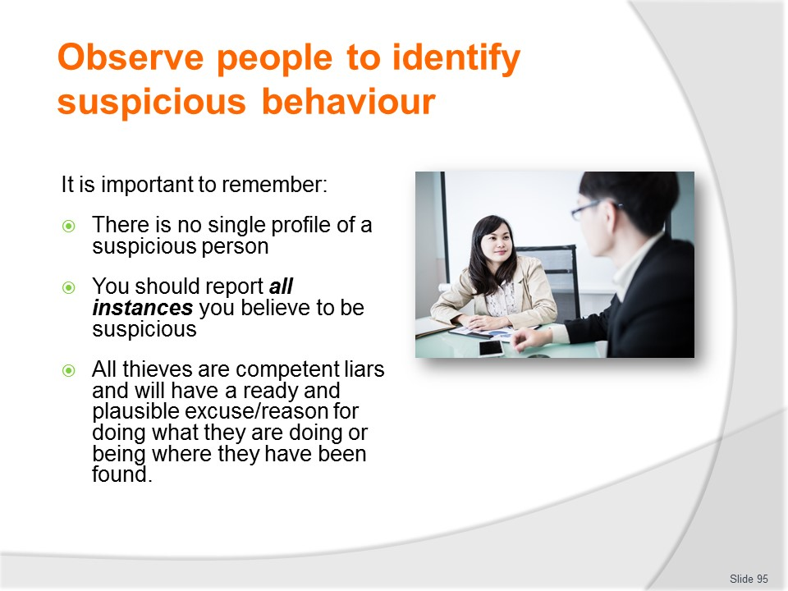
Slide No | Trainer Notes
Trainer notes when seeking to identify suspicious persons it is important to remember:
- There is no one single profile for a suspicious person – anyone can be a thief
- Always report anyone you believe to be suspicious to your supervisor or nominated person – and allow them to determine what action should be taken: never put yourself in harm’s way
- Experienced thieves always have a plausible story for why they are in an area they should not be – and why they are doing things they should not be doing: maintain your scepticism about their story until you can confirm the truth.
Class Activity – Guest Speaker
Trainer arranges Security Guard to attend and talk to students about monitoring/observing customers to identify suspicious persons/circumstances and give advice of things to look for and provide advice about action to take in response.

Slide
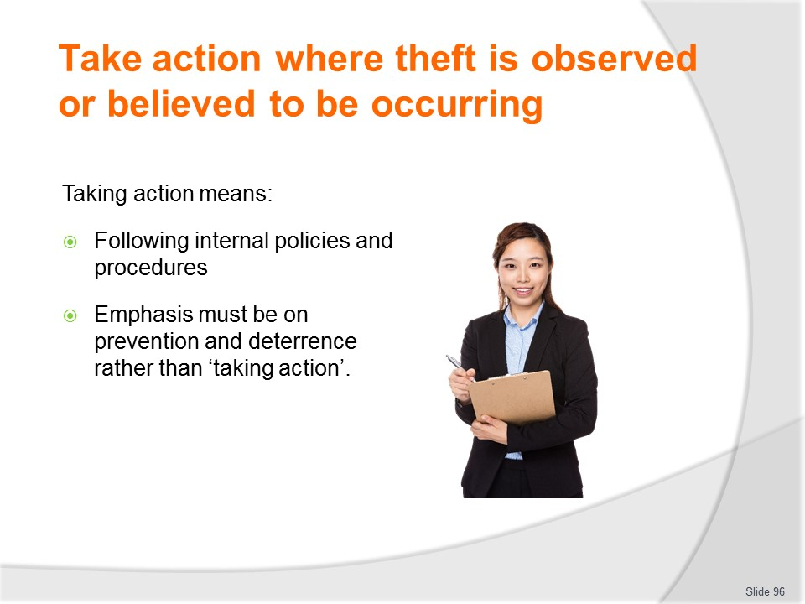
Slide No | Trainer Notes
Trainer highlights taking action means following internal policy and procedures and it is vital to follow the directions given in internal policy and procedures:
- In general terms, you should attempt to prevent (deter) shoplifting occurring in the first place, as opposed to watching/letting it happen and then trying to do something about it.
- In practice this means implementing the requirements of the established plans and procedures for theft minimisation such as:
- Ensuring security systems and anti-theft devices are fully functional
- Providing high levels of customer service
- Checking all goods are secured in accordance with SOPs
- Monitoring activities to identify suspicious behaviour or suspicious circumstances.

Slide
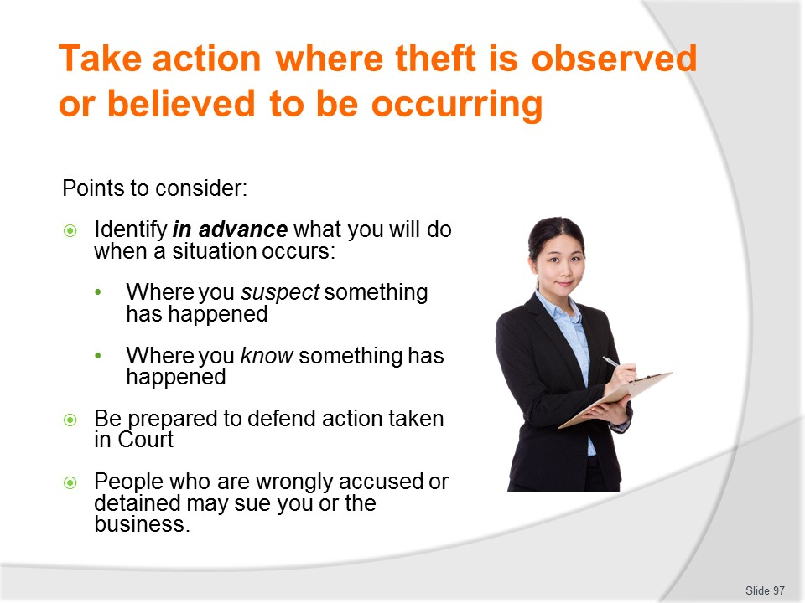
Slide No | Trainer Notes
Trainer presents points to consider in relation to ‘taking action’:
- Identify in advance what your exact response will be when you suspect someone has stolen an item – this takes the pressure off you when such a situation actually eventuates
- Identify in advance what your exact response will be when you know without any shadow of a doubt someone has stolen an item
- Realise you must be prepared to defend in a court of law any observations or opinions you form, or state, in relation to a shoplifting/stealing incident – bear in mind people are considered innocent until they are proven guilty
- People who are wrongly accused or wrongly apprehended have legal recourse and may sue you.

Slide
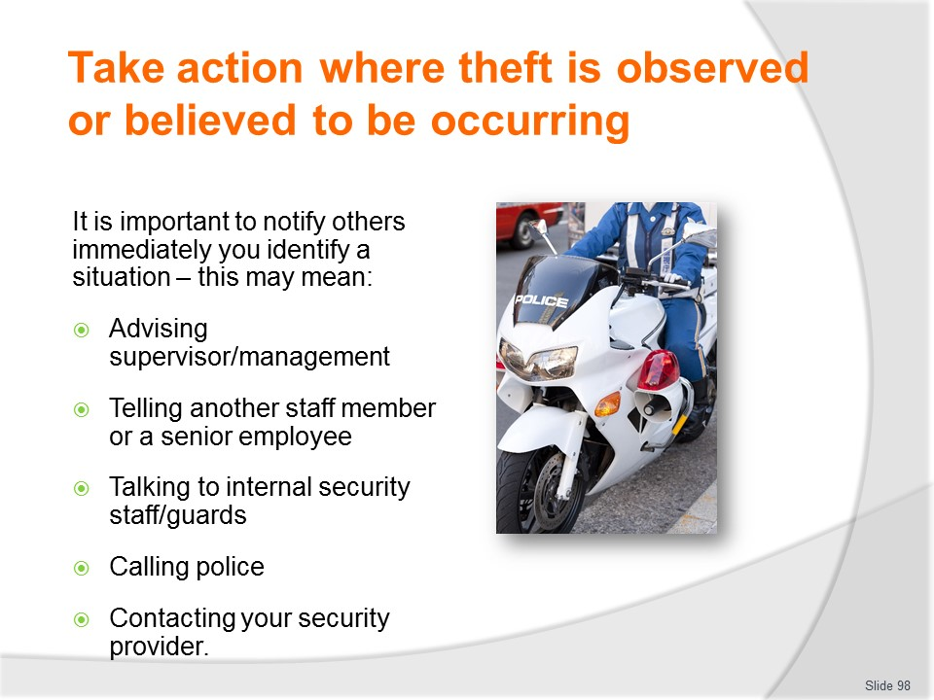
Slide No | Trainer Notes
Trainer advises standard practice is to notify a nominated person (or organisation) about beliefs or suspicions in relation to theft. This may mean:
- Contacting your supervisors and telling them what you have seen or what you suspect
- Informing a more senior member of staff
- Talking to internal security officers
- Calling the police – only if authorised to do so by internal protocols
- Placing a call to the security company what provide security for the business.
It is important you have practiced doing this so you are competent in doing it when/if the need to do so arises.
Class Activity – Guest Speaker
Trainer arranges for local police to attend and discuss and demonstrate appropriate action to take where theft is suspected or identified as having occurred.

Slide
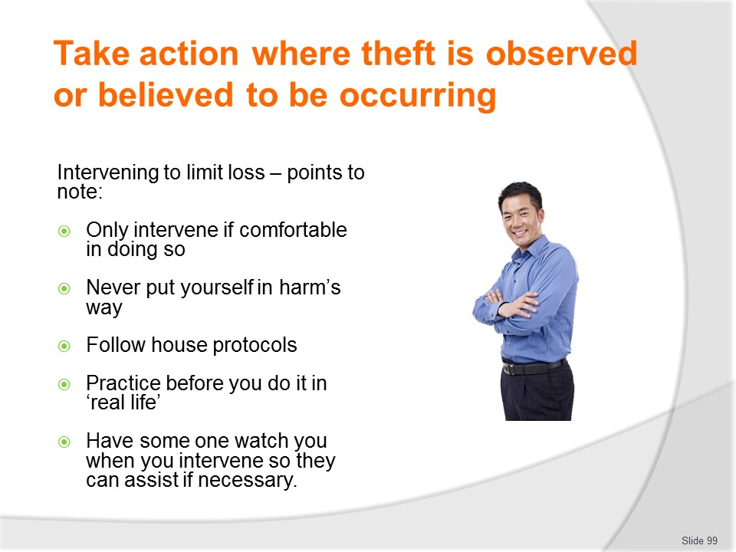
Slide No | Trainer Notes
Trainer presents strategy for intervening to limit loss and deal with shoplifting highlighting:
- Need to feel comfortable intervening/taking action
- Never jeopardise personal safety
- Adhere to internal protocols for such situations
- Make sure practice has been undertaken before taking action
- Advise others so they can monitor you and help if needed.
Class Activity – Demonstration and Role Play
Trainer uses strategy described in Trainee Manual to demonstrate how to address situation where staff know customer has taken an item, and provides opportunity for students to practice same.

Slide
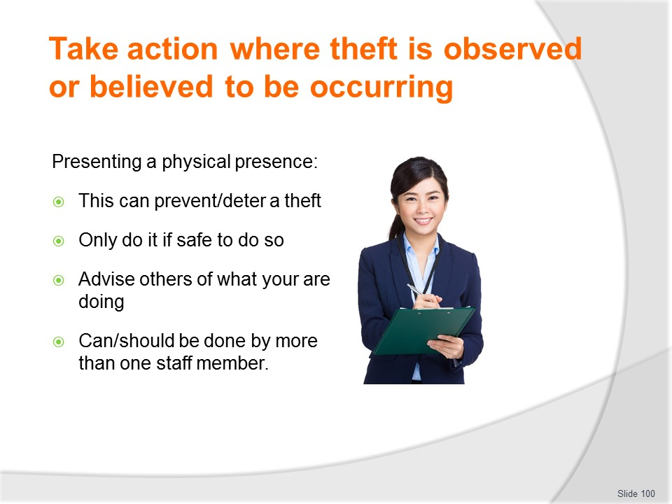
Slide No | Trainer Notes
Trainer discusses presenting a physical presence as a response to a suspicious situation stating it requires moving near to where the suspected thief is and make them aware someone is there.
- The intention is to scare them off, and/or to hope a presence prevents a theft from taking place.
- Only do this where safe to do so.
- Always advise other staff of intention to do this and always make sure support is available if needed.
- It is preferable for more than one person to provide a ‘physical presence’ as they are more of a deterrent value (i.e., show of force/numbers’).

Slide
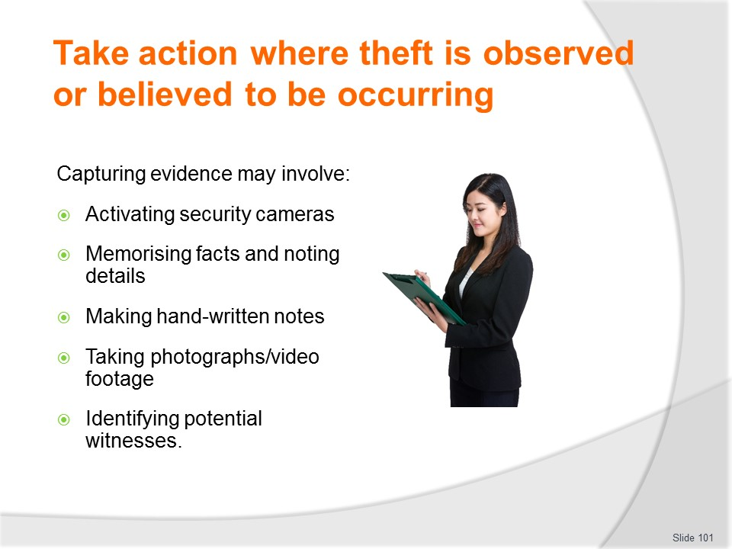
Slide No | Trainer Notes
Trainer explains need to capture evidence
- When you suspect a theft has occurred you should attempt to obtain evidence in relation to what has happened.
- This will not always be possible but you must be alert to the potential to do so.
- Capturing evidence may involve you in:
- Activating security cameras
- Memorising facts and noting details
- Recording notes about what you saw
- Taking photographs or footage with your cell phone
- Identifying other witnesses who can also provide evidence.

Slide
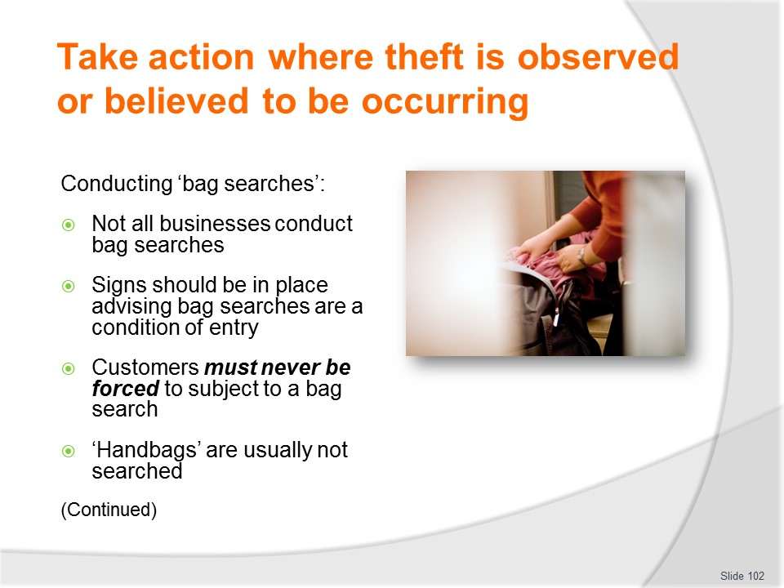
Slide No | Trainer Notes
Trainer discusses conducting bag searches:
- Some businesses undertake them and some do not. Check what applies where you work and adhere to what they say
- Where they are used the business (may) seek to check customers’ bags as they leave the business in order to deter and detect theft
- It is important the business advises customers bag checks are conducted at the site when they want to conduct such checks/searches. – The most common way of doing this is via a standard sign posted at or near the entrances.
- This sign must clearly set out the rights and obligations of both the business and the customer
- In general terms, most customers who walk into a business, enter ‘under licence’ meaning the owner can set conditions governing their entry
- One of these conditions may be – and frequently is – customers allow their bags to be searched by staff, on request
- When the customer enters a business where such signage is displayed, they are automatically agreeing to the conditions. Signs should be posted in languages reflecting the languages of the customers who frequent the business
- Even though businesses may have the legal right to search/check customers’ bags, anyone who forcibly conducts such a check/inspection may very well find themselves being charged with assault
- It is standard practice for personal handbags not to be subjected to these bag checks.

Slide
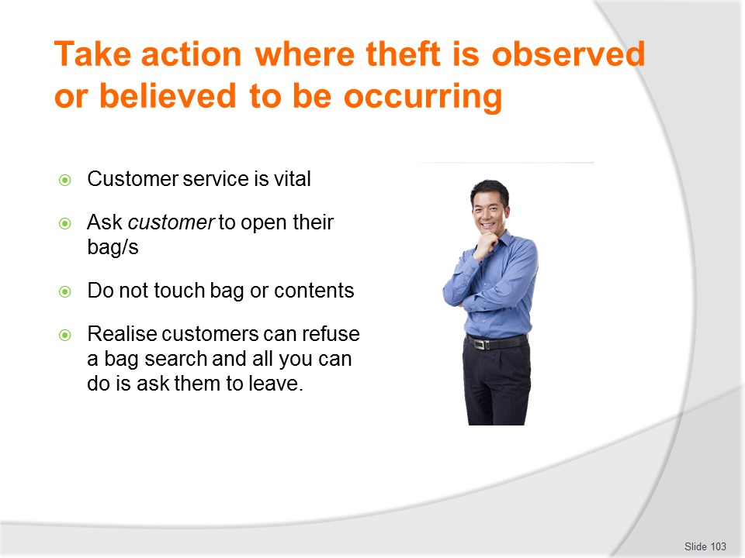
Slide No | Trainer Notes
Trainer discusses conducting bag searches:
- As with any aspect of customer service – including aspects relating to detection of theft – courtesy is paramount: not only can it help to defuse a situation, but courtesy can encourage cooperation and help avoid subsequent legal action
- When checking the customers’ bags, customers must be asked to open their bags, to avoid any physical contact by staff with the bag or its contents. Similarly, if there is something in the bag blocking your view of what is in the bag, ask the customers to move it – do not touch it yourself
- Where you touch the bag, or the obstruction in the bag, this may provide a ready-made defence to legal action: the customer can claim you placed the item in the bag when you put your hand in the bag
- Note, too, customers can refuse to have their bags inspected, in which case there is little that can be done: remember previous advice bags must not be forcibly searched
- Where a customer refuses your attempt to check their bag, all you can do is ask them to leave and not return (please check your organisational policy first, and comply with that where it differs from this advice)
- Never attempt to detain a customer just because they are refusing to have their bag inspected, unless you are 200% sure they have stolen something
- Again, you can find yourself the subject of legal action if you forcibly detain someone and they have not stolen anything
- Never get into an argument with the customer, but get help as soon as possible: get security or the manager immediately, inform them of your beliefs/suspicions and let them deal with it.
Class Activity – Demonstration and Role Play
Trainer demonstrates how to conduct a bag search and provides opportunity for students to practice same.

Slide
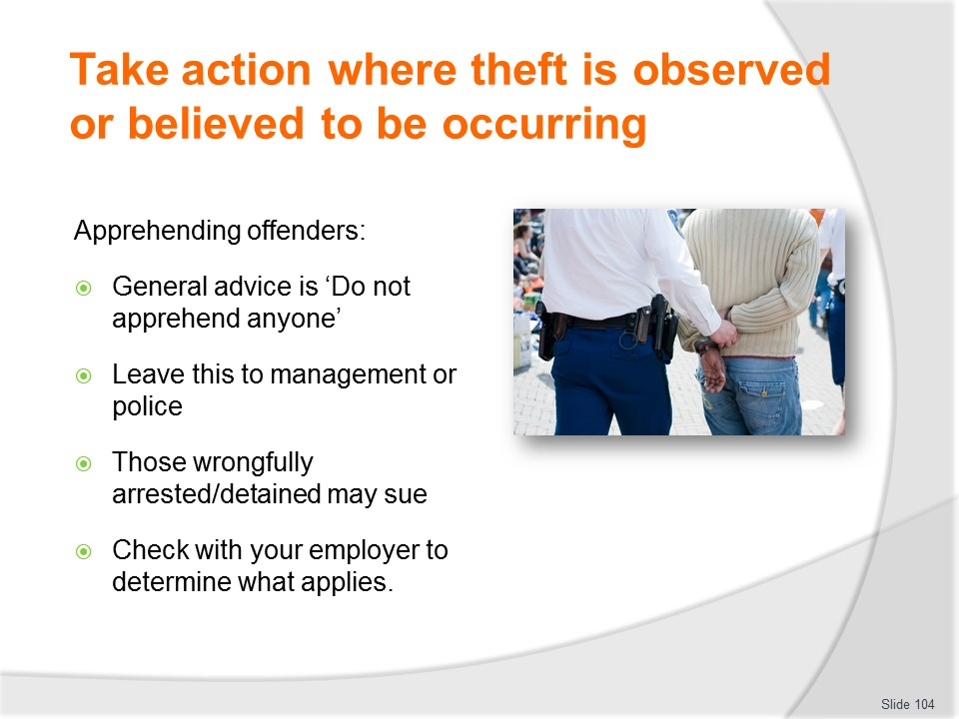
Slide No | Trainer Notes
Trainer discusses apprehension of offenders:
- The brief advice is – Don’t!
- There are too many potential problems associated with doing so.
- Let your supervisor, security staff or the police do it.
- Detaining a suspect or making a citizen’s arrest may sound fine on the television, but that is not reality.
- There is too much that can go wrong from allegations of, and the potential for, physical violence and assault through to possible legal action against you.
- Discuss this with your supervisor and be guided by them and specific organisational policy.

Slide
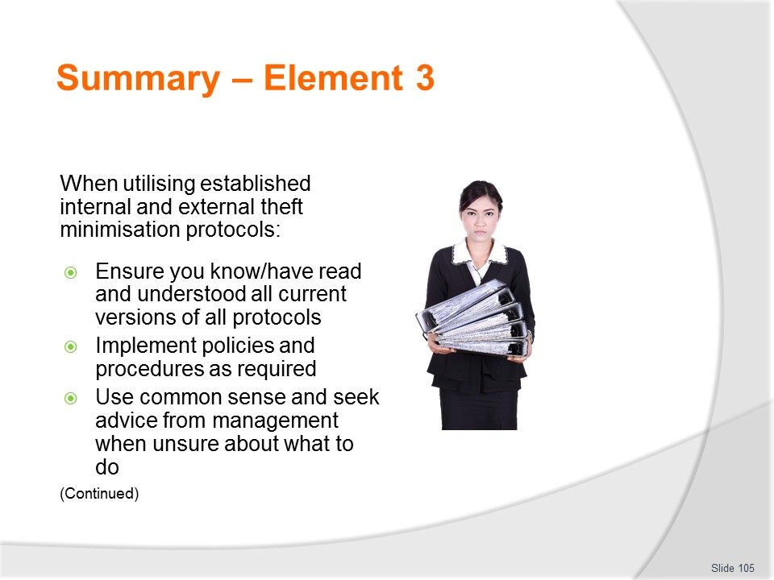
Slide No | Trainer Notes
 | Trainer provides a recap of the Element asking questions to check trainee understanding and responding to questions from trainees, as required.

Slide
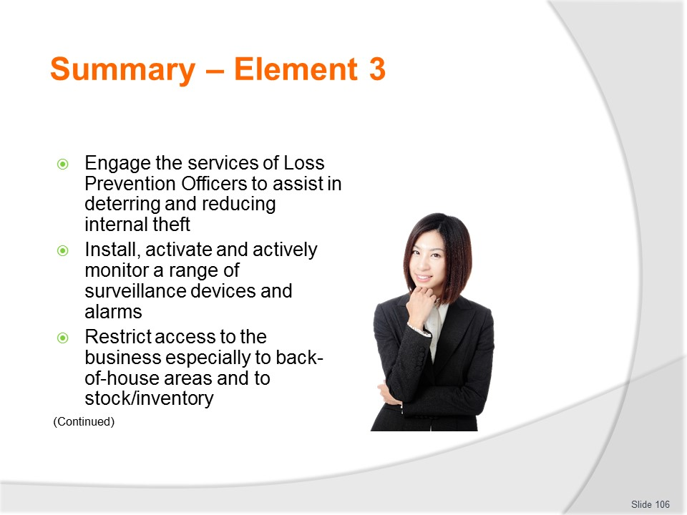
Slide No | Trainer Notes
 | Trainer provides a recap of the Element asking questions to check trainee understanding and responding to questions from trainees, as required.

Slide
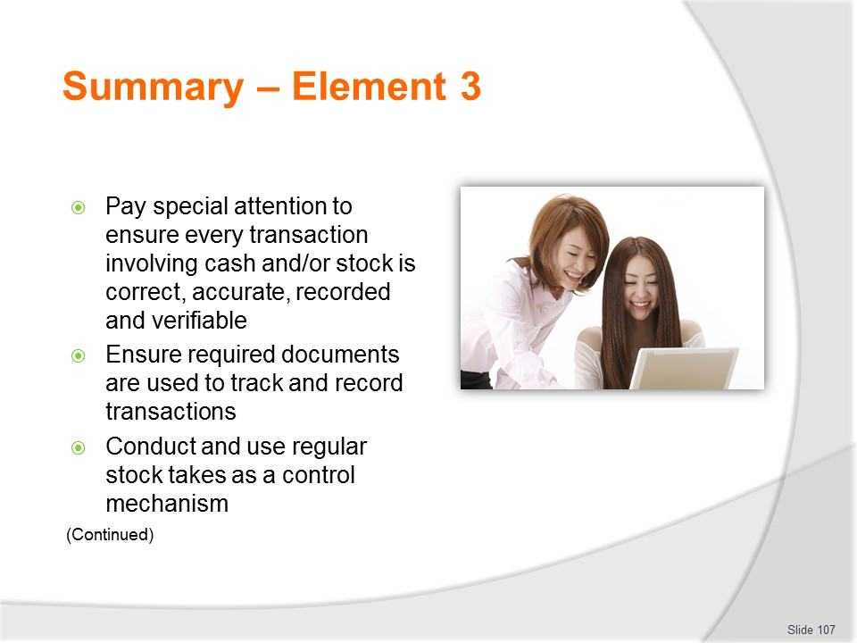
Slide No | Trainer Notes
 | Trainer provides a recap of the Element asking questions to check trainee understanding and responding to questions from trainees, as required.

Slide
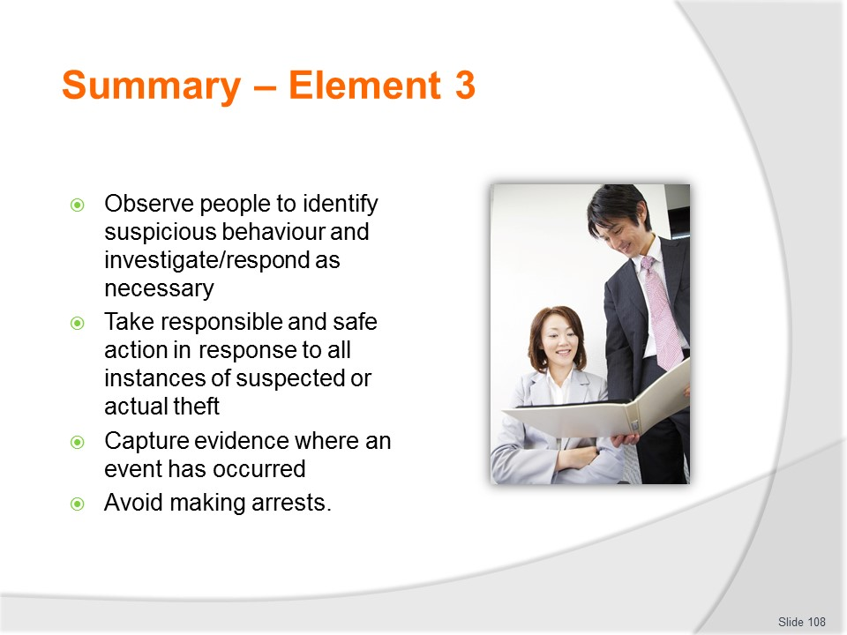
Slide No | Trainer Notes
 | Trainer provides a recap of the Element asking questions to check trainee understanding and responding to questions from trainees, as required.

Slide
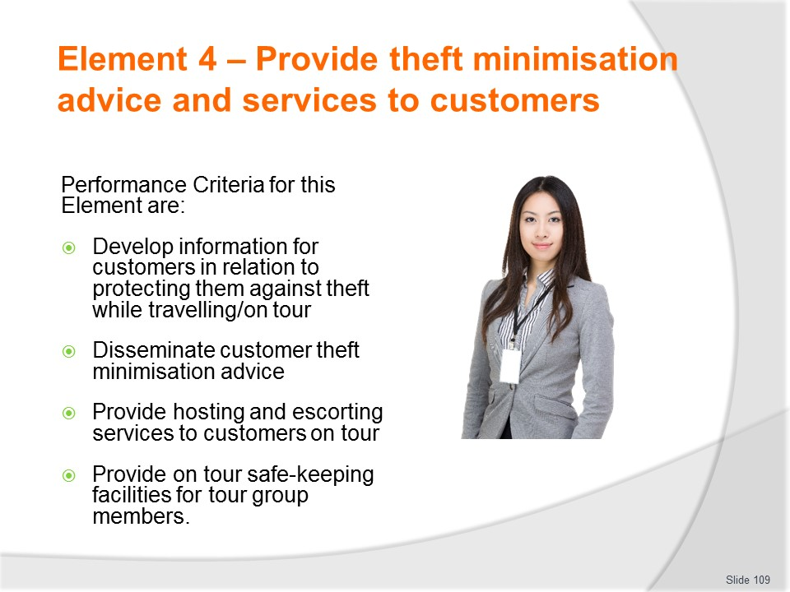
Slide No | Trainer Notes
Trainer identifies for trainees the Performance Criteria for this Element, as listed on the slide.
Class Activity – General Discussion
Trainer leads a general class discussion by asking questions such as:
- What information would you provide to customers regarding their travelling/on tour activities?
- Why would you provide this information?
- When would you provide the information?
- How would you pride this advice?

Slide
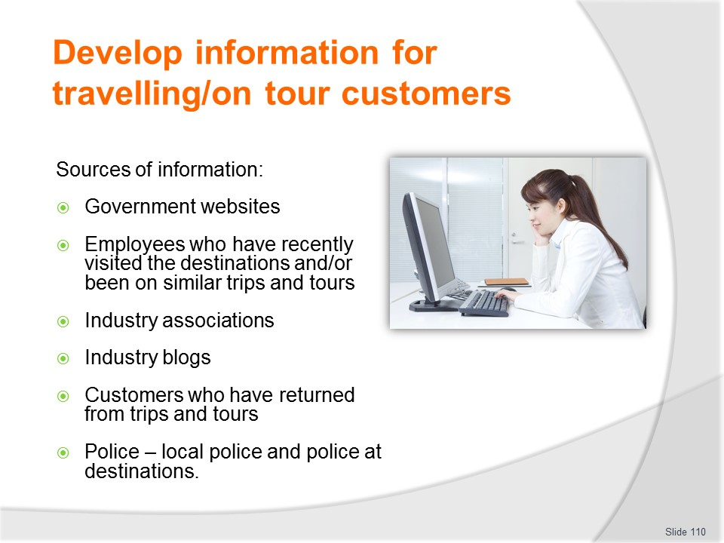
Slide No | Trainer Notes
Trainer identifies sources of information which can be used to generate information to provide to customers:
- Government websites which provide travel advice and warnings to travellers – domestic and international
- Staff from the workplace who have been on trips and tours and experienced first-hand what your customers are going to experience
- Industry associations – especially ‘alerts’ and ‘advisories’
- Industry blogs – which always seem to be able to communicate new problems, issues and scams more quickly than other mediums
- Customers who have just returned from travel, trips and tours – either through:
- Verbal feedback they provide
- Online comments they send in to your website
- Written comments they make.
- Local police and police based at destination countries//locations.
Class Activity – Internet research activity
Trainer provides computers with internet connection and provides time for students to visit relevant industry, government and public websites related to the topics relevant to source information for the provisions of advice/information to travellers.

Slide
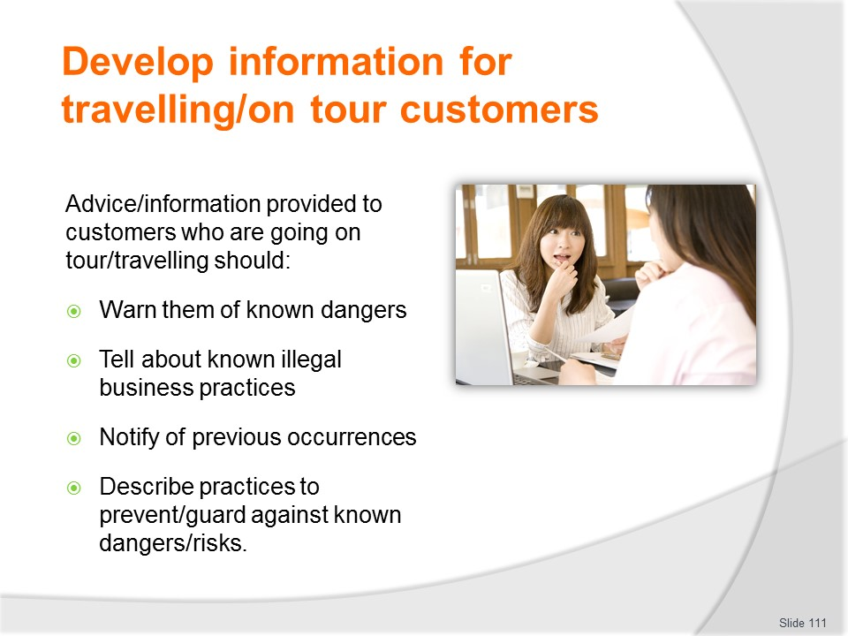
Slide No | Trainer Notes
Trainer advises in general terms advice to customers should:
- Warn them of known dangers in the areas they are visiting
- Tell them of known illegal business practices which may impact them
- Notify them of previous occurrences which have resulted in loss to customers
- Identify and describe practices and measures which can be taken to guard against known problems, threats and dangers.
In more specific terms information for customers in relation to protecting them against theft should address all the following where, as and if it is appropriate/relevant to the nature of the tour the customer is taking, the destination/s the customers are visiting and the activities they are participating in.

Slide
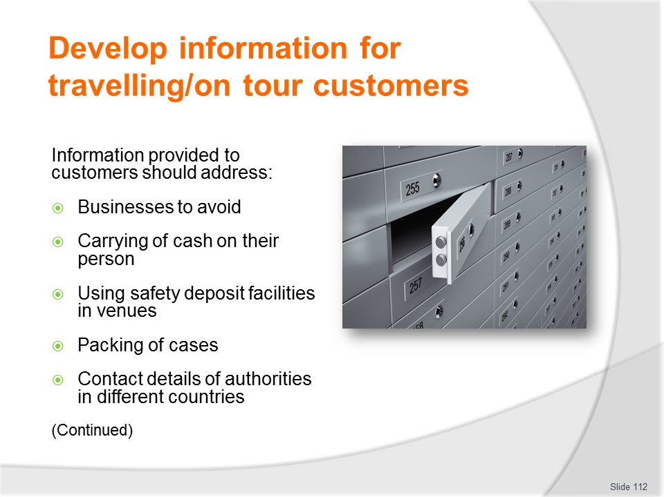
Slide No | Trainer Notes
 | Trainer gives overview of information to be given about business to avoid advising each will be covered in more detail on following slides.

Slide

Slide No | Trainer Notes
 | Trainer gives overview of information to be given about business to avoid advising each will be covered in more detail on following slides.

Slide
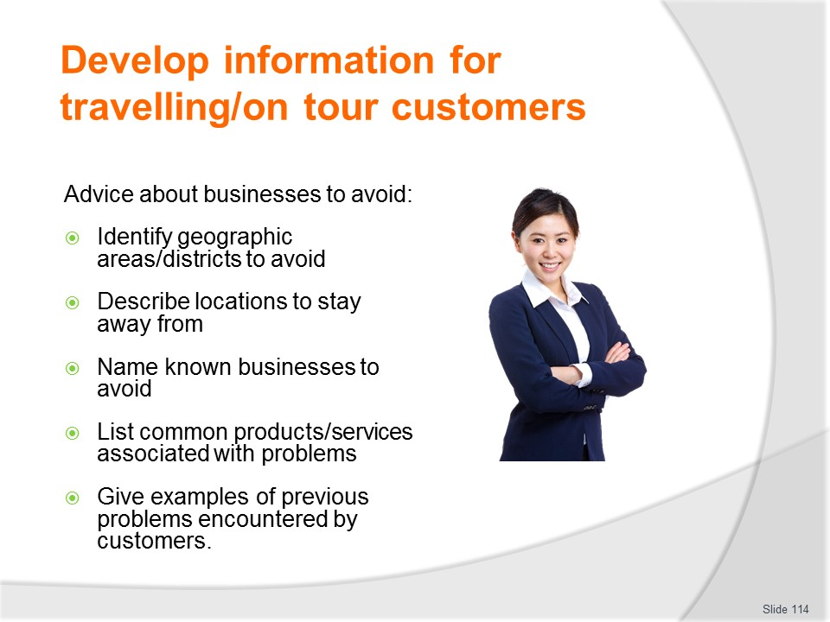
Slide No | Trainer Notes
Trainer provides information which may be given to tourists/travellers regarding businesses to avoid:
- Identify geographic regions/areas to avoid
- Describe locations to stay away from
- Name individual businesses and persons known to be associated with malpractice and theft-related activities
- List products and services which have been commonly associated with causing loss to customers (in relation, for example, fraud or theft of property occurring while customers are in the business)
- Give examples of previous problems encountered including how theft may manifest itself – such as through deception and false/misleading advertising, over-pricing [price gouging or exploitation of visitors/tourists], substitution of items after purchase [swapping the item actually purchased for an inferior product], and poor money exchange rates when customers exchange money or pay for goods/services.
Class Activity – Guest Speaker
Trainer arranges Guest Speaker form a travel/tour business to talk to students about advice they give to travellers/customers, why they do so, how they do so and when they do it, including hand-out of sample information provided.

Slide
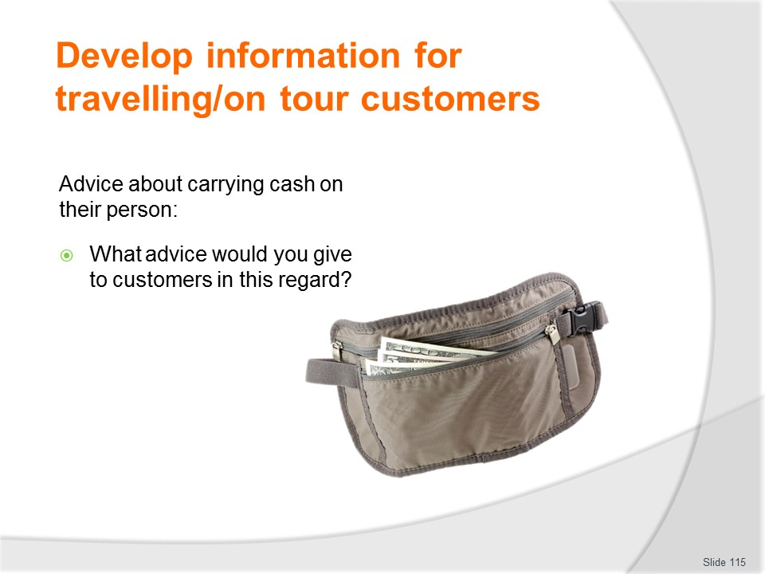
Slide No | Trainer Notes
Trainer reminds students they will need to provide information to tourists/travellers regarding carrying cash on their persons.
Trainer uses Class Activity below to communicate these requirements.
Class Activity – Group Exercise
Trainer divides class into small groups and asks them to prepare a list of advice they would provide to travellers regarding carrying cask on their person while on tour.
Trainer uses the information below to provide feedback to class:
- Advise customers of maximum cash amounts to keep on their person
- Suggest and describe the use of money belts
- Recommend the use of travellers’ cheques
- Describe the different denominations of coin and notes used in different countries
- Provide a general indication of exchange rates in the countries to be visited
- Identify known ethical money exchangers
- Stress the need for customers to hand over cash if they are challenged or subject to attack or armed hold-up
- Suggest customers keep money in two places on their person:
- One for spending
- The other for ‘throw down money’ to surrender in case they are robbed/held-up.
- Advise against carrying hand bags or shoulder bags which may be easily snatched.

Slide
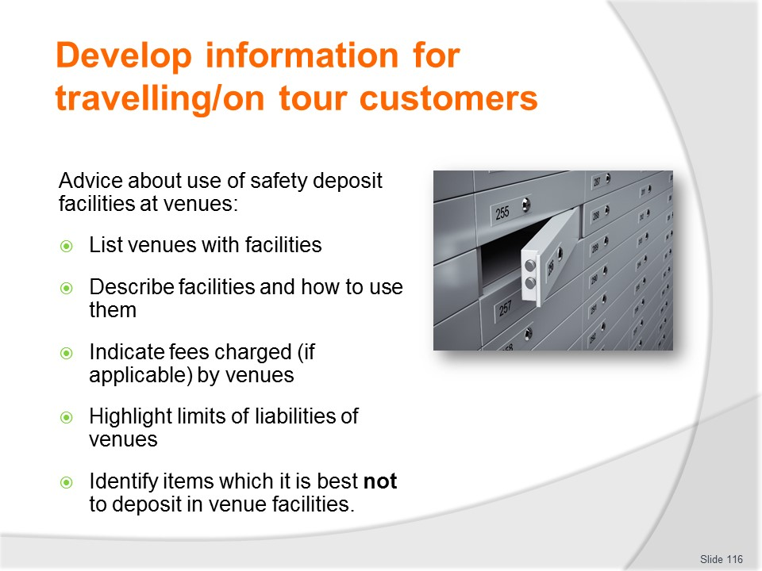
Slide No | Trainer Notes
Trainer provides information which may be given to tourists/travellers regarding use of safety deposit facilities at venues:
- List venues with appropriate in-room and/or in-house facilities
- Describe the facilities available and explain how to use and/or access them
- Indicate, where/if appropriate, the fees charged for using these facilities
- Highlight the limits of liability venues are under if customers seek to rely on guarantees provided to customers who use facilities and suffer loss
- Identify items which it may be best not to deposit in to safety deposit facilities.

Slide
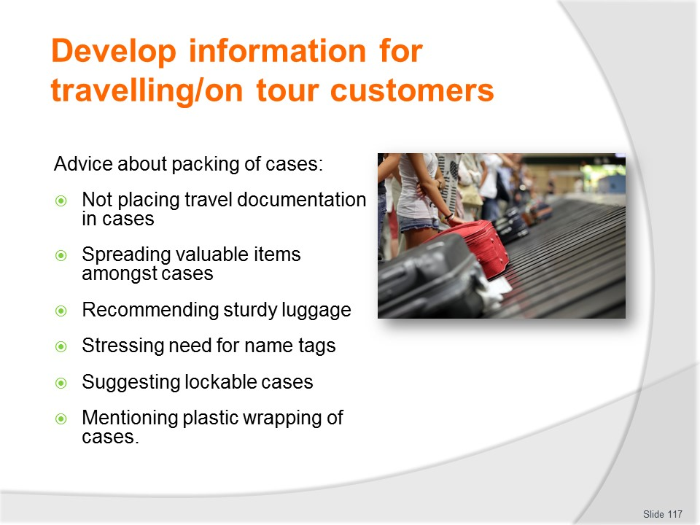
Slide No | Trainer Notes
Trainer provides information which may be given to tourists/travellers regarding packing of cases:
- Advise not placing travel documents into suitcases and/or bags
- Suggest customers spread valuable items among all cases/bags
- Recommend suitcases/bags are of sturdy construction and in good repair
- Stress need to attach name tags to all bags/cases
- Suggest the use of locks on cases
- Mention the option of wrapping cases in plastic prior to travel.

Slide
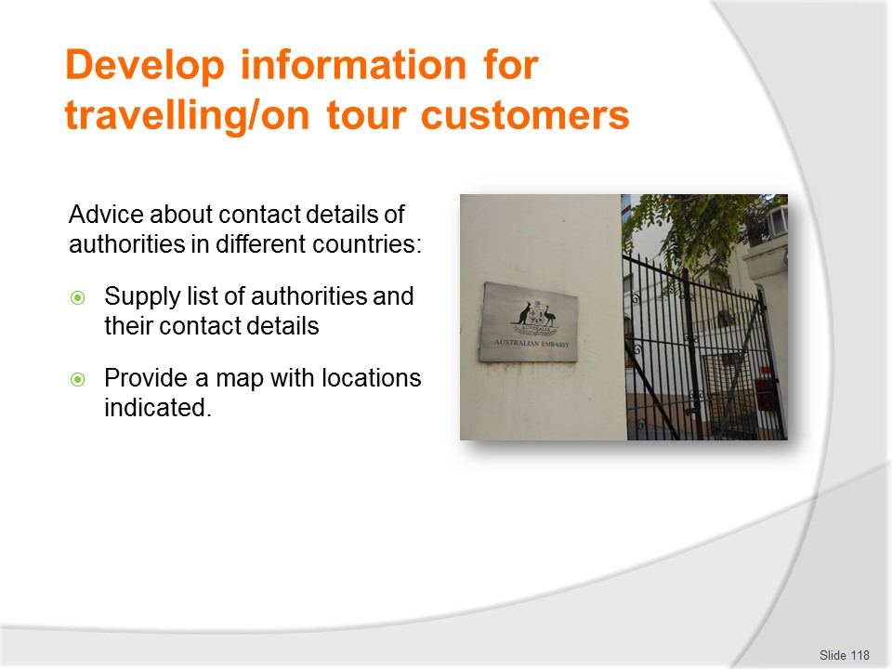
Slide No | Trainer Notes
Trainer provides information which may be given to tourists/travellers regarding contact details of authorities in different countries:
- Supply list of authorities
- Provide telephone numbers
- Give street addresses
- Indicate locations on map.

Slide
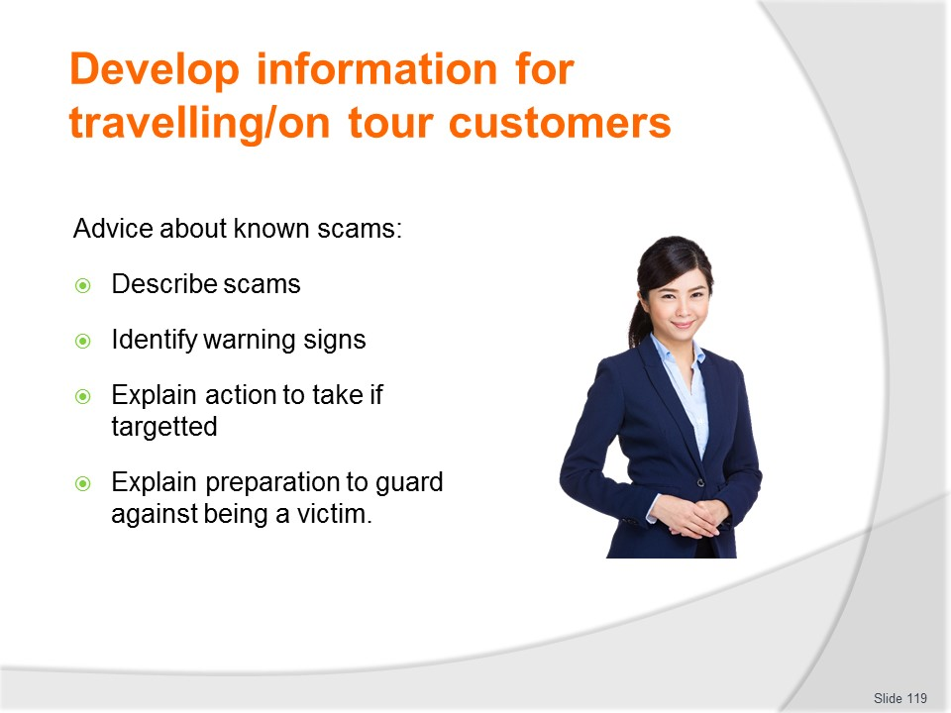
Slide No | Trainer Notes
Trainer provides information which may be given to tourists/travellers regarding known scams:
- Describe types of scams and how they operate
- Identify triggers (‘red flags’) to be alert for
- Explain action to take when targeted by a scam
- Provide details of how to prepare to avoid or counteract scams.
Class Activity – Guest Speaker
Trainer arranges Guest Speaker from local authorities and/or police to talk to students about the information they should provide to travellers/tourists while they are on tour, providing sample information (as applicable).

Slide
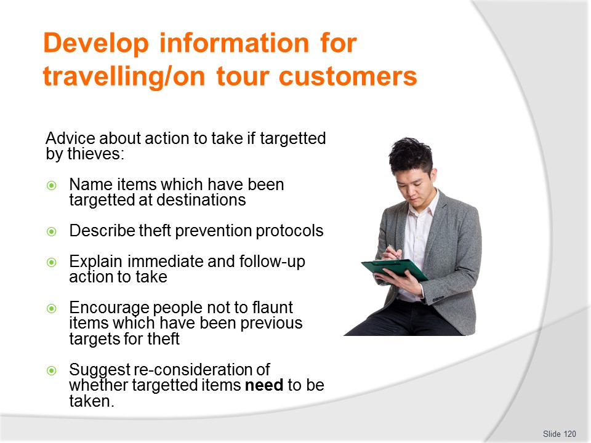
Slide No | Trainer Notes
Trainer provides information which may be given to tourists/travellers regarding action to take if they are targeted by thieves at different destinations:
- Name items (by type) which have been the subject of thefts at individual destinations
- Describe theft prevention protocols which may be applied to deter or thwart thieves – this should address the potential for theft from persons, and from accommodation venues
- Explain immediate and follow-up action to take if a theft occurs
- Encourage customers not to display targeted items so they attract attention
- Suggest customers re-consider their need to take items with them which have proved to be target items for thieves.

Slide
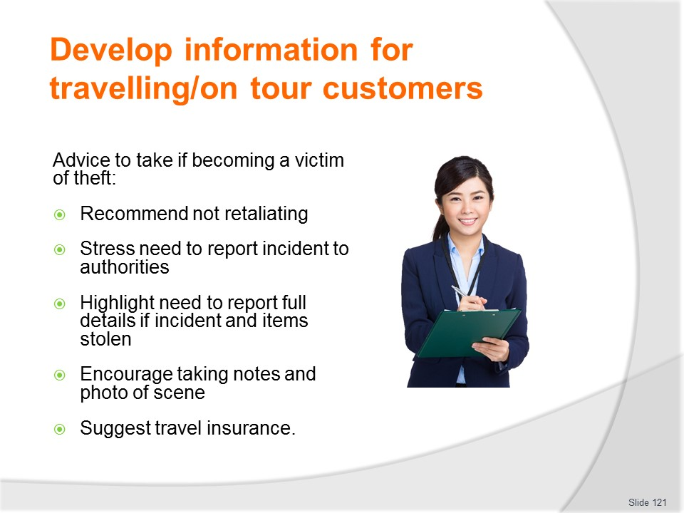
Slide No | Trainer Notes
Trainer provides information which may be given to tourists/travellers regarding action to take if they become a victim of theft:
- Recommend not fighting back when a robbery occurs – standard procedure is to recommend complying with demands of the robber
- Stress the need to report the incident to local authorities
- Highlight need to provide full details of what was stolen
- Encourage taking of notes or photographs of the scene
- Suggest taking out travel insurance as a safeguard measure.

Slide

Slide No | Trainer Notes
Trainer provides information which may be given to tourists/travellers regarding travel insurance:
- Provide descriptions for options available for different types of travel insurance available
- Give cost prices (‘premiums’) for policies
- Highlight reasons to and benefits of taking travel insurance stressing potential savings and value-for-money
- Describe coverage and claim procedure
- List exclusions and explain ‘terms and conditions’
- Detail application process.
Class Activity – Guest Speaker
Trainer arranges Guest Speaker from travel/tour business to discuss travel insurance and explain what it covers, how to promote/sell it, how much it costs, commissions payable and the reporting/claiming procedure.

Slide
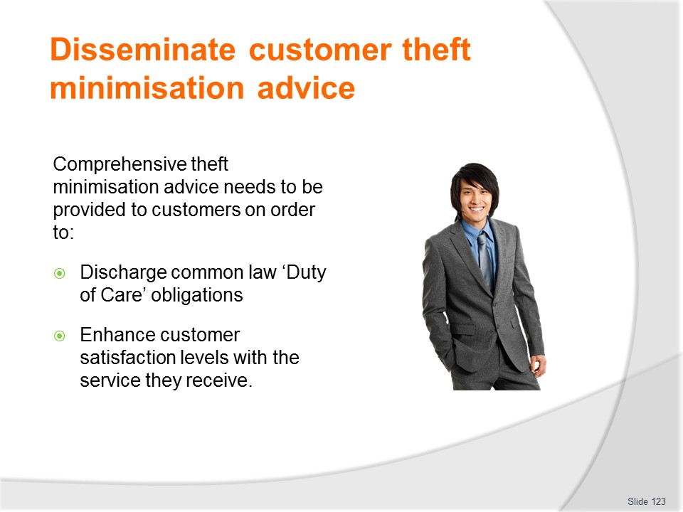
Slide No | Trainer Notes
Trainer talks about context for providing theft minimisation advice to customers stating this information is necessary in order for businesses to:
- Discharge their common law ‘duty of care’ which requires them to take action to prevent ‘foreseeable harm’ to their customers
- Enhance the satisfaction (and safety and security) of customers while they are tour so they are more likely to become repeat customers as well as advocates for the business.

Slide
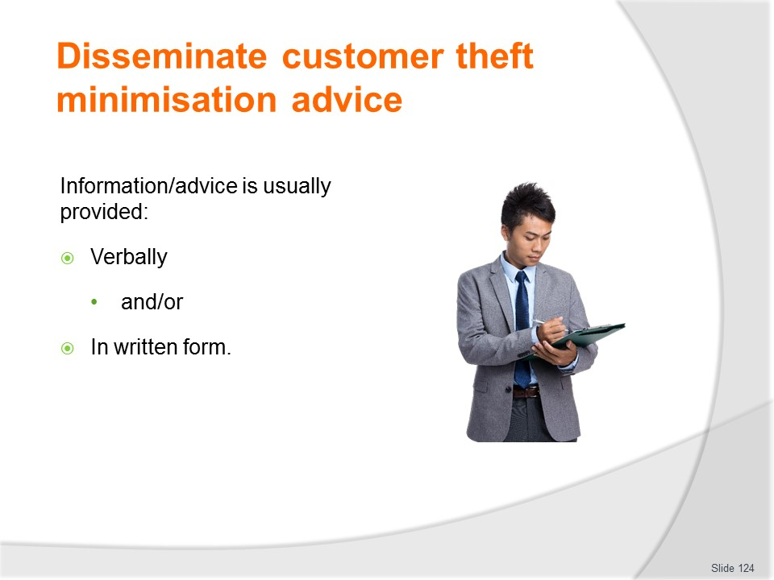
Slide No | Trainer Notes
Trainer explains information may commonly be provided:
- Verbally – most advice where the business feels there is a need to name/identify specific persons or businesses as being persons/places to avoid are conveyed in this form to help avoid possible legal action for slander
- In written form – in the form of a list/handout which may be:
- Given when tickets are purchased
- Included in the travel/ticket wallet
- Distributed at a pre-trip briefing
- Handed out on arrival at destinations.
- On the company website – for people to access as they want.
Class Activity – Demonstration and Role Play
Trainer demonstrates how to verbally provide advice/information to travellers/tourists (using the information provided on previous slides) and provides opportunity for students to practice same.

Slide
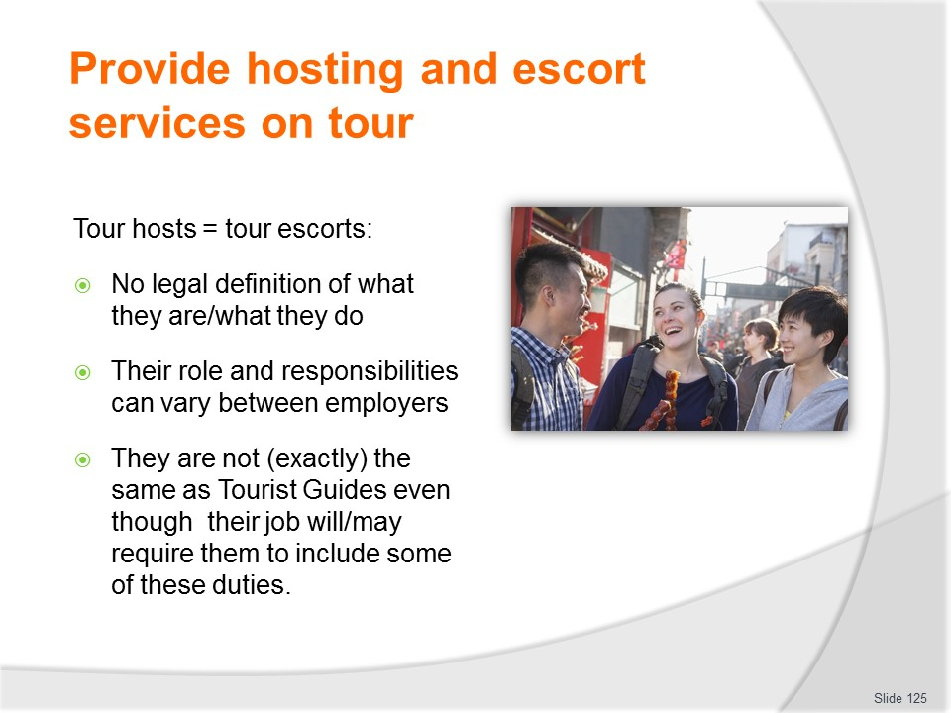
Slide No | Trainer Notes
Trainer clarifies names/job roles and titles stating:
- Tour hosts and tour escorts are the same thing.
- They are two different terms for the same job position/title.
- There is no legal, or generally-accepted, industry-wide accepted definition for the position.
- While they may perform some tour/tourist guide duties they are not tour guides: they provide many more services than a tour/tourist guide.
Class Activity – Guest Speaker
Trainer arranges for a Tour Escort/Host to attend and talk to students about their role and responsibilities.

Slide
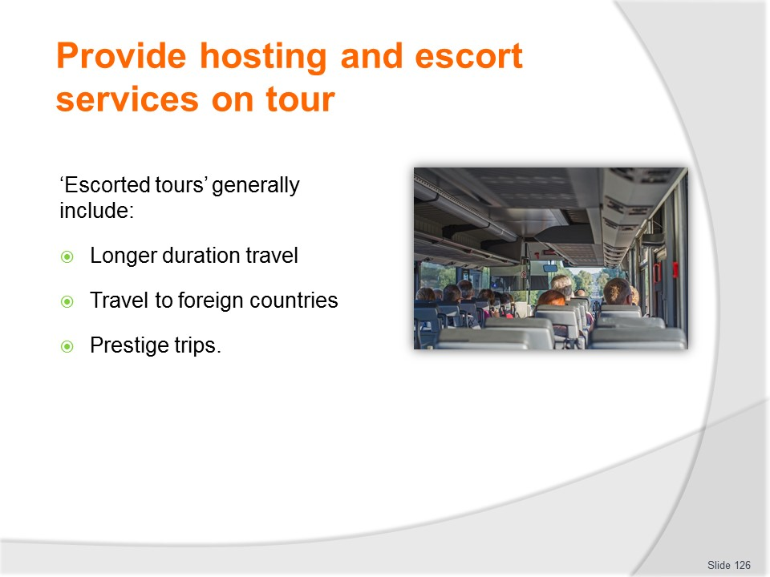
Slide No | Trainer Notes
Trainer explains tours, trips and travel which are normally provided with hosts and escorts include:
- Those targeted at older customers
- Longer duration travel – of multiple days/weeks
- Travel to foreign places – especially where language is expected to be an issue
- Prestige (high-class, expensive) trips.
Where a tour or package features a host/escort it is referred to as ‘an escorted tour’ to differentiate it from one without a host/escort.
Note: if the agency/operator does not provide a host/escort as part of the package/deal customers can often engage their own at each destination on a fee-for-service basis.

Slide
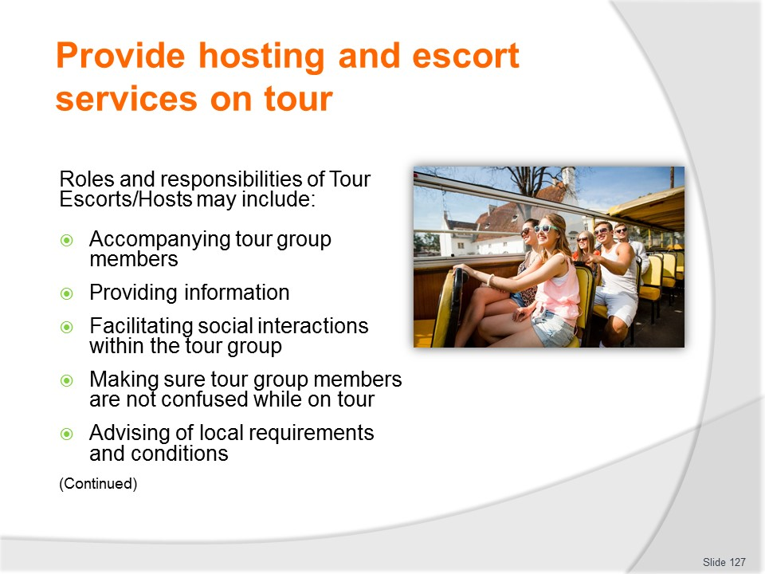
Slide No | Trainer Notes
Trainer identifies possible roles and responsibilities of Tour Escorts/Hosts:
- Accompanying the tour group members at all time they are on tour
- Providing information and commentary
- Facilitating social cohesion of the group
- Avoiding tour group member confusion and uncertainty by providing necessary explanations and clarifications
- Advising of local conditions, customs, laws, rituals and restrictions.

Slide
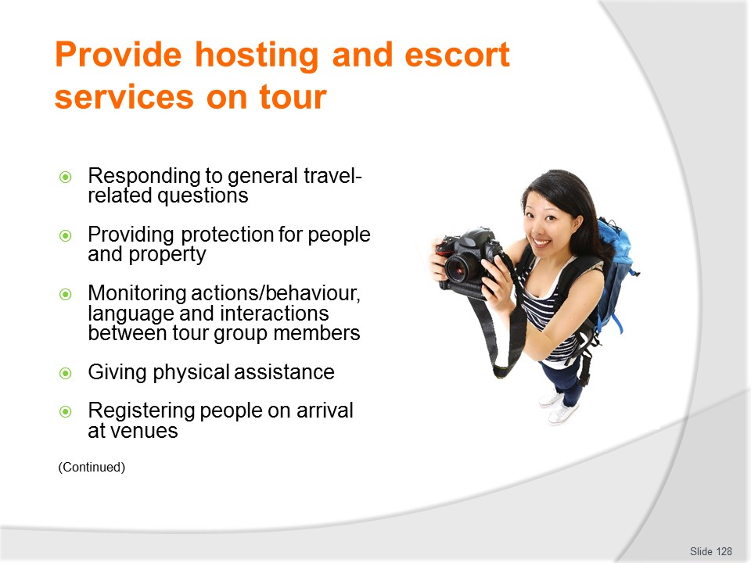
Slide No | Trainer Notes
Trainer continues identifying possible roles and responsibilities of Tour Escort/Host:
- Responding to general travel, tour, transport, scheduling and /or itinerary questions
- Protecting physical property and people
- Monitoring individual and group activity, behaviour and language to ensure compliance with laws and local custom, and to avoid unintended offence
- Giving physical assistance as required – carrying luggage, getting on and off transport
- Registering tour group members at accommodation venues.

Slide
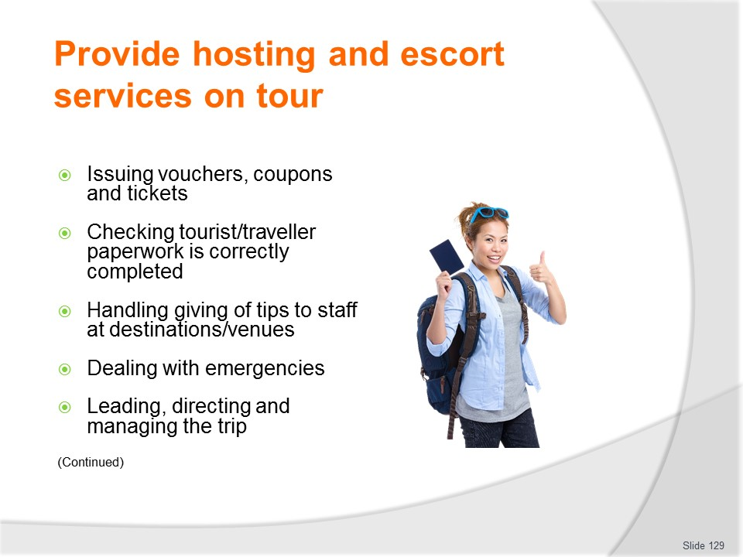
Slide No | Trainer Notes
Trainer continues identifying possible roles and responsibilities of Tour Escort/Host:
- Issuing required vouchers, coupons, tickets and other documentation at venues and destinations
- Checking appropriate paperwork is completed by tour group members when they enter and leave countries
- Handling tipping of service staff at meal times and other appropriate occasions
- Dealing with emergency situations and issues arising
- Leading, directing and managing the trip.

Slide
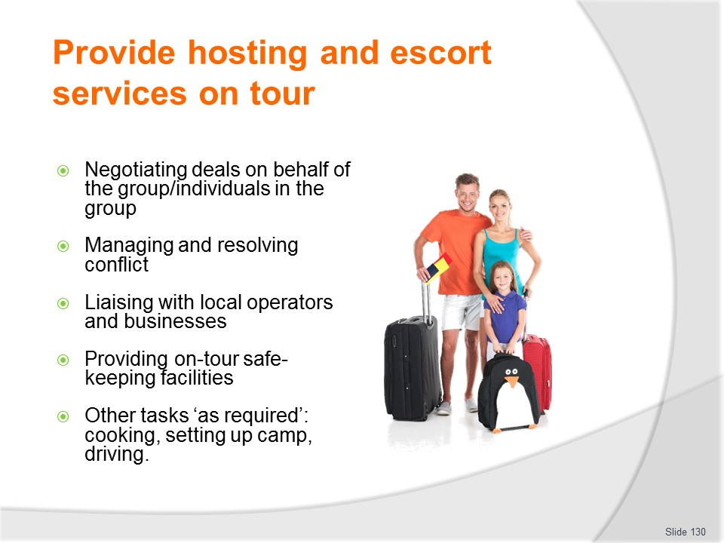
Slide No | Trainer Notes
Trainer continues identifying possible roles and responsibilities of Tour Escort/Host:
- Negotiating deals and situations on behalf of the group
- Managing and resolving conflict and dissatisfaction within the group
- Liaising with local operators, officials, contacts and business partners
- Providing on tour safe-keeping facilities for tour group members – see following slides.
Individual agencies/operators may have a list of additional services, duties or tasks they require hosts/escorts to deliver and these vary dependent on the type, nature and duration of the trip/tour.
For example, on some tours/trips the host might also drive the vehicle, set-up camp and cook meals.

Slide
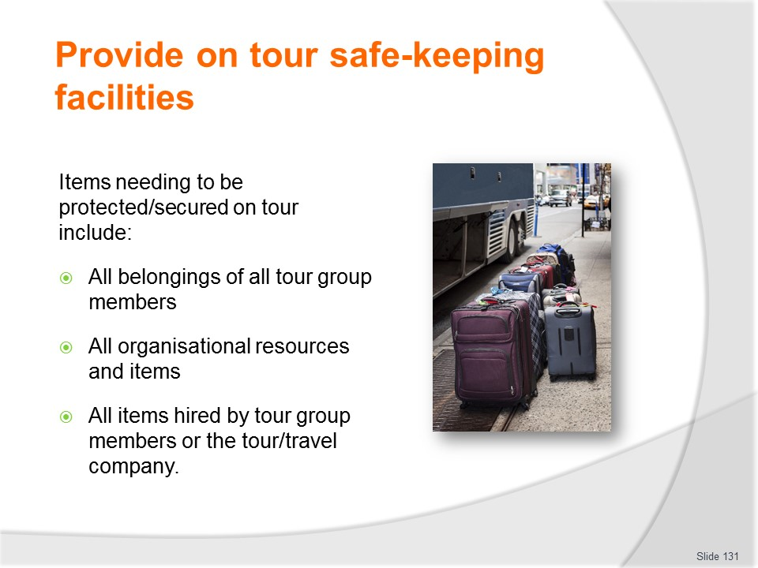
Slide No | Trainer Notes
Trainer identifies items needing to be secured while on tour stating this requirement applies to:
- All belongings of all tour group members – including:
- Valuables – jewellery, cameras, watches, laptops
- Luggage and bags
- Cash
- Travel documents
- Personal items – which may have little monetary value but are of significant sentimental value to customers
- All resources belonging to the tour company/operator – which may include:
- Cash, cheques and credit cards
- Vehicles – and in some cases, pack animals
- Camping and cooking equipment
- Food and beverages
- Tickets, coupons and vouchers
- All items hired on behalf of the tour company/operator and/or tour group members – such as:
- Vehicles – buses, go-karts, scooters: for transportation, recreation, adventure or sporting purposes
- Clothing, safety equipment and sports equipment
- Animals – for riding.

Slide
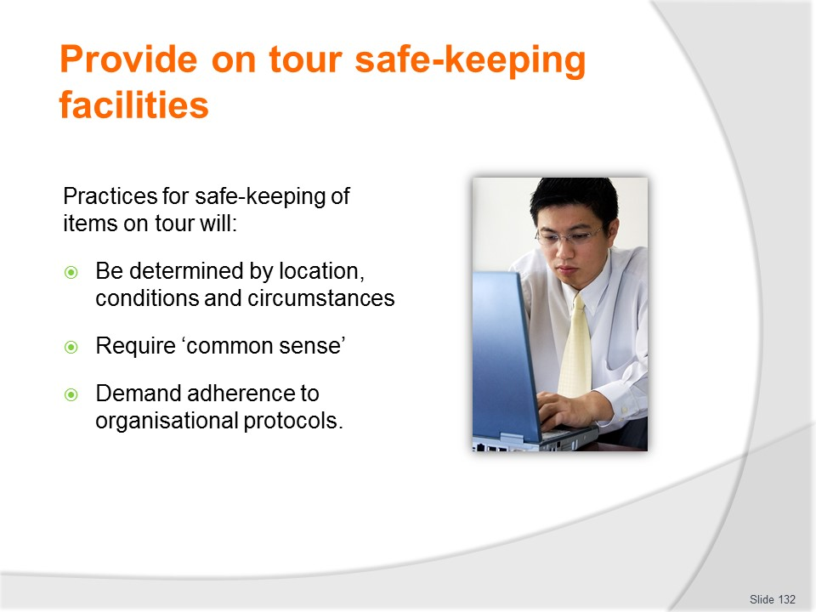
Slide No | Trainer Notes
Trainer provides a context for providing safe-keeping of items while on tour stating:
- Practices for the safe-keeping of customer belongings will:
- Be determined to a great extent by the physical location and situation the group is in ‘at the time’ – being inside a five-star hotel overnight will require a different approach to securing luggage when leaving the tour bus for a three-hour trek
- Require the application of common sense – this is arguably the single biggest factor which determines how well customer belongings are cared for/protected
- Necessitate adherence to protocols established by individual tour companies/operators as appropriate to the different nature of individual trips/tours.

Slide
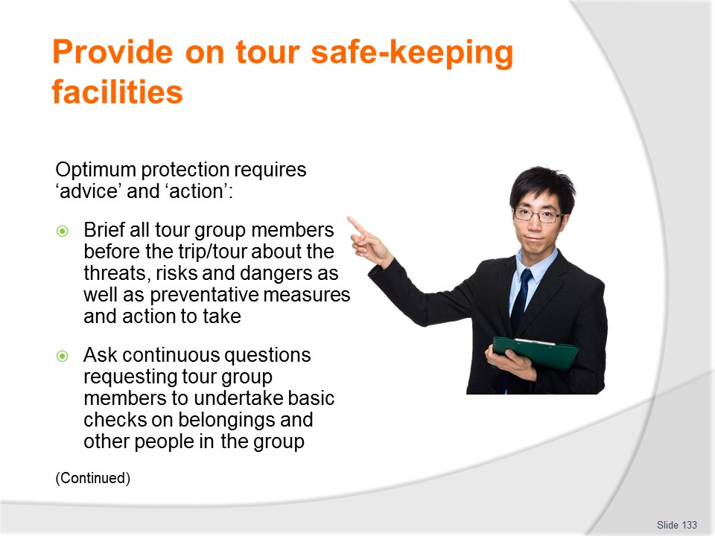
Slide No | Trainer Notes
Trainer states a combination of ‘advice’ and ‘action’ is necessary for optimum protection of customer belongings explaining the following have emerged over time and with the benefit of experience as an effective range of effective procedures which can be applied depending on the situation and the circumstances which apply:
- Brief all tour group members prior to the departure of every tour regarding potential threats and:
- Advise of preventative measures to take – verbally, via handout and (where necessary) by demonstration
- Explain preventative measures taken by the tour company on their behalf
- Urge everyone to monitor their luggage and belongings – and be prepared to take personal responsibility for their own items: explain the limits of what the tour operator/host or escort can do to assist
- Emphasise the need to place the value of life/personal safety above the value of property – that is, stressing the need to surrender cask or property if threatened or confronted by an assailant: highlight the need for/benefit of travel insurance in this regard
- Continually ask tour group members to check:
- They have all their bags/luggage
- They have their passports and tickets
- They have not forgotten anything
- Everyone is on board.
Slide
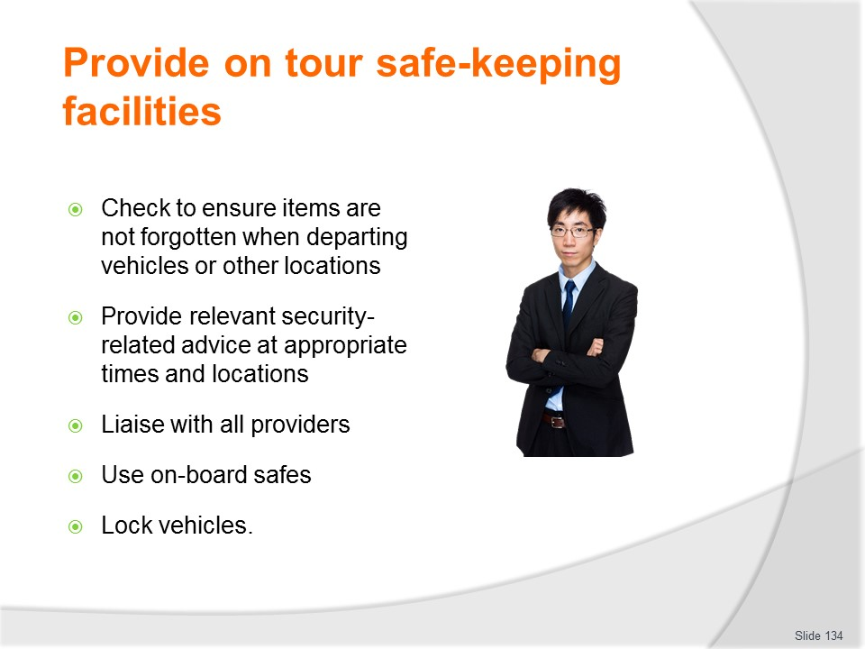
Slide No | Trainer Notes
Trainer continues identifying how protection can be optimised:
- Check:
- All vehicles when alighting to ensure no bags/items are left on board
- All departure points to make sure tour group members have not left anything behind
- All departing rooms (accommodation, meals, visits, attractions, activities, shops) to verify no items forgotten
- Advise/urge tour group members to:
- Use in-house or in-room safe-keeping facilities provided by accommodation venues to store their valuables
- Name all their items and luggage
- Minimise the amount of money they carry with them
- Use travellers’ cheques
- Lock doors to their rooms
- Leave valuables on board the bus when getting off the bus
- Keep an eye out for other tour group members
- Advise you of any suspicious persons or circumstance
- Leave contact with providers so contact can be made with group if lost belongings are identified after group has departed – so arrangements can be made to forward them
- Place guest valuables into on-board safe (where provided) to enhance security when travelling on buses or boats
- Lock the bus/vehicle when leaving it – at all times.

Slide
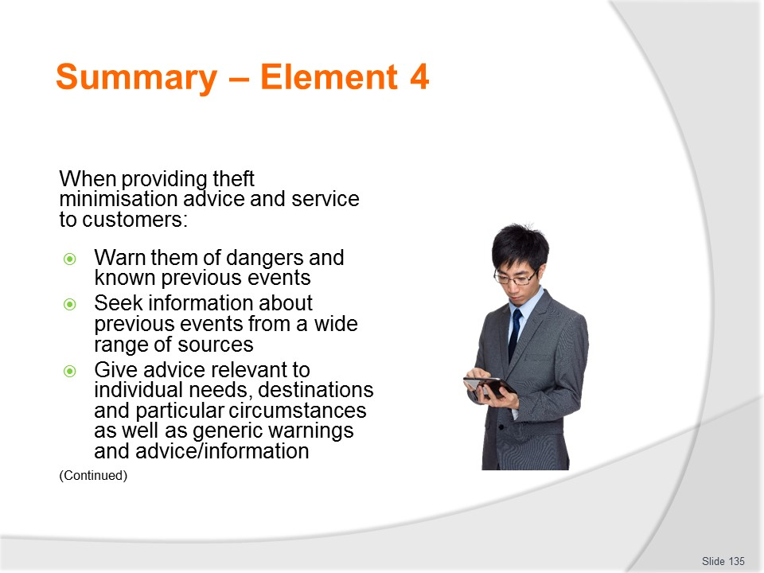
Slide No | Trainer Notes
 | Trainer provides a recap of the Element asking questions to check trainee understanding and responding to questions from trainees, as required.

Slide
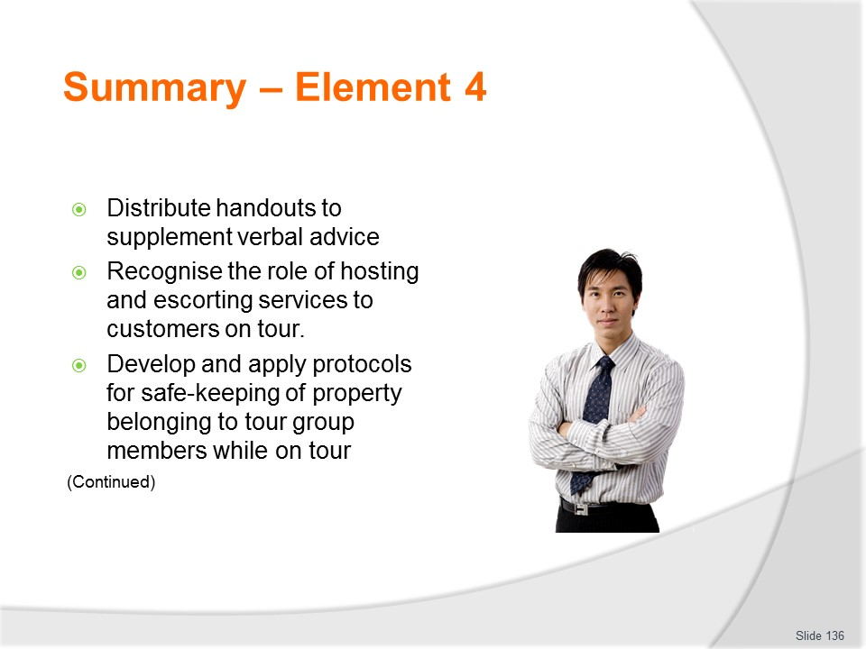
Slide No | Trainer Notes
 | Trainer provides a recap of the Element asking questions to check trainee understanding and responding to questions from trainees, as required.

Slide
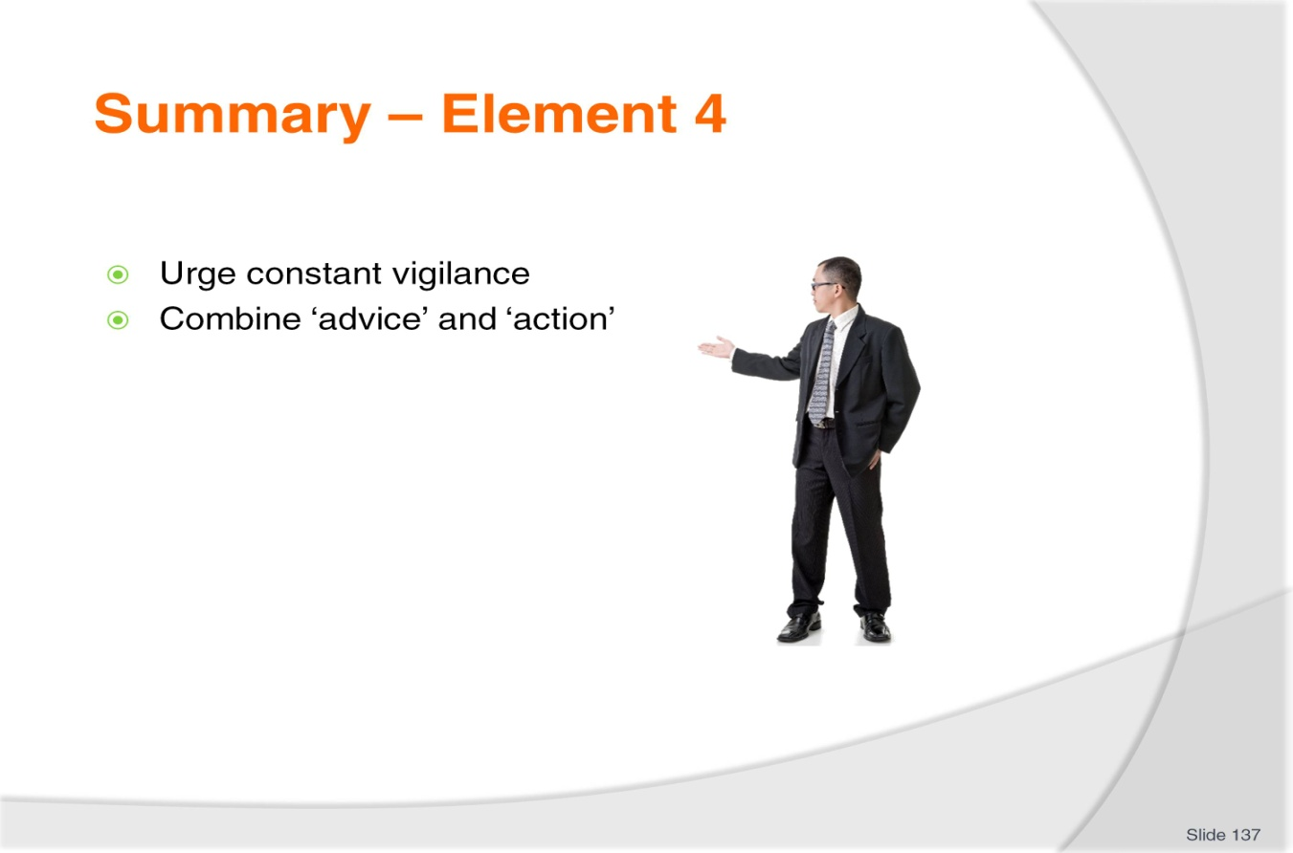
Slide No | Trainer Notes
 | Trainer provides a recap of the Element asking questions to check trainee understanding and responding to questions from trainees, as required.

Slide
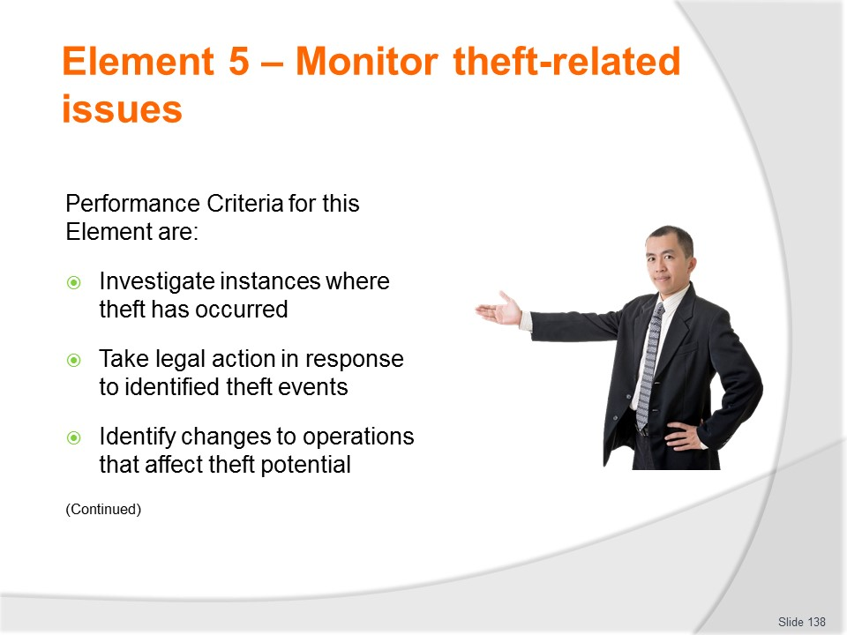
Slide No | Trainer Notes
 | Trainer identifies for trainees the Performance Criteria for this Element, as listed on the slide.

Slide
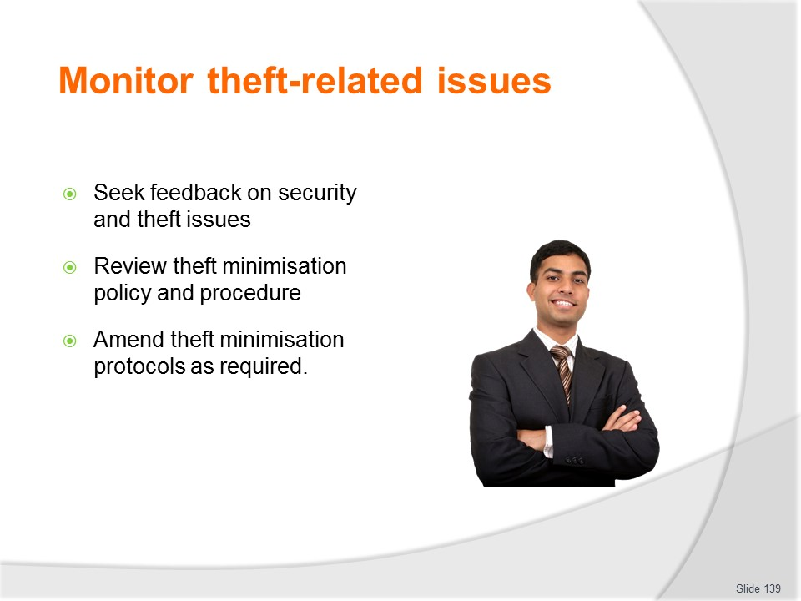
Slide No | Trainer Notes
Trainer identifies for trainees the Performance Criteria for this Element, as listed on the slide.
Class Activity – General Discussion
Trainer leads a general class discussion by asking questions such as:
- Why is there a need to monitor theft-related issues/events? What benefits can it bring?
- How might you investigate a theft event? What actions might you take as part of the investigation?
- What legal action might you take? Why might you not take legal action?

Slide
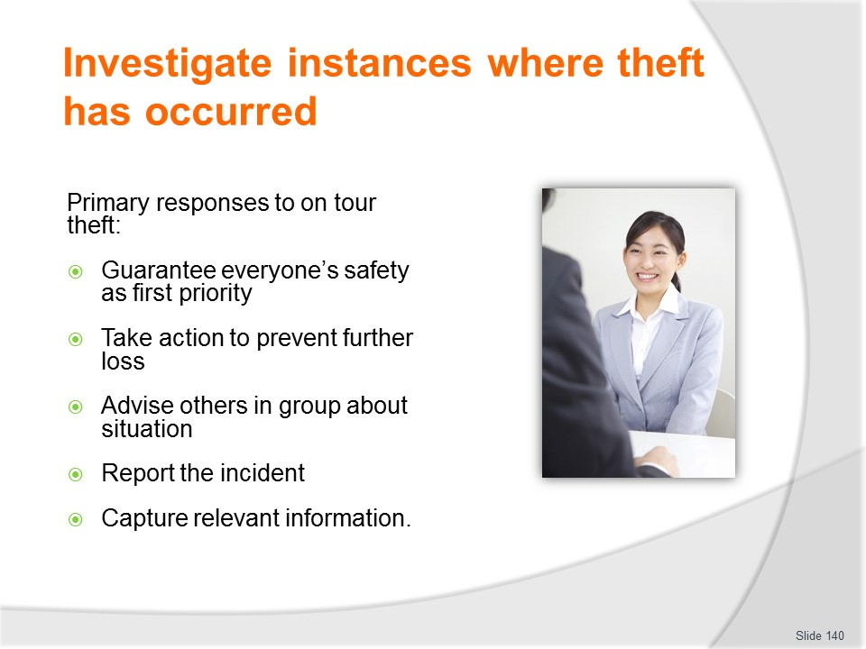
Slide No | Trainer Notes
Trainer informs students they need to follow established protocols when responding to/investigating on tour theft presenting examples of primary responses:
- Guarantee the physical safety of the person who has had their belongings stolen
- Take action to prevent further loss – this may require you to secure items, lock doors, close windows, move to a safer/different location
- Advise others in the group – so they may take appropriate preventative action
- Report the incident – to the establishment you are in, the authorities/local police and to your head office (or other according to internal directions)
- Capture any relevant information – see later slide ‘Investigating the theft’
- Details and description of what was stolen
- Details of where and how the theft occurred
- Names and contact details of witnesses
- Description/s of offenders or suspects.

Slide
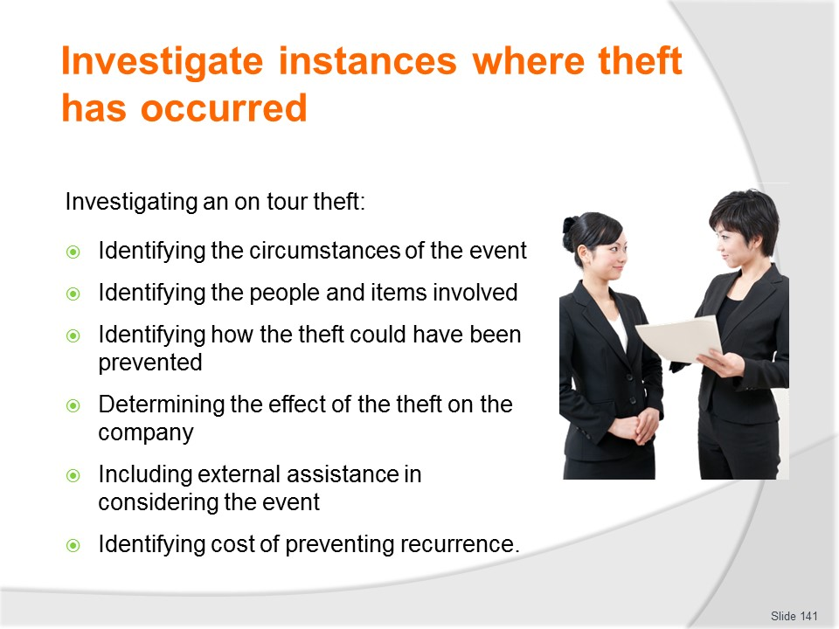
Slide No | Trainer Notes
 | Trainer lists activities which comprise investigation of an on tour theft explaining each will be presented in more detail on the following slides.

Slide
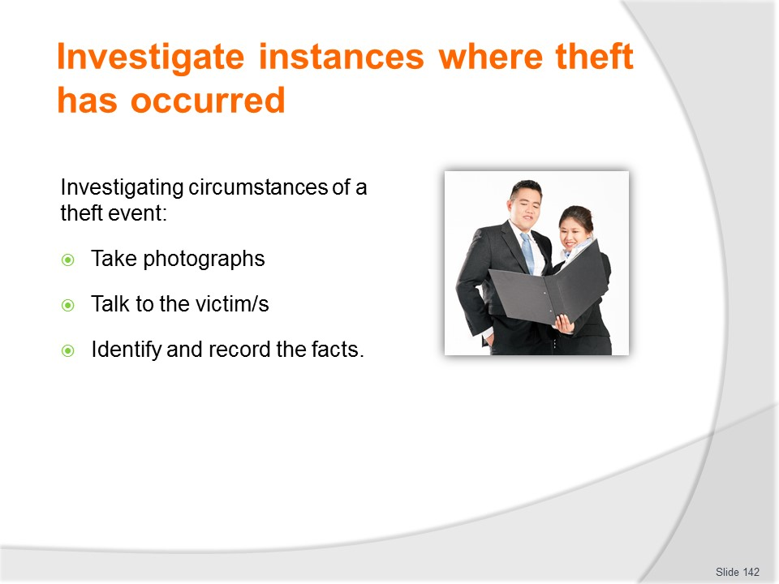
Slide No | Trainer Notes
Trainer explains activities involved in identifying the circumstances of a theft event:
- Photograph the area/situation
- Talk to the person who had their item/s stolen
- Identify ‘the facts of the situation’ to the best extent that can be determined – for example:
- Where the theft occurred – identifying (as appropriate) street address; room number; name of shop; geographic location
- When it occurred – day of week, date and time of day
- How the theft occurred – for example and as appropriate:
- Stolen from room when customer was at dinner
- Taken from bus when group was sight-seeing
- Snatched from shoulder when walking in the street

Slide
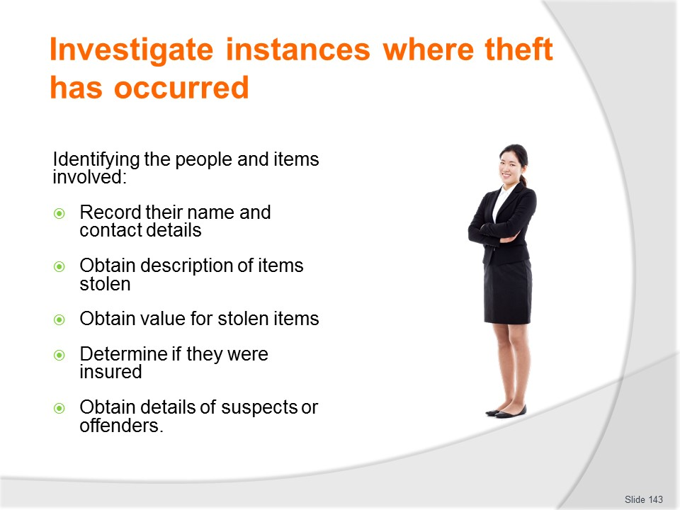
Slide No | Trainer Notes
Trainer talks about identifying the people involved:
- Record the name of the customer who lost the item/s
- Record their contact details
- Obtain a description of the item/s
- Obtain a value for the item/s stolen
- Determine if they were insured or not
- Obtain name and description of offenders or suspects.

Slide
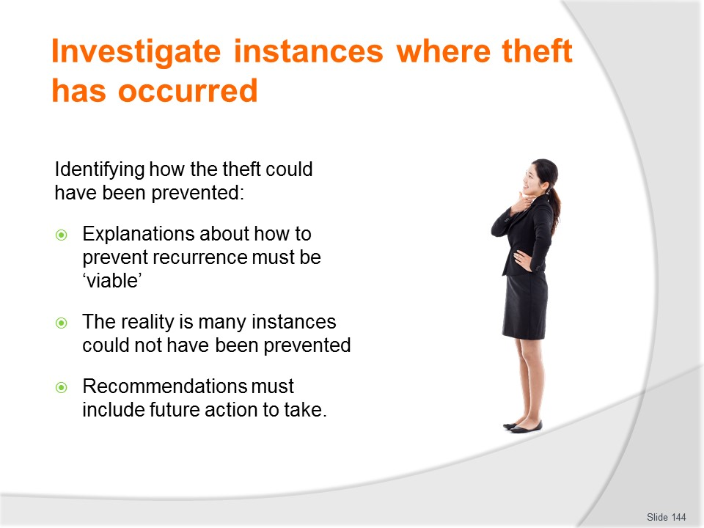
Slide No | Trainer Notes
Trainer talks about identifying how the theft could have been prevented
- This should be a common sense explanation of what could have been done to prevent the theft taking place
- It is important the explanation is ‘viable’: it must be workable, practical and able to be effectively implemented
- The reality in many cases is lots of instances of theft could not have been prevented
- Analysis might reveal, for example, future similar events could be prevented:
- If customers walked in small groups instead of on their own
- By securing valuables in in-room safes
- Through the wearing of money-belts
- By keeping passport in a separate location to cash.

Slide
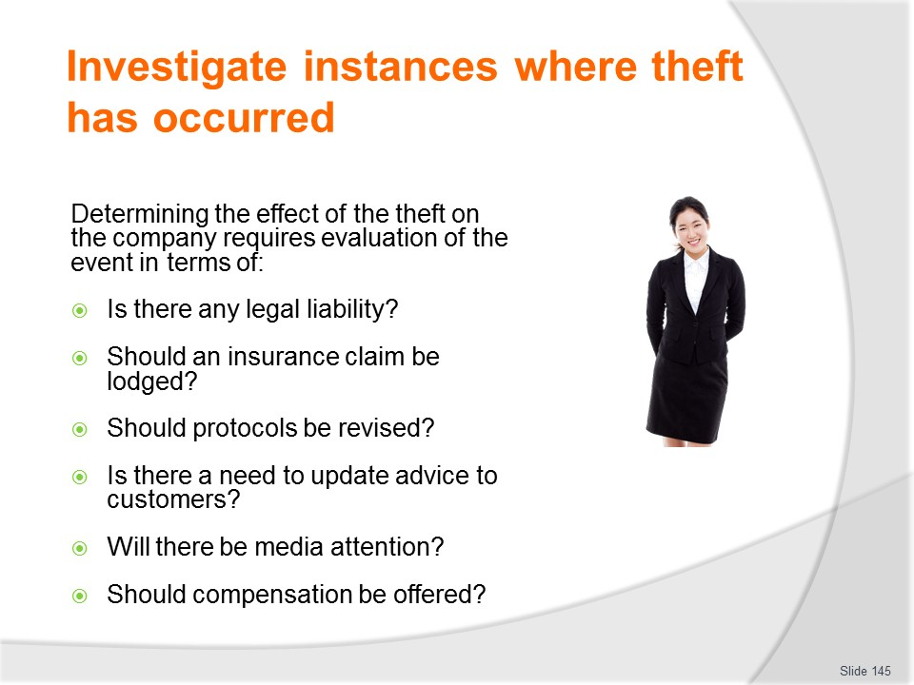
Slide No | Trainer Notes
Trainer talks about determining the effect of the theft on the company stating this requires evaluation of the event to identify if the tour operator/company:
- Is legally liable for anything
- Needs to lodge a claim under a relevant insurance policy
- Should revise its operating protocols
- Needs to update the advice it provides to customers
- Will suffer adverse media attention/publicity
- Should make an offer of recompense to the person/s affected
- Will have to participate (as a witness) in legal action against offenders.

Slide
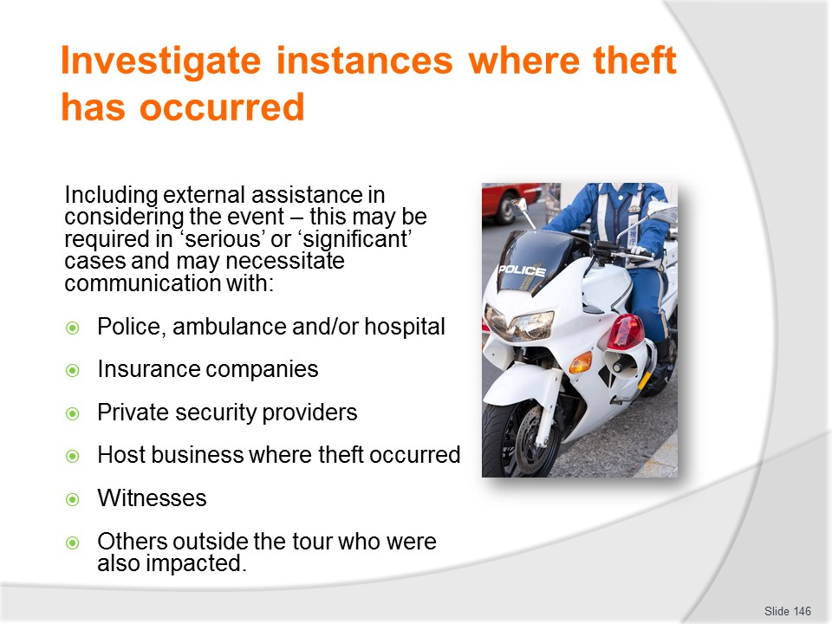
Slide No | Trainer Notes
Trainer discusses possible need for including external assistance in considering the event which may require contact with:
- Police
- Ambulance and hospital
- Insurance companies
- Private security providers (at the location where the theft occurred)
- Host businesses (where the theft took place)
- Witnesses
- Others outside the tour group who also suffered loss as part of the theft.

Slide
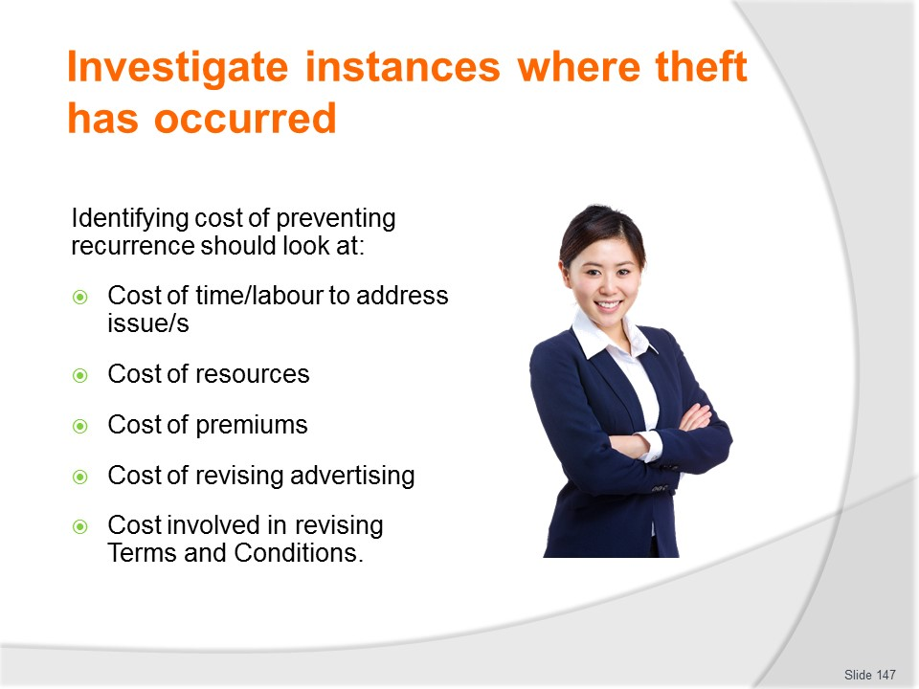
Slide No | Trainer Notes
Trainer states in most cases tour companies/operators will want to take action to prevent recurrence of a theft event because they understand ongoing instances of theft will damage their reputation and reduce repeat and referral business. Considerations should include cost and in this regard should address:
- Time – taking action to prevent recurrence will always involve time. This means it will cost ‘labour’ (wages), in terms of, for example:
- Participating in meetings, briefings and de-briefings
- Liaising with authorities and security and safety experts
- Training
- Researching and investigating security initiatives
- Preparing new protocols and advice
- Delivering different/longer or more detailed theft minimisation briefings to customers
- Extra hours required to provide enhanced levels of security when on-tour
- Cost of extra or different physical resources – to enable greater security while on-tour
- Cost of premiums for new or additional insurance coverage
- Cost of revising advertising for trips and tours
- Cost and implications of altering terms and conditions offered by the tour company/operator.
Slide
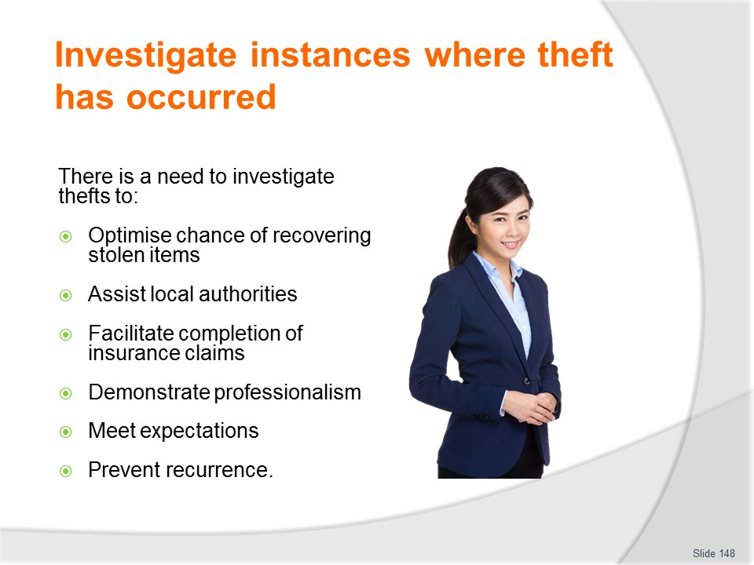
Slide No | Trainer Notes
Trainer discusses investigation into theft events explaining these actions may need to be taken to:
- Optimise chance of recovering the items which were stolen
- Assist local authorities
- Facilitate completion of an insurance claim
- Demonstrate professionalism and due diligence
- Meet customer expectations
- Prevent recurrence of a similar event in the future.

Slide
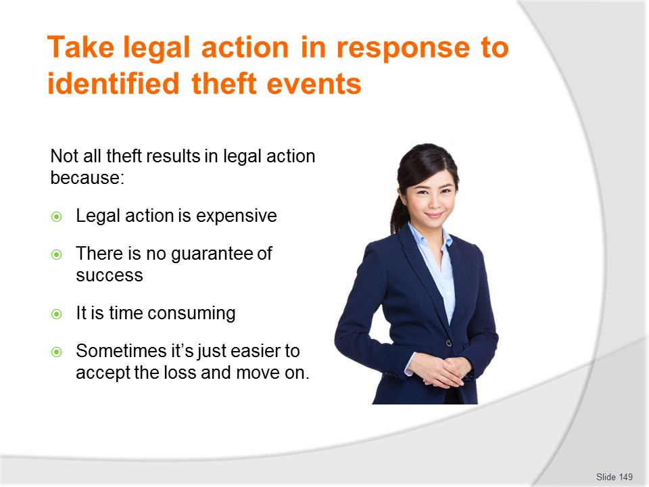
Slide No | Trainer Notes
Trainer informs not all instances of identified theft result in legal action and this may be because:
- Taking legal action is expensive and there is never any guarantee of success – and there can be times where you win the case but the undertaking still costs the tour operator/company money
- It is often very time consuming to pursue legal action – and becoming involved in such a time-consuming activity adds more expense to a loss event. Being involved in lengthy legal action can cause ongoing anxiety for staff and business owners – and the potential payout is not worth this distress
- It is often just quicker, easier, simpler and more cost-effective to accept the loss and move forward.

Slide
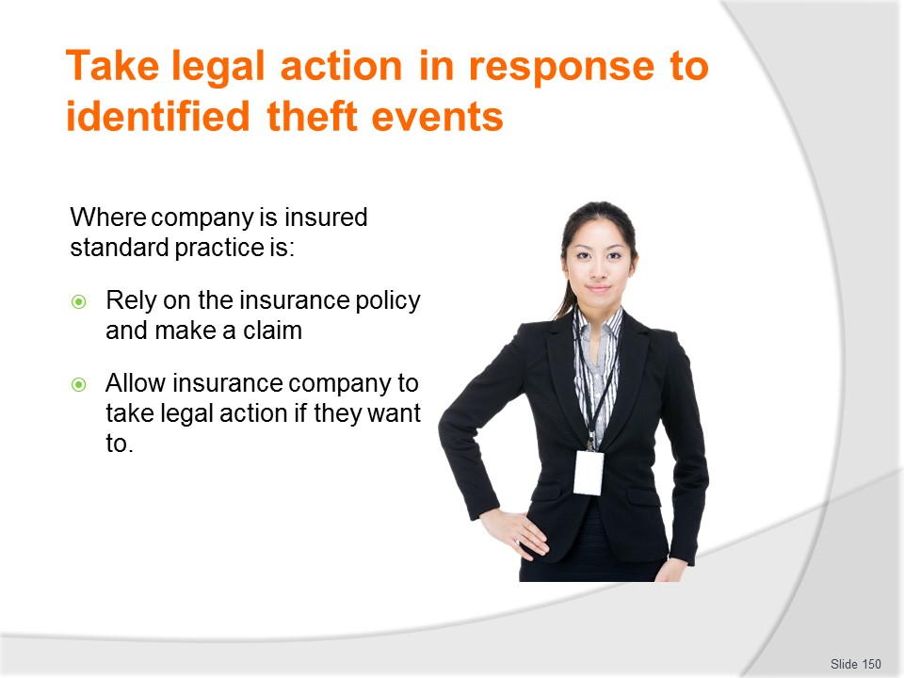
Slide No | Trainer Notes
Trainer notes where the tour company/operator is insured, the standard procedure is:
- Rely on the insurance policy and make a claim
- Allow the insurance company to decide if it wants to take legal action to recover monies.
Class Activity – Guest Speaker
Trainer arranges Guest Speaker from insurance company to discuss role of insurance companies in responding to theft-related claims and taking legal action on behalf of policy holders to recover monies.

Slide
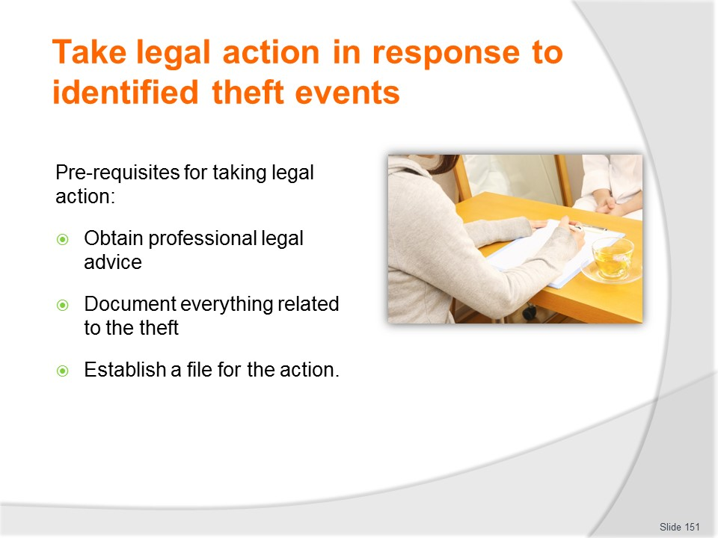
Slide No | Trainer Notes
Trainer discusses pre-requisites for taking legal action:
- Obtain professional legal advice – to indicate the likelihood of successful action, and the potential costs and time involved in pursuing the action
- Document everything about the theft event which is known (see above, section 5.1) – for use as reference material and/or evidence
- Establish a file for the legal action to be taken – in which all relevant activities and associated documents are recorded/placed. This file will contain items and information such as:
- Notes taken of meetings with lawyers, police, witnesses, insurers, victims and other persons connected with the case
- Correspondence – in and out
- Evidentiary documentation
- Times and dates of meetings
- Costs involved.

Slide
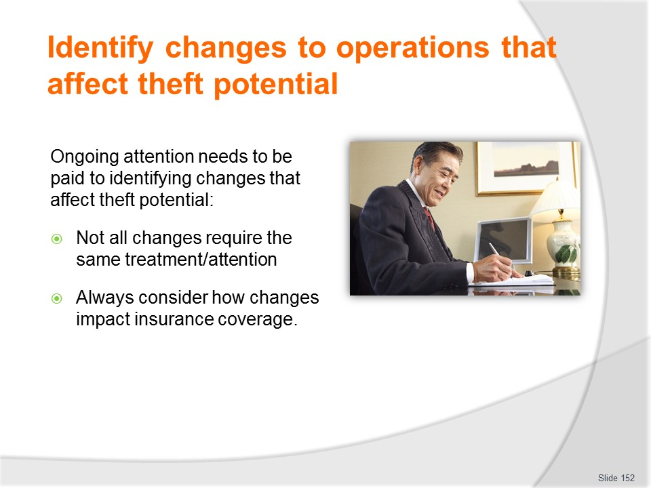
Slide No | Trainer Notes
Trainer explains there is always a need for this type of activity to factor in the specific nature/type of the theft event being considered:
- Not all situations will require the same treatment, and individual circumstances are always unique.
- All considerations of anything with the potential to impact ‘theft potential’ should always include:
- Reference to existing insurance policies – to determine of the new threat is covered by the policy, and is, to what extent and under what provisions
- Discussion with insurers – to verify perceived coverage or to identify new coverage (policies and premiums) which may need to be taken out.

Slide
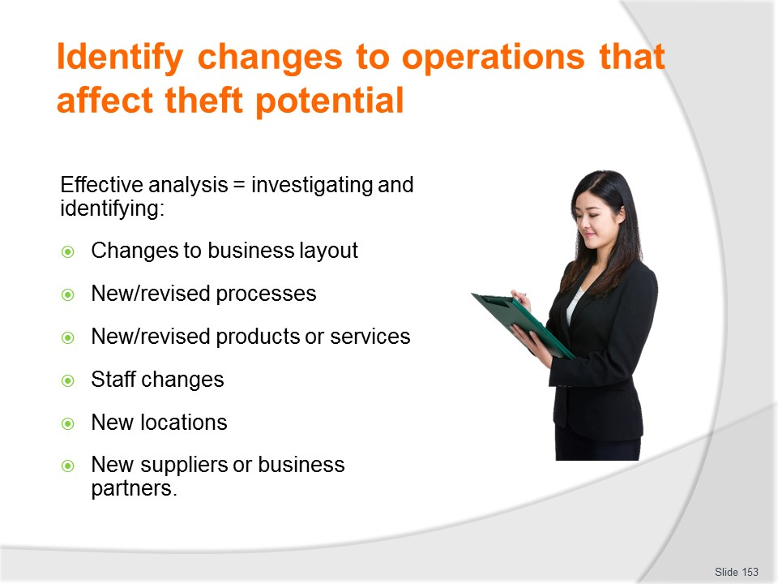
Slide No | Trainer Notes
Trainer explains effective analysis will involve investigation into the following and identifying specific changes which should be made: (each to be covered in more detail on following slides)
- Identifying changes to business layout
- Identifying new (or revised) processes
- Identifying new products or services that introduce theft potential
- Identifying staff changes that may introduce theft potential
- Identifying new locations, including destinations that introduce theft potential
- Identifying new suppliers or business partners that introduce theft potential.

Slide
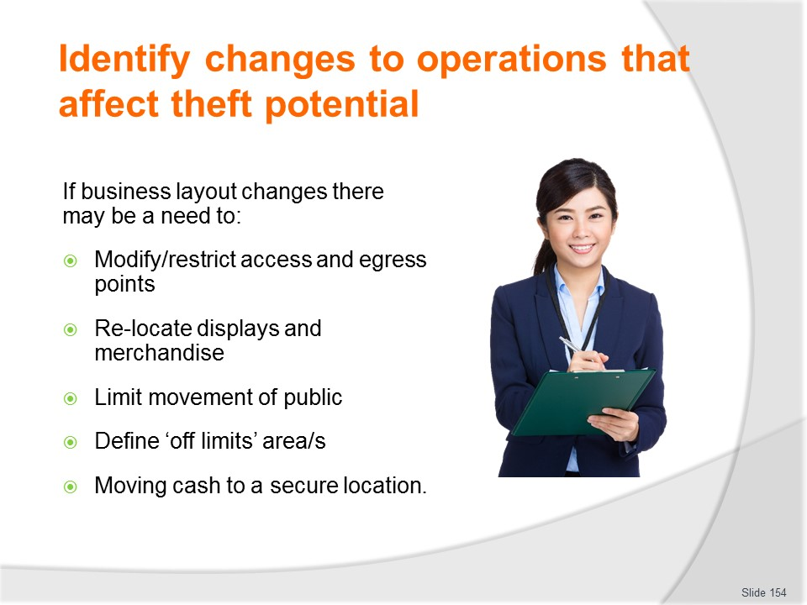
Slide No | Trainer Notes
Trainer talks about investigations into changes in business layout observing this may include suggestions regarding:
- Modifying and/or restricting access and egress points
- Re-locating displays and/or merchandise which is presented in the business
- Limiting movement of public within the business
- Defining areas of the business which are ‘off limits’ to those who do not work in the business
- Moving cash and registers to a more secure position.

Slide
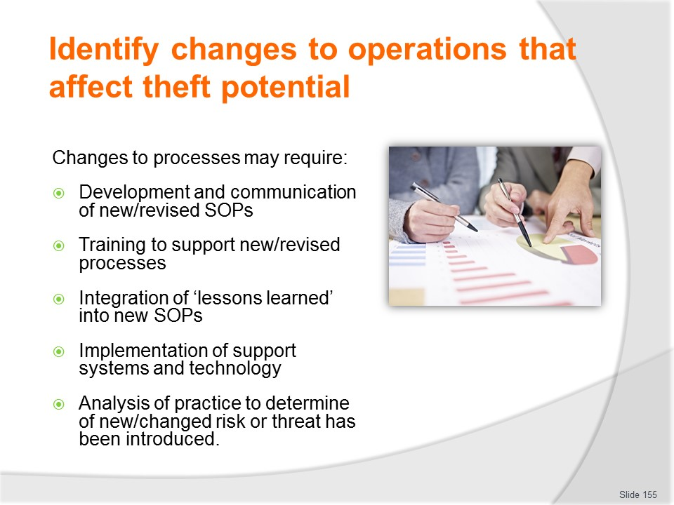
Slide No | Trainer Notes
Trainer notes changes to processes may require:
- Developing revised or new SOPs to control activities associated with revised or new processes – all revisions to existing practice, and all introductions of new practices must be subject to analysis and the development of effective SOPs
- Communicating new SOPs and policies to staff
- Providing appropriate support training
- Integrating ‘lessons learned’ from previous events into revised/new processes
- Implementing appropriate systems and technology into SOPs for the business
- Paying special attention to the introduction of any revised or new practices which raise the potential for new or different threat or risk.

Slide
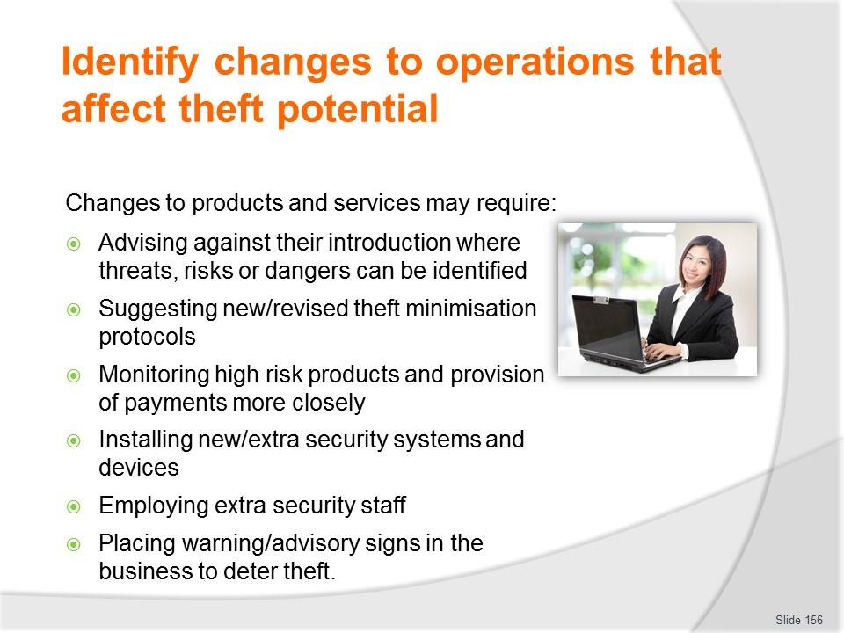
Slide No | Trainer Notes
Trainer states changes to products and services may require:
- Advising against introducing new products or services which are likely to:
- Create a known target for identified thieves
- Pose unacceptable risk
- Suggesting theft minimisation protocols appropriate to the new product, service and theft potential
- Monitoring high-risk products more closely
- Tracking provision of and payment for services more closely
- Installing new or extra monitoring/surveillance systems and equipment
- Employing extra security staff
- Placing warning signage in the business to advise of protection which is in place to deter thieves.

Slide
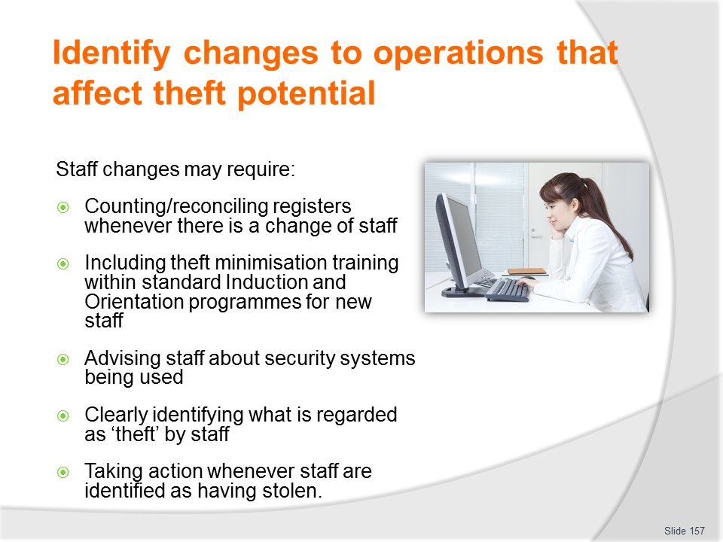
Slide No | Trainer Notes
Trainer talks about staff changes which may necessitate:
- Reconciling all registers whenever there is a change of staff who operate those registers/terminals
- Implementing standard orientation and induction for all staff ensuring these programmes contain a significant theft minimisation component
- Advising staff the business uses CCTV, Static Guards and LPOs – to deter internal theft
- Clearly describing activities the business identifies as ‘theft’ and clearly identifying what staff are allowed to do without those actions being regarded as stealing
- Dismissing and prosecuting all staff who steal from the business – and making sure all staff are aware this is the non-negotiable position of the business.
Class Activity – Guest Speaker
Trainer arranges for Guest Speaker from travel/tour business to talk to students about what they do to identify changes to operations that may introduce new/different threats, and what they do in terms of responding to identified changes.

Slide
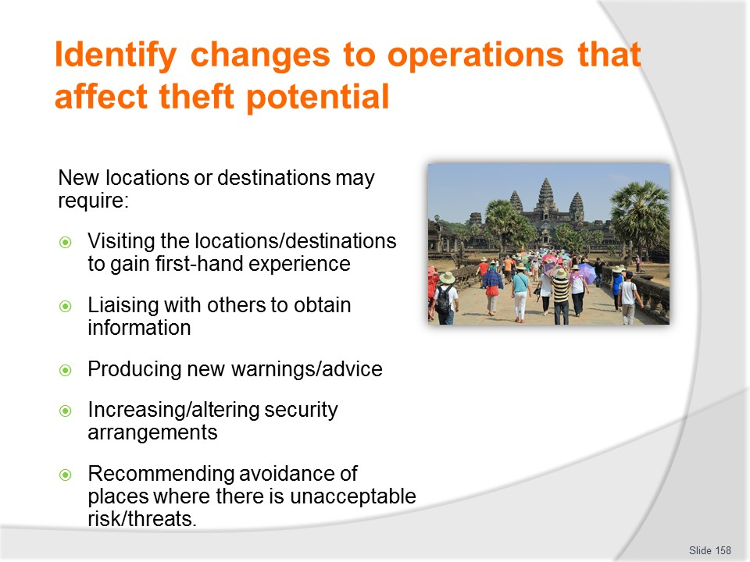
Slide No | Trainer Notes
Trainer discusses new locations/destinations which may necessitate:
- Visiting new locations to experience and review them from a theft minimisation/threat perspective
- Liaising with other operators, government agencies and industry bodies to gather relevant information, experience and advice
- Producing new advice/warnings for new destinations, attractions and sites
- Increasing security/staffing for locations and tours where an increased theft risk/potential is identified – and indicating how the cost of this will impact the selling prices of tickets/packages
- Recommending the business avoids locations where safety and security cannot be guaranteed without undue cost or effort.

Slide
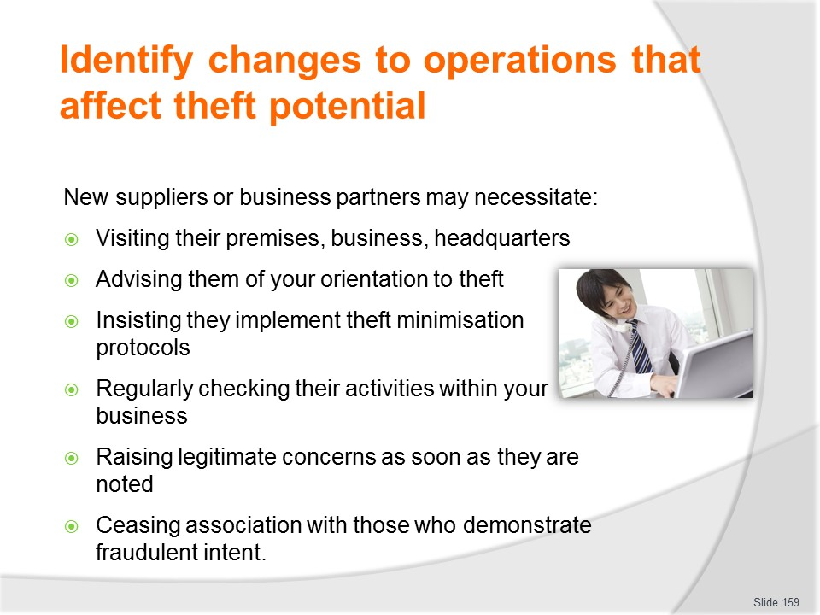
Slide No | Trainer Notes
Trainer explains new suppliers or business partners may necessitate:
- Visiting the premises of new suppliers or partners to assess their security and anti-theft protocols
- Making the new suppliers or partners aware of your orientation to theft events, and theft minimisation
- Insisting new suppliers or partners adopt or implement certain theft minimisation protocols as developed by your business
- Checking the activities (such as deliveries, actions, paperwork, prices charged) of new suppliers or partners regularly over the first few months of dealing with – and then on an ongoing basis at a reduced frequency
- Raising legitimate concerns with new suppliers or partners immediately they are detected – as opposed to allowing things to remain unaddressed
- Ceasing association with new suppliers or partners who demonstrate fraudulent intent.

Slide
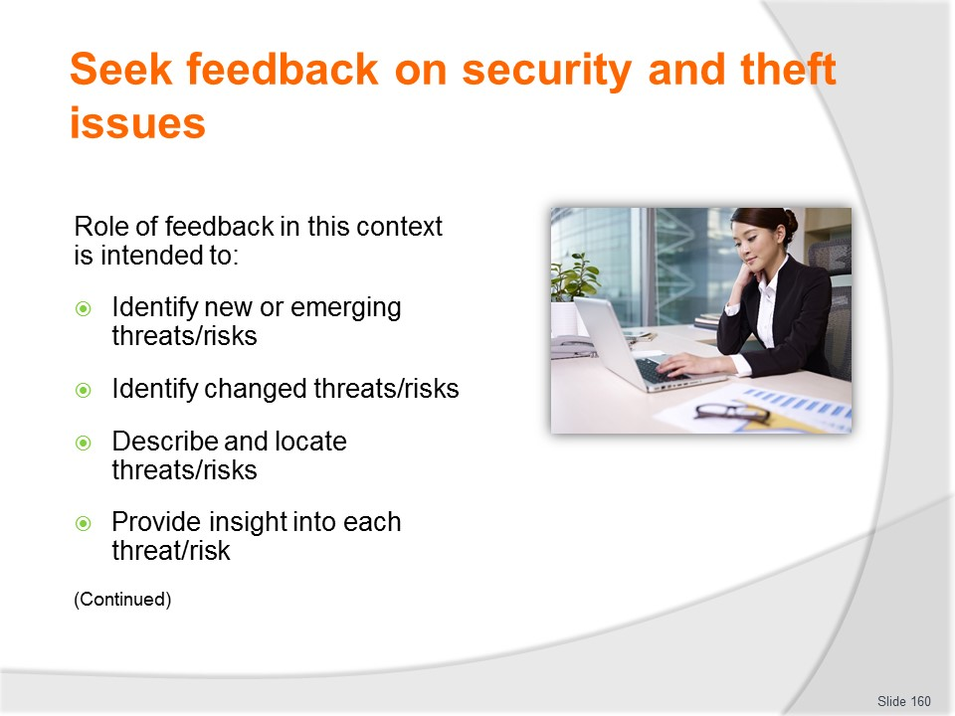
Slide No | Trainer Notes
Trainer discusses role of feedback stating in relation to theft minimisation feedback is intended to:
- Identify new or emerging threats and risks
- Identify changed risks and threats
- Describe and locate identified risks/threats
- Provide insight into the potential provided by each issue – in terms of likelihood and consequence

Slide
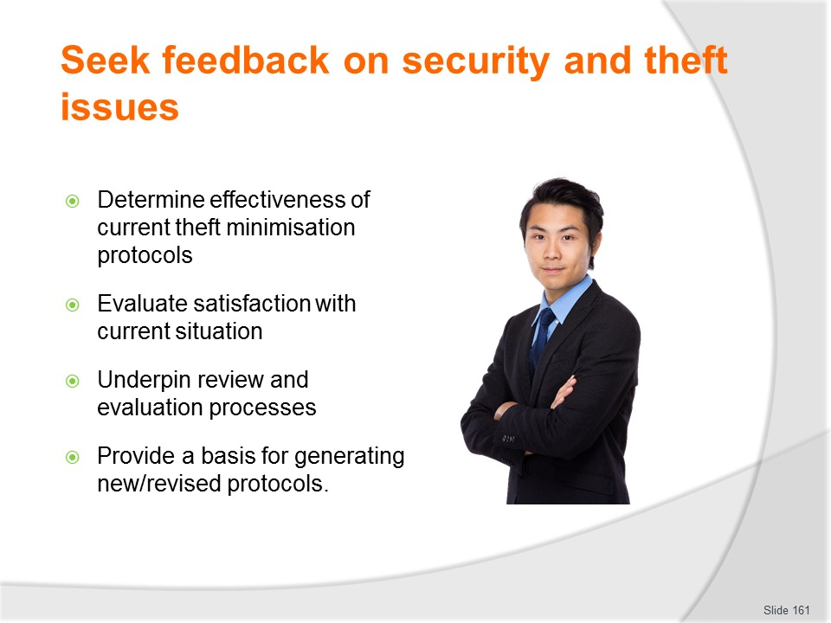
Slide No | Trainer Notes
Trainer continues discussing role of feedback in this context:
- Determine the effectiveness of existing theft minimisation protocols
- Evaluate customer satisfaction with current theft minimisation advice and procedures
- Comprise a vital element of a formal theft minimisation review and evaluation process
- Form the basis of changes to theft minimisation policies and SOPs.
Class Activity – Guest Speaker
Trainer arranges for management of a travel/tour business to attend and talk to students about how and why they seek feedback on security and theft issues and explain how they have used the feedback to improve service delivery/products provided.

Slide
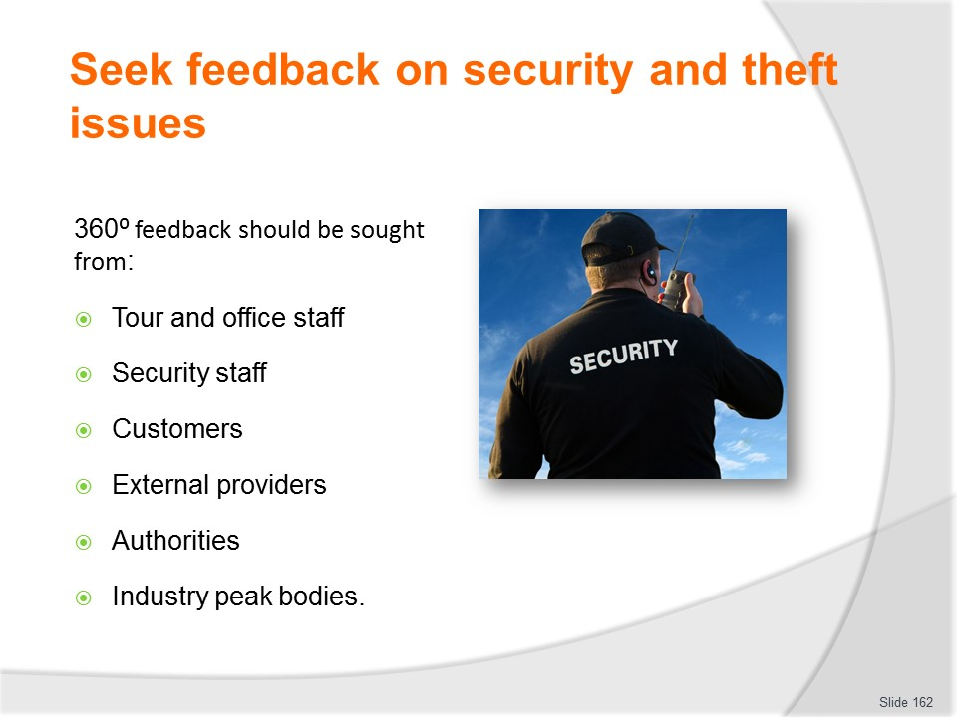
Slide No | Trainer Notes
Trainer states it is standard practice to seek feedback from a variety of sources covering all relevant parties or stakeholders (known as 360˚ feedback) highlighting feedback regarding security and theft issues may be sourced from:
- Staff who accompany tours – hosts, escorts, guides, drivers
- Office staff
- Security staff
- Customers – who go on-tour; who visit the office to make enquiries and make purchases; who undertake online transactions with the business
- External service providers – including the range of businesses involved in supporting the tours, trips and travel offerings of the business:
- Carriers
- Accommodation venues
- Food and beverage providers
- Insurers
- Subsidiary booking agencies
- Attractions
- Authorities – police, embassies, government departments (involved with travel and tourism, international affairs and similar)
- Industry peak bodies.
Class Activity – Guest Speaker
Trainer arranges for a Guest Speaker from industry peak body, agency or authority, or industry service provider to attend and talk to students about the role they can play to assist businesses with their reviews and revisions regarding theft minimisation.

Slide
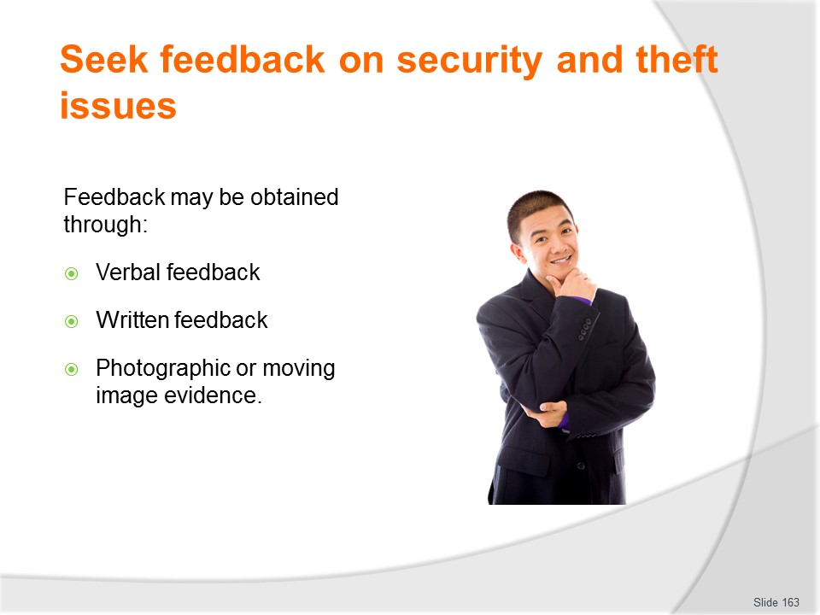
Slide No | Trainer Notes
Trainer ways in which feedback stating it can be obtained in the following ways:
- Verbal feedback – which may be obtained:
- When farewelling departing customers
- While talking to customers on their return from a trip/tour
- During formal staff de-briefings following a tour
- Listening to talks at industry events
- As a result of talking to industry contacts
- Written feedback – which may be provided:
- By customers completing hand-written ‘Customer Comment’ cards
- By customers completing online feedback
- By staff completing required ‘end of tour’ reports
- By external security providers submitting weekly/monthly reports updating the business about new/emerging threats they have identified
- Through industry reports generated by peak bodies or in industry magazines
- By reading ‘recognised’ blogs which have industry credibility
- Photographic or moving image evidence – as captured by:
- Staff and/or customers while on-tour – using cell phones or video cameras
- Internal CCTV
- You or other staff during investigation/research into potential theft situations and threats.

Slide
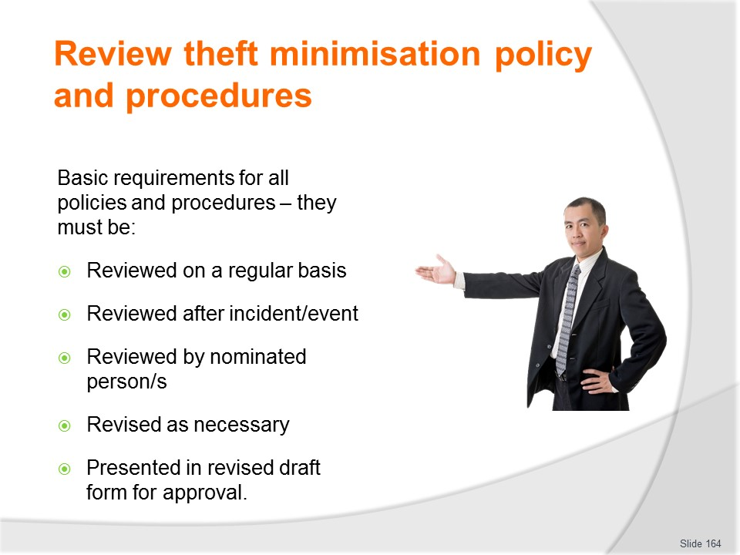
Slide No | Trainer Notes
Trainer discusses basics of reviews stating it must be a standard requirement all theft minimisation policies and procedures are:
- Reviewed on some regular basis, regardless – such as ‘every six months’ or ‘annually’
- Reviewed when there has been an incident, theft, theft attempt, serious complaint, loss or other nominated event/occurrence
- Reviewed by nominated persons
- Revised as necessary – based on the findings of the review (see next slide)
- Presented in draft form following review for approval by nominated people – staff, stakeholders, team members, focus groups of customers, authorities, insurers, head office.

Slide
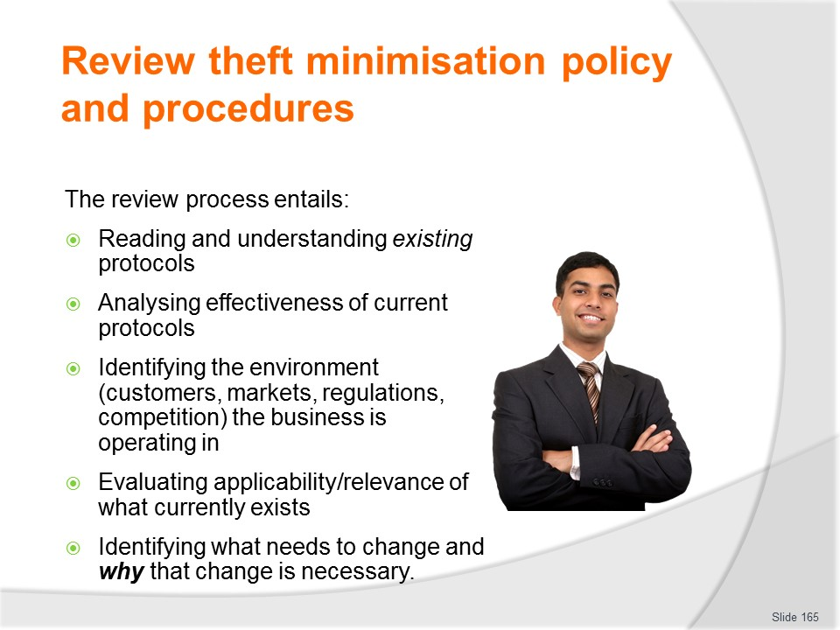
Slide No | Trainer Notes
Trainer presents elements of the review process noting in practical terms the review entails:
- Reading and understanding existing protocols
- Analysing the effectiveness of current protocols
- Identifying the context the business is operating in
- Evaluating the on-going applicability/relevance of what currently exists
- Identifying what needs to change – and why it needs to change.

Slide
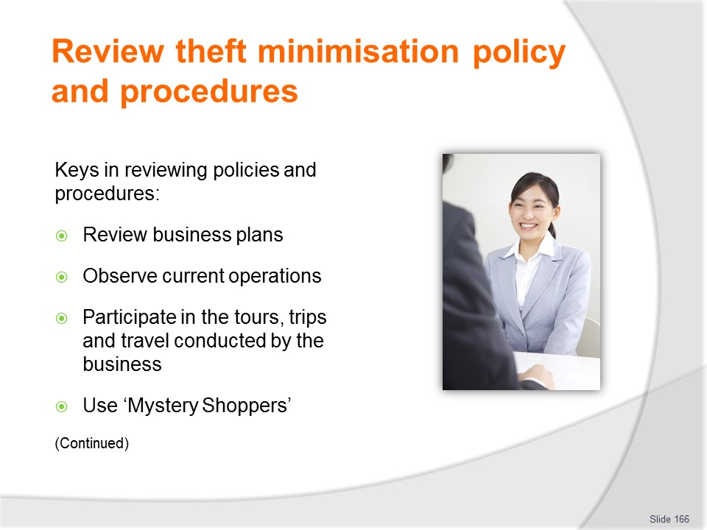
Slide No | Trainer Notes
Trainer identifies keys in reviewing policies and procedures:
- Reviewing the plans of the business – to verify policies and procedures align with where the company wants to go
- Observing current operations – to gain first-hand evidence to use as the basis for analysis, and so this experience can be integrated with input from other sources
- Participating in tours – to see operations through the eyes of customers
- Using ‘Mystery Shopper’ on a tour – and task them with (for example) trying to steal something, or with being a deliberate, intentional or ‘easy’ target for theft.
Class Activity – Guest Speaker
Trainer arranges for manager/owner of a travel/tour business to attend and discuss their protocols for reviewing and revising theft minimisation protocols.

Slide
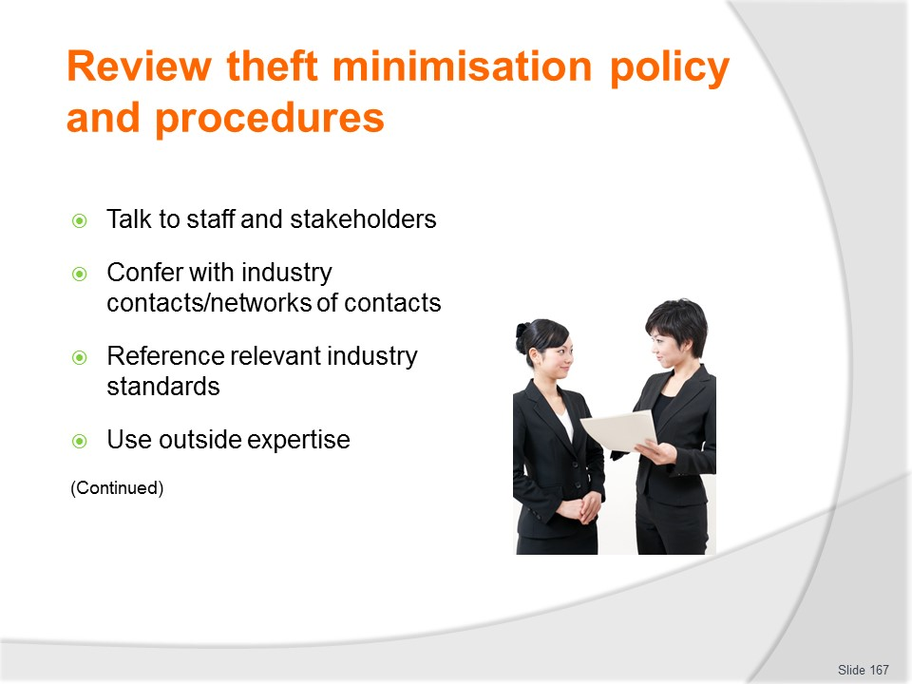
Slide No | Trainer Notes
Trainer continues identifying keys in reviewing policies and procedures:
- Talking to staff and key stakeholders – to obtain their theft-related input
- Conferring with others in the industry (your ‘network of contacts’) – to determine what they see as threats, and identify how they are addressing them via their policies and procedures
- Referencing accepted standards, industry criteria, benchmarks and Codes of Practice – with the intention of using these as the basis for formulating new or revised policies and procedures
- Employing expertise from outside the business to look into the business – to analyse operations, identify threats, evaluate existing theft minimisation protocols and recommend new/alternative strategies.

Slide
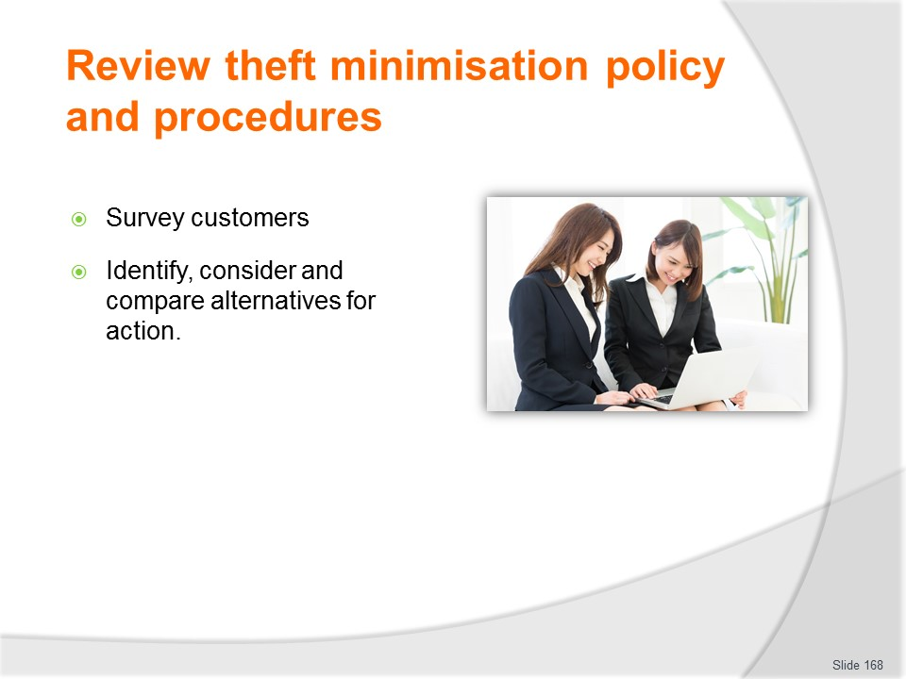
Slide No | Trainer Notes
Trainer continues identifying keys in reviewing policies and procedures:
- Surveying individual customers and targeted customer groups – to determine what they identify as issues and what they offer as solutions to them
- Identifying, considering and comparing alternatives for action – to address actual and potential issues/deficiencies.

Slide
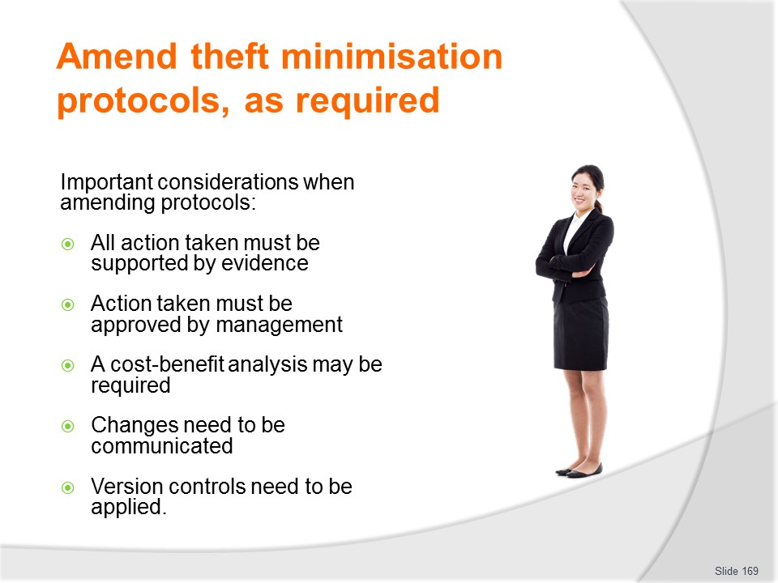
Slide No | Trainer Notes
Trainer provides context for amending theft minimisation protocols advising the following points need to be taken into account when amending theft minimisation policies and procedures:
- All action taken should be supported by evidence
- Action taken must be approved by management prior to implementation
- A cost-benefit analysis may need to precede final adoption of amendments
- Changes must be communicated to all staff and external stakeholders
- It is important to apply version control protocols to all documentation to ensure currency of items
- All changes need to be communicated – there is no point making changes unless those impacted by them are advised of the amendments and provided with advice to enable compliance.

Slide
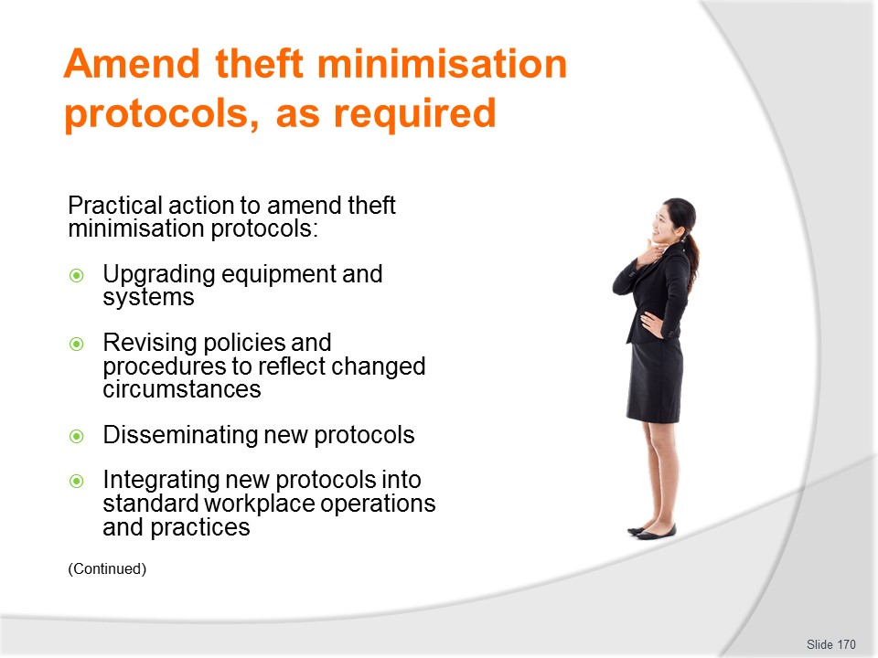
Slide No | Trainer Notes
Trainer presents possible practical action required to amend theft minimisation protocols:
- Upgrading security equipment and systems – which may mean:
- Installing more modern technology
- Adding extra items to the existing infrastructure
- Revising existing policies and procedures to address changed circumstances
- Disseminating new policies and procedures to address newly identified threats
- Integrating new protocols into:
- Organisational induction and orientation
- Formal internal training
- Workplace manuals, checklists and other documents
- Standard workplace practice – by explaining new/revised protocols to staff, scheduling a period for training and implementation, and supporting the changes with necessary time and other resources.

Slide
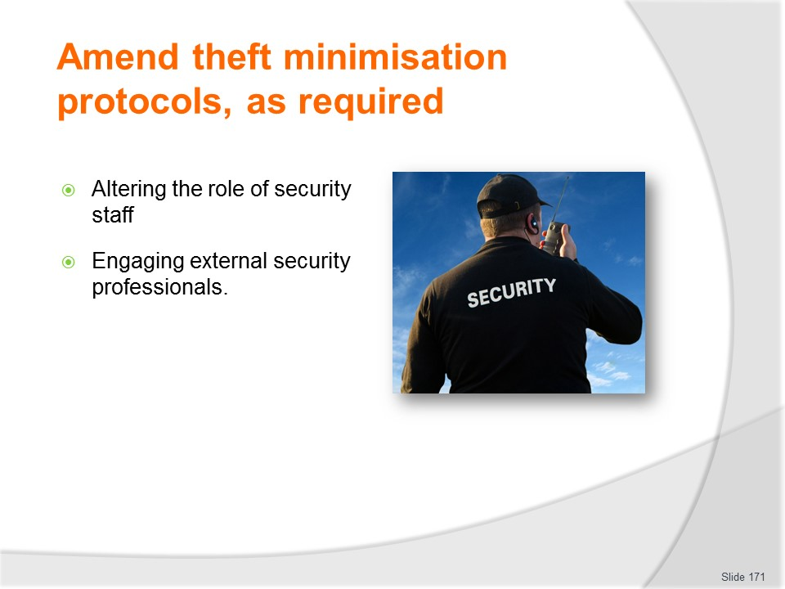
Slide No | Trainer Notes
Trainer continues presenting possible practical action required to amend theft minimisation protocols:
- Changing role of security staff – which may entail:
- Increasing number of security staff, or their hours
- Altering the times they work
- Engaging external security contractors
- Changing the focus of the work they do – patrols, inspections, checks, targets
- Shifting from a high-profile presence (Static Guard) to a covert workplace presence (Loss Prevention Officer), or vice versa
- Engaging the services of security professionals.

Slide
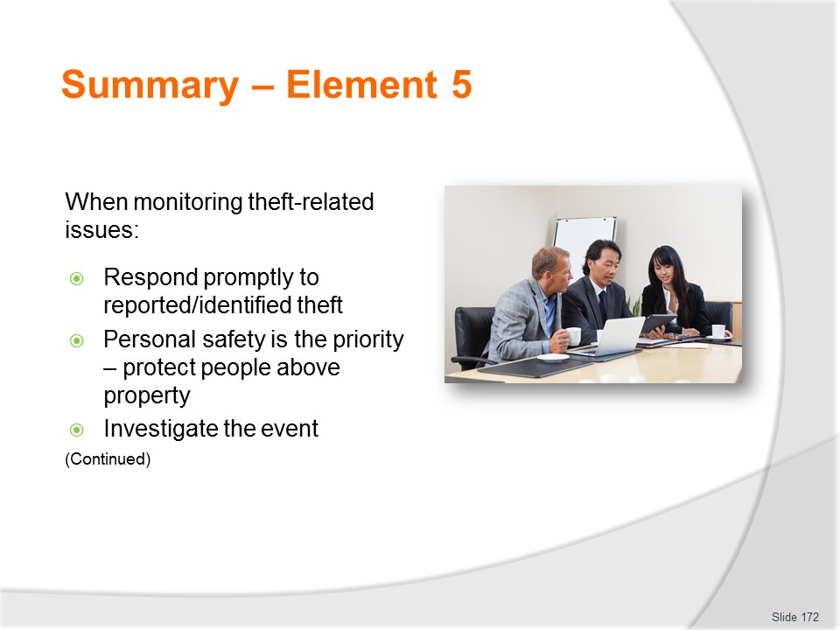
Slide No | Trainer Notes
 | Trainer provides a recap of the Element asking questions to check trainee understanding and responding to questions from trainees, as required.

Slide
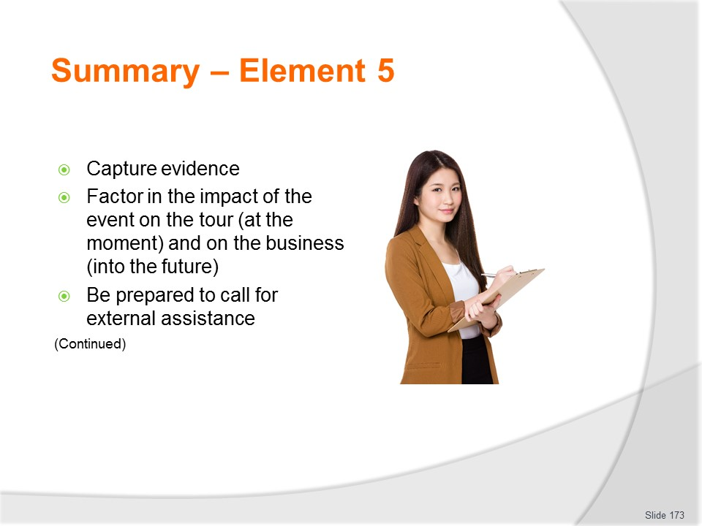
Slide No | Trainer Notes
 | Trainer provides a recap of the Element asking questions to check trainee understanding and responding to questions from trainees, as required.

Slide
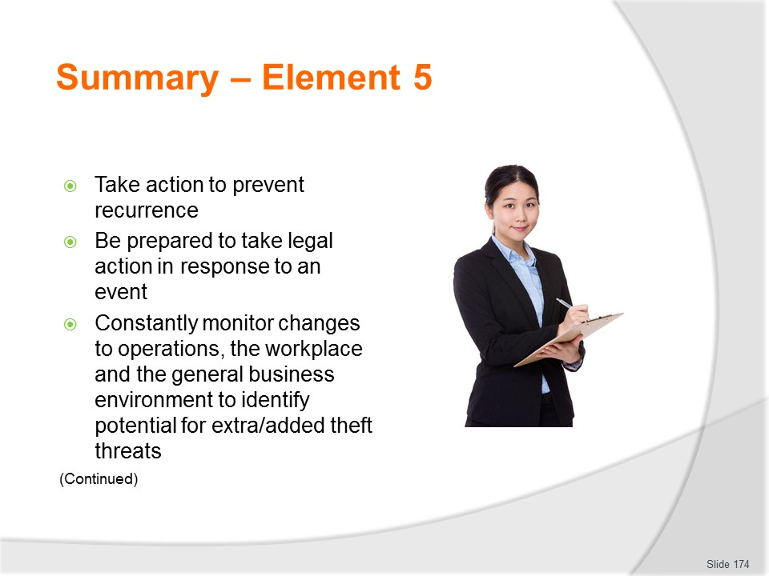
Slide No | Trainer Notes
 | Trainer provides a recap of the Element asking questions to check trainee understanding and responding to questions from trainees, as required.

Slide
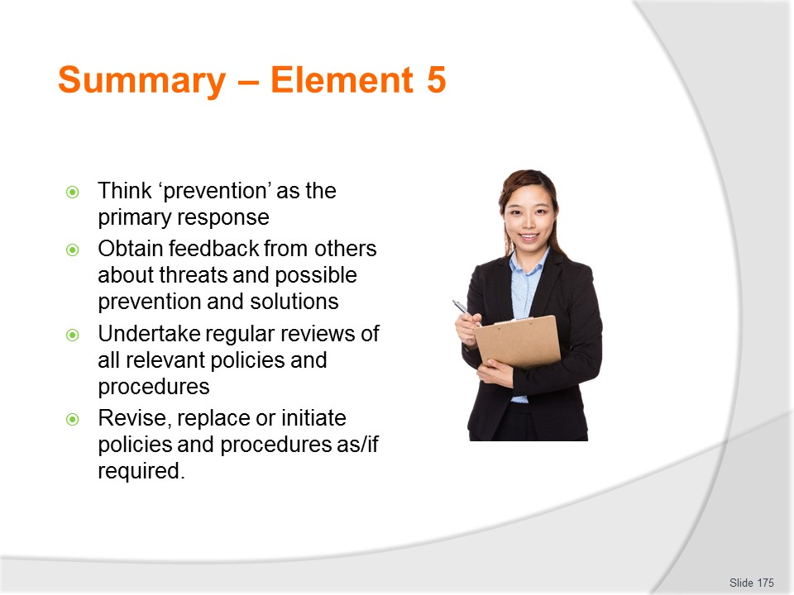
Slide No | Trainer Notes
Trainer provides a recap of the Element asking questions to check trainee understanding and responding to questions from trainees, as required.
Trainer thanks trainees for their attention and encourages them to apply course content as required in their workplace activities.

Recommended training equipment
Sample industry/organisation theft minimisation policies and procedures
Host country Codes of Practice and legislation relevant to:
- Theft prevention
- Duty of care
- Bag searches
- Citizen’s arrest
- Evidence required
- Best practice and sample industry standards in theft prevention/minimisation.
Sample documentation – such as:
- Dockets
- Vouchers
- Tickets
- Stock take sheets
- Requisition
- Cash and stock control documents
- Key register
- Inspection checklists
- Evidence recording forms
- Internal reports
- Cash handling and transaction forms, including forms for refunds, exchanges, voids and similar other events
- Bin cards
- Stock transfer sheets
- Damaged goods sheets
- Forms for recording tickets and vouchers incorrectly completed and voided/invalidated
- Advice sheets distributed to customers providing information on action to take to safeguard property/valuables while travelling/on tour
- Visitor sign-in register.
POS registers/terminals with cash (for demonstrations/role plays)
Safes

Examples of security equipment and systems – such as:
- Alarm systems
- Video surveillance/CCTV
- Mirrors
- Locks
- Display units
- Barriers
- Electronic Article Surveillance
- Key safe.

Instructions for Trainers for using
PowerPoint – Presenter View
Connect your laptop or computer to your projector equipment as per manufacturers’ instructions.
In PowerPoint, on the Slide Show menu, click Setup Show.
Under Multiple monitors, select the Show Presenter View check box.
In the Display slide show on list, click the monitor you want the slide show presentation to appear on.
Source: http://office.microsoft.com
Note:
In Presenter View:
You see your notes and have full control of the presentation
Your trainees only see the slide projected on to the screen
More Information
You can obtain more information on how to use PowerPoint from the Microsoft Online Help Centre, available at: http://office.microsoft.com/training/training.aspx?AssetID=RC011298761033
Note Regarding Currency of URLs
Please note that where references have been made to URLs in these training resources trainers will need to verify that the resource or document referred to is still current on the internet. Trainers should endeavour, where possible, to source similar alternative examples of material where it is found that either the website or the document in question is no longer available online.

Appendix – ASEAN acronyms
AADCP | ASEAN – Australia Development Cooperation Program
ACCSTP | ASEAN Common Competency Standards for Tourism Professionals
AEC | ASEAN Economic Community
AMS | ASEAN Member States
ASEAN | Association of Southeast Asian Nations
ASEC | ASEAN Secretariat
ATM | ASEAN Tourism Ministers
ATPMC | ASEAN Tourism Professionals Monitoring Committee
ATPRS | ASEAN Tourism Professional Registration System
ATFTMD | ASEAN Task Force on Tourism Manpower Development
CATC | Common ASEAN Tourism Curriculum
MRA | Mutual Recognition Arrangement
MTCO | Mekong Tourism Coordinating office
NTO | National Tourism Organisation
NTPB | National Tourism Professional Board
RQFSRS | Regional Qualifications Framework and Skills Recognition System
TPCB | Tourism Professional Certification Board





